1A
Cruelty Free  Never Tested on Animals | Organic Ingredients | FREE OF: Parabens, Synthetics, Fragrance,  GMOs, or any other fakeness.
Handmade in small batches with Love

Directions: Shake well before use. Gently massage scrub in circular motions over wet skin (not face). Pay special attention to rough or dry patches. After use, a residual layer of oil will remain on skin. Rinse thoroughly and pat dry with towel. Skin will feel elegantly soft and nourished. Avoid use on freshly shaven or broken skin.

Caution: Oils in product may leave shower or tub surfaces slippery. Not intended for facial use. Essential oils or use on freshly shaven skin may cause skin irritation. External use only.

(recycle symbol) Please recycle. I want to come back as a solar panel.
------------------------------------------------------------------------------------------------------------------------------------------------------------
1C
Made with naturally derived ingredients only.

The combination of ingredients in this loving scrub were chosen with problematic body skin in mind. The high concentration of magnesium in Dead Sea Salt is instrumental in improving skin hydration and reducing inflammation.

Pink salt is readily absorbed into the skin, cleansing and purifying the pores from the inside out. It can improve the texture, tone, and appearance of the skin.

This loving essential oil concoction helps fight acne by removing toxins and cleaning sebaceous glands. Some EOs contain strong antibacterial, antifungal, and anti inflammatory properties. Certain EOs inhibit the bacteria that cause skin infections as well as target acne scarring and pigmentation from previous breakouts.

Each of these ingredients plays an elemental role in anti aging, as well as fighting problematic skin. Use this skin polish regularly to receive prime results.

Ingredients: Dead Sea Salt, Pink Himalayan Salt, Coconut oil, Argan Oil, Jojoba Oil, Almond Oil, Lavender EO, Tea Tree EO, Geranium EO, Chamomile EO, Frankincense EO, Bergamot EO, Rosemary EO.
------------------------------------------------------------------------------------------------------------------------------------------------------------
1B
B R A N D N A M E
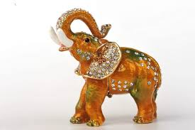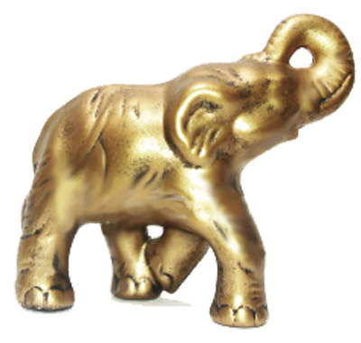

The label is 11 inches long by 1 12/16in wide

The photo titled “structure for oz and grams” -That needs to be included at the bottom of 1B. I like the horizontal and vertical bar that separate the two. I want that.

Color Inspiration - The photo titled “stila color inspiration” and “color combo inspiration” are the colors I want. BLACK, GOLD, WHITE. I want the label background black and the writing in white with some gold somewhere on it. My logo is going to be a golden elephant.

Color Inspiration - The photo titled “color inspiration” and “another color inspiration” is an option I would also like to see. Rather than black, I’d like to see what it would ALSO look like with a navy background. NAVY, GOLD, WHITE, maybe black somewhere.

The photos titled “I like how clean this looks” and “I also like how clean this looks” - I want 1B to look super clean. I don’t want a lot of information in this box. I want simple and clean. This is where the logo and brand name will go.

The photo titled “sideways writing and silver rim” - I want 1C to be written sideways like this. My text will be much more extensive so the font won’t be able to be so big. I also REALLY like how this label is rimmed in silver, but I would want gold. This is not mandatory, but I really like this.

The photo titled “melted honey” - This is another option I really like. The gold that looks like honey dripping on the label is really cool. Not mandatory, but I really liked that. I also like the craft background on this.

Logo - A golden elephant. I want it to be solid gold. There can be dimension like this elephant example on the left of the 1B description. I want the trunk to be facing to the left and the trunk needs to be raised overhead and touching the animal's forehead.

I want to allow some creative inspiration on this. If something is mandatory, I have specified that I want it. The rest, feel free to be creative.

