GRAND OPENING!
DiMarco’s Butcher Shoppe
brings back the ‘true art’ of expert butchering…
carefully hand selected meats… and homestyle cooking!
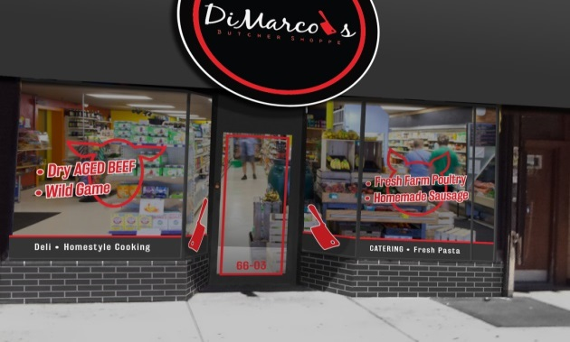
66-03 Myrtle Avenue, Glendale
1-718-628-7300
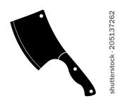Certified Angus Beef Antibiotic-Free Chicken
Dry Aged Beef Fresh Pasta
Wild Game Imported Food Products
All Natural Pork Deli and Catering
Homemade Sausage Homestyle Cooking
Young Lamb and Goat Suckling Pigs
Farm Fresh Holiday Turkeys & Trimmings Full Line of Smoked Meats
Quality Cuts at Great Prices!

Phone Orders Accepted - WE DELIVER!
Accepting EBT and All Major Credit Cards

