DiMarco’s
Butcher Shop
NEWLY OPENED!
BRINGS BACK THE ‘TRUE ART’ OF BUTCHERING…
at
66-03 Myrtle Avenue in GLENDALE!
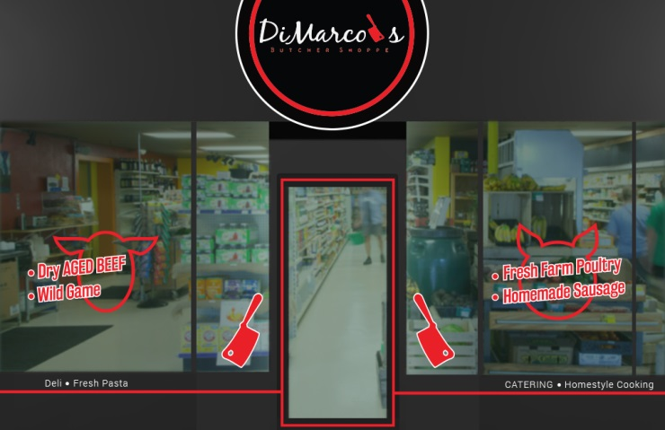

Mark Cacioppo, master butcher and owner of DiMarco’s Butcher Shoppe knows meat, for sure! In fact, he is often referred to as a “doctor of meats.” His vast experience in the meat industry and extensive training has given him this distinction among butchers. The admiration for his craft began when he was a teenager, working as an assistant butcher in Forest Hills. He continued on his journey to work in top rated butcher shops, carefully studied meats, and over time had developed broad-based knowledge in the meat process from beginning to end. Mark is an expert on how meat age rotation is handled, as well as the process with which beef needs to be properly aged to ensure tenderness and flavor. Mark’s aging process involves a skill and style where meats are much softer and much more tender.
Mark is a graduate of the New York Culinary Institute in NYC. He’s trained and worked in some of the finest kitchens in NYC, including the famous Felidia’s Restaurant owned by Lidia Bastianich . He’s worked as a head butcher at the Amish Market at the Atlas Park, meat manager at BJ’s Wholesale Club, as well as at Ottominelli’s Brothers. He’s also gained vast experience on the wholesale level, as sales rep at the famous DeBragga and Spitler Meat Distributors, and has served as advisor to butchers and chefs from all over the country.
Whether he’s recommending a particular cut of meat, or offering a special recipe, Mark’s goal is to provide to his customers at DiMarco’s Butcher Shoppe, the ultimate dining experience…with expert personalized service. Mark personally inspects and scrutinizes all his meats at DiMarco’s Butcher Shop for quality, color, marbling and texture.
Come see for yourself how the true art of meat cutting is returning at DiMarco’s Butcher Shop! Mark is looking forward to providing the community with highly personalized service, and quality wholesome meats and cuts. He will be carrying a full line of aged beef, homemade delicious sausage, pork products, fresh farm poultry, and wild game meats. Visit the butcher shop to indulge in DiMarco’s most flavorful homestyle cooking, appetizing deli products, fresh pasta and catering. Mark is looking forward to building long, personalized business relationships with the entire community. Feel free just to stop in and visit with Mark at DiMarco’s 66-03 Myrtle Avenue, Glendale , for advice on meats.

