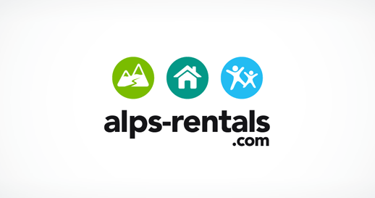
Like the concept of icons and logos covering services

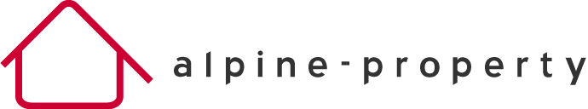
Like the simplicity of the logo and offer – colour feels impactful
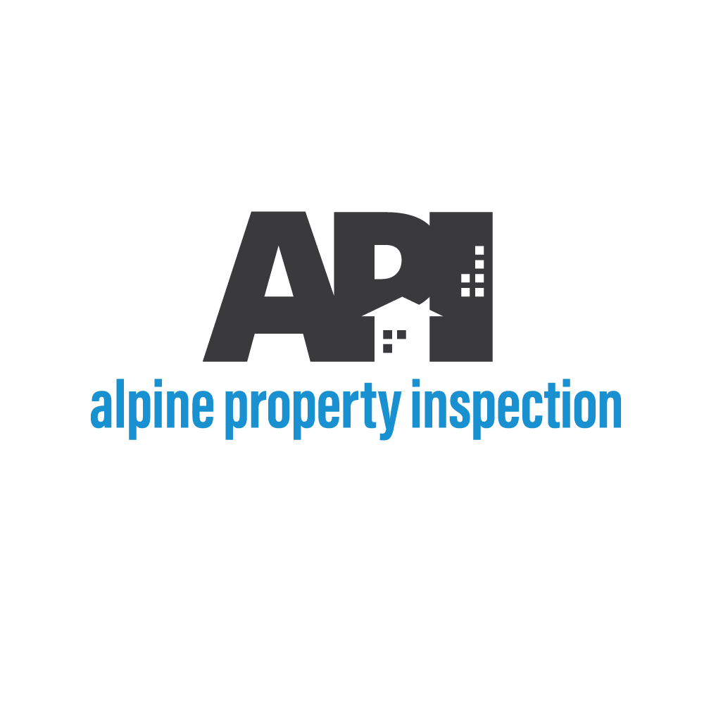
Like the boldness of logo and text

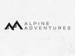
Like the mountain simplicity

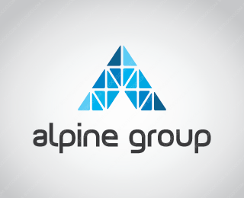
Looks very professional and logo could be intergrade into wider brand design. Ie triangles to make the roof and different colours

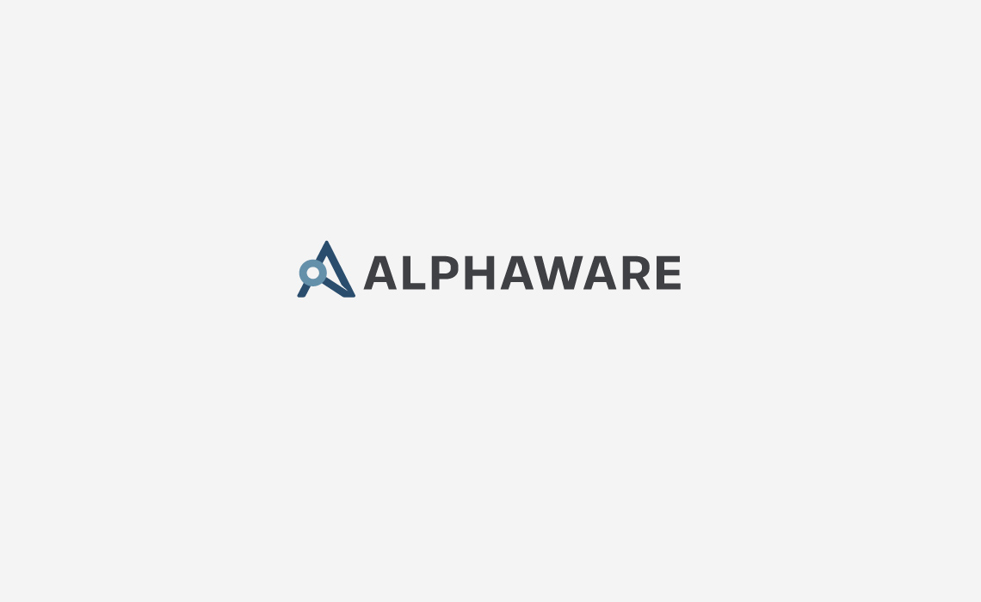

Like the modern bold colours and fonts – strong web based impression

