The Brisbane Courier Qld: 1864-1933_Wed 9 March 1932

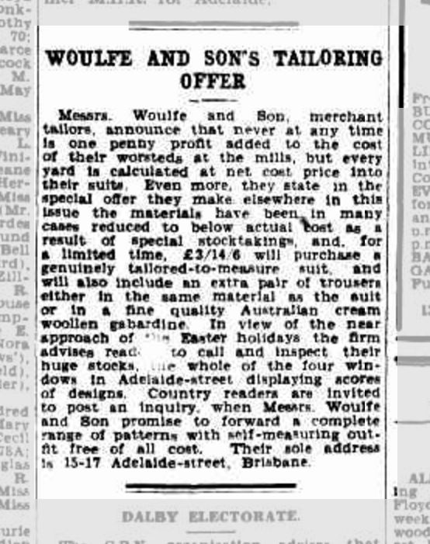

The Brisbane Courier (Qld: 1864-1933)_Wed 25 Feb 1931

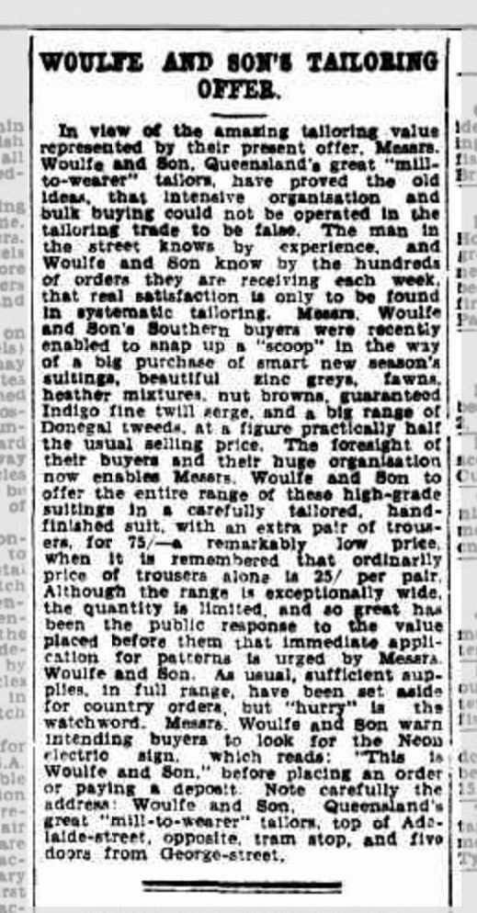

The Brisbane Courier (Qld: 1864-1933)_Tues 29 March 1932

