Instructions and copy

[Amoy logo – Please fetch it from the packaging layout]
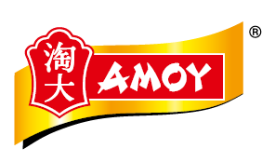
[Product name – Please use the ones that are used in the packaging layout]
極品金蠔油 Deluxe Oyster Sauce

[Product description – Please utilize the modern Chinese fonts (refer to the mood boards). For the French language, please refer to the font used in the “mood board font 01”]

精選紅糖 鮮蠔配方Sauce d’huître supérieure élaborée avec du sucre brun

[Product packages]
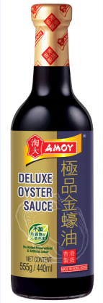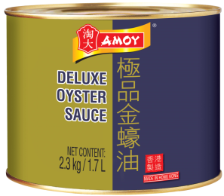

[Key benefits – It’s also an ideal to use a circle/rectangle outline to emphasize the key benefits, but we appreciate your creative ideas.]

- 鮮味提升Riche en umami
- 色澤豐潤 Révèle les couleurs de vos plats
- 健康加分Pour une cuisine saine

[Unique selling point visual – Please grab this from the packaging layout]



