New Website Brief
We’re looking to redesign our website – so that it is 3 things: smart, stylish and simplistic.
About Croud:
Our mission is to build the world's greatest performance digital agency. In our experience, there is no such thing as a great agency, just great people in search agencies, so we have built an agency that focuses on 4 key pillars:
1) Great people
2) Supported by our very own network of digital marketing experts
3) Everyone should own a share
4) Technology should enhance everything that we do
Croud was set up in late 2011 and in that time have been credited with being Google's fastest growing agency for both 2013 and 2014 and the fastest agency to ever get Tier 1 Google support. We have a great bunch of clients including Interflora, Cambridge Satchel Company, Regus, Net-A-Porter, The Guardian, Hiscox, Find My Past and more...
Our key services include PPC, SEO, Display, Content, Social Ads and Analytics and we use the best marketing talent in the world to deliver this.
The real USPs of the company are our network of digital marketing experts who are located all over the world and the technology that allows them to work this way.
Croud exists to re-invent the digital media agency model. Agencies are hampered by lack of skilled expertise to deliver the work clients ask of them, and the right co-ordination to complete work on time. The Croud network of 600 freelance experts across the world solves this problem, and we manage the network through our proprietary technology, Croud Control.

The Brand
I’m very keen to make the brand look far more grown up – we’re experts at what we do and our brand should reflect this. So I want to move away from the cartoony feel of the site at the moment and replace that with beautiful looking images.
We’re happy to keep our logo very similar to how it looks now, but if there are any small tweaks that you think might work then we’re happy to consider those.
The Website:
What’s the Croud website for?
The primary goal of the site is to generate appropriate incoming leads to the business. The secondary goal is to attract employees to the business.
The main things that the site needs to be are:
- Highly mobile optimised, cross-browser compatible
- Simple and easily digestible – we need to enable users to understand immediately what we do from the homepage
- There needs to be not too long a scroll
- Have a focus on our network and tech
- Grown up feel – I’m keen to move away from cartoons and head towards beautiful images
- A great showcase for our work, via case studies
- A recruitment tool – via the ‘Team’ (FTE) page, but also for our network of Croudies
- Encourage inbound contact
- Beautiful looking, ‘designerish’ site whilst remaining professional
- Engaging and ‘buzzy’ without being cluttered
- Crisp, cool, clean
- Focus is ‘show don’t tell’
- SEO optimised
- Whilst we want to create a cool site, the main thing needs to be it’s really intuitive to navigate
Pages needed:
- Homepage
- Join us page:
  - Team page
  - Croudie network
- Blog page
- Contact page
- Editable page for each of our offerings
- Page for our network/ our technology
- Case studies design
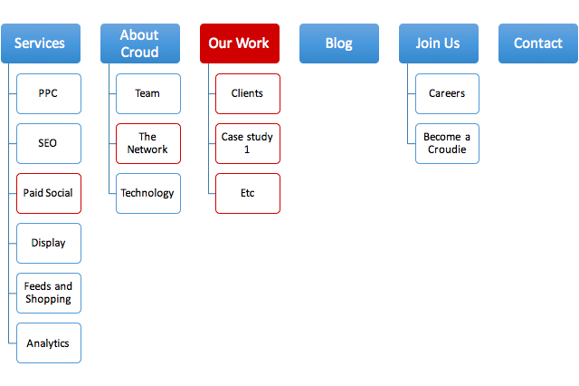
Who is the audience for the Croud website?
The primary target audience is marketing directors, digital directors, marketing managers and online acquisition managers. The secondary audience are people in the industry looking for work either as permanent employees or as part of the Croud freelance network.

Websites we like:

Site | Why we like it | Things we don't like
http://www.iris-worldwide.com | Very simple | You need to scroll down to understand what they do
https://www.freshminds.co.uk/ | ○ Stylish, beautiful images  ○ I really like the blog grid page | Time that it takes to load
http://minimums.com/ | ○ I like the grid, but also the fact that it doesn't look too busy  ○ I also like the fact that videos and images are mixed | Not clear what they do
https://www.bigcartel.com/#tour | ○ I like the opening video  ○ Very smart looking  ○ I like the blog style | No homepage
http://rsq.com/ | Smart looking | Quite unclear
http://bluestag.co.uk/ | ○ Clean and crisp  ○ Cool videos and images  ○ Very stong emphasis on case studies  ○ I like the 'life' and 'articles' pages | Slow loading
http://www.welikesmall.com/work/ | I really like the case studies page, with the changing dates | Very unclear navigation
http://www.laphase5.com/ | I really like the grid style | Cartoon images slightly jarring
http://method.digital/ | ○ Nice scroll, and it's not too long  ○ I like the background images | Slightly content heavy
http://conversion.com/ | Very simple | Not particularly stylish
http://checklandkindleysides.com/ | ○ I love the whole site!  ○ Really clear what they do  ○ I love the animations for their services - really clever touch  ○ I wonder if we could do something similar with our network - joing everything together | Not sure how to get back to the homepage

Going forward
We will also be needing collateral designed.

