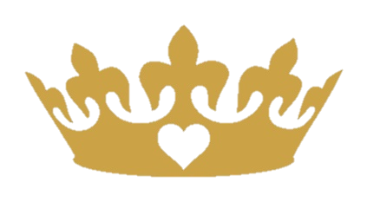

- This 1875 watt Salon level hair dryer has a long lasting motor that gives you the power of multiple hair dryers in ONE!
- The Positive Ion Setting opens the hair cuticle when the air blows through, giving a deeper and more effective drying penetration to the cortex
- The Negative Ion Setting provides 100x more negative ions than a regular hair dryer which makes the hair softer and healthier, and minimal static!
- 2 Speeds and 3 Temperature settings allow for the options best suited for your hair type
- The Silent Fan Blade makes reduces the hair dryer noise
- Durable housing makes it durable and strong
- Included are 2 concentrators and 1 Diffuser
- 9ft 360° swivel cord
- 125v/60Hz
One Year Warranty Included

