ZEUS POWER

ZeusPower
POWER

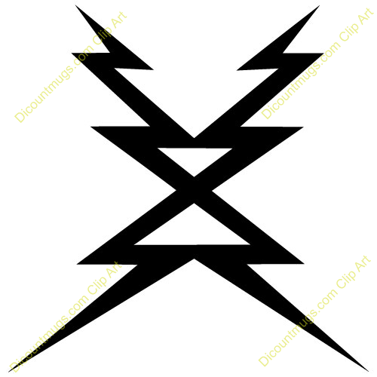Power
zeuspower®
z-power®
powerz® powerZ®
go power
repowerz®
LightZ
PhoneZ
GameZ

