Inside Sales WEB Site and Company Boucher

Clearwater LED is a Specialty LED manufacturer and exporter based in Texas. We are specializing in custom marine quality LED lights, focusing on building high quality lights that can survive in our harsh saltwater environments. We start be Important Heavy duty vapor proof and explosion proof frames, lens and seals, next we add only the top rated components like Cree diodes and Mean-well drivers and seal everything with using 316 SS hardware, by directly importing the frames and adding the technology in the US, we are not only able to produce a high quality lights we can produce them at a big savings. We also can leverage our team in ASIA to assist our customer with special orders and have the capabilities to source Led lighting for small to mid-size projects at the quality and price you can afford. We are committed to delivering cutting edge technology with the highest quality of components while meeting and exceeding all safety protocols and energy efficiency standards, all to improve our customers’ service, bottom line

Currently we are focusing on 3 basic models on lights .
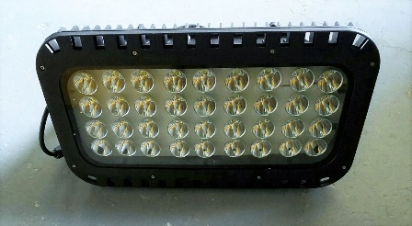Ultra 2000 SS
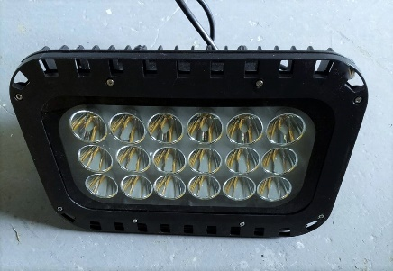Ultra 1250 SS
Ultra 2000 Super Spot series: & Ultra 1250 SS IP 67, Indoor and outdoor rated ,Input 110V-277 Volt VAC, UL and CE approved, 5 degree spot beam Colors White and Green, 36 x10 or e chips and Meanwell Driver to give our customer Unprecedented spot light control Using a 5 degree spot controlled beam. This specialized light is designed to give the customer precise control over exactly where they want the light to go. Whether it is for fishing or wanting to light up some over 100 yards away The most common use for this light has be replacing large 2000 watt train lights on large fishing Piers, Surf fishing , Marina's and several applications.
Ultra 2000 Super Spot: Input Power: 110-227 VAC , IP67, UL,CE approved , 5-60 degree beam angle , Colors, White, Warm White and Green. Cree 36x10W 360 Watts 45,000 Lumens Meanwell Drivers.
Ultra 1250 Super Spot: Input Power: 110-227 VAC , IP67, UL,CE approved , 5-60 degree beam angle, Colors, White, Warm White and Green. Cree 18x10W 180 Watts 22,500 Lumens Meanwell Drivers.
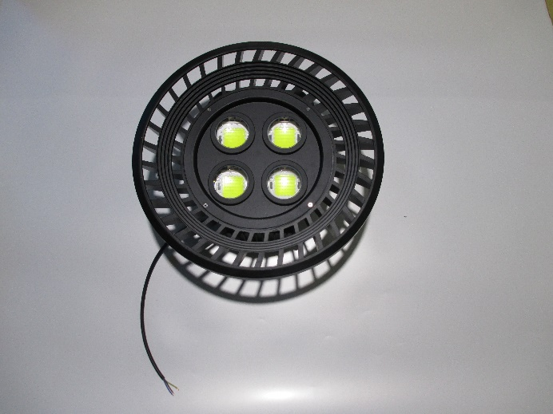
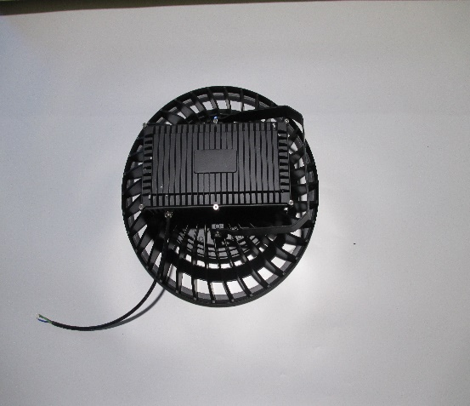 Ultra 1500
Ultra 1500, Pier Light Series: This Heavy Duty Light , is in an explosion/vapor proof frame, comes in a standard 60 degree Beam angle also so available in 90/120 beam angles, colors GREEN AND White, 110-227 Input, RoHS compliant and UL CE Approved , 4x50 watt Cree diodes that are producing 125 lumens per watt for 25,000 lumens total and a Meanwell Driver. This light has become a favorite when replacing the 1000-15000 Metal Halide sports lighters and other HID systems currently on Dock and fishing Piers throughout the country. The Ultra 1500 has also been popular for Parking lots, warehouses, construction sites marina's and anywhere you need a High powered LED light.

Ultra 250-1000 High Powered LED Light, This is our multi purpose Line of light that features a super Heavy Duty frame and lens, IP67, RoHs compliant and both UL, CE approved for Indoor or Outdoor uses. We have the ability to offer different beam controls featuring three different beam angles 60,90, and 120 degrees respectively The Ultra 250, 600 and 1000 series of lights offer our customer with a wide variety of lighting options. The most common uses has been using the green lights of the docks of canal homes using a 60 degree lens gives to customer control over where they want the light to hit and it makes a great fishing lights in tight quarters. They have served in several countries and has been extremely dependable from the marina's and constructions site this high quality light will give you years of trouble free performance.
Ultra 250 , IP67, UL and CE approved, Input Power 110-227 AC or 12 volt , 60-12 Beam Angle 50x1 Cree LED, Meanwell Driver with a total output of 6250 Lumens. Replaces 100-250 Metal Halide
Ultra 600 , IP67 , UL and CE approved, Input Power 110-227 AC or 12 volt , 60-12 Beam Angle 50x2 Cree LED, Meanwell Driver with a total output of 12,500 Lumens, Replaces 250-600 Metal Halide
Ultra 1000 , IP67 , UL and CE approved, Input Power 110-227 AC or 12 volt , 60-12 Beam Angle 50x1 Cree LED, Meanwell Driver with a total output of 18750 Lumens Replaces 600-1000 Metal Halide.
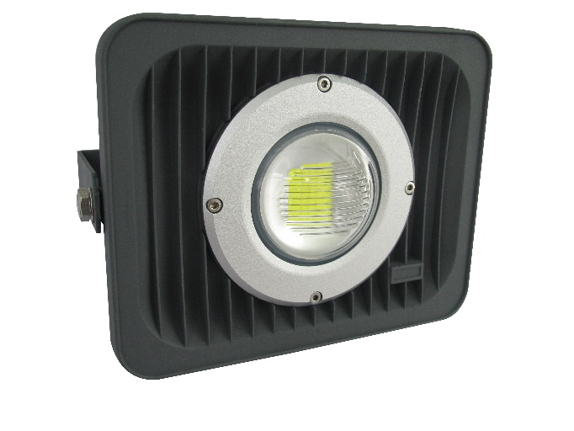Ultra 250 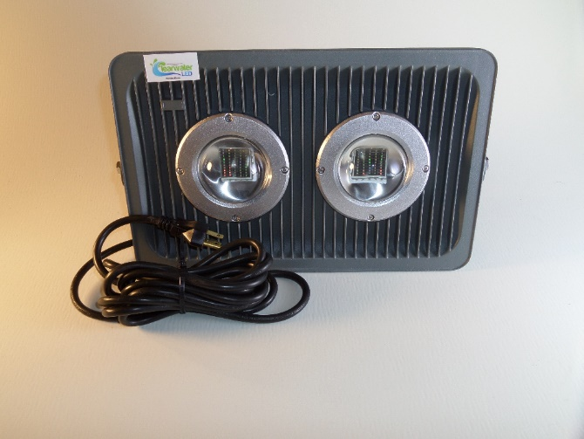Ultra 6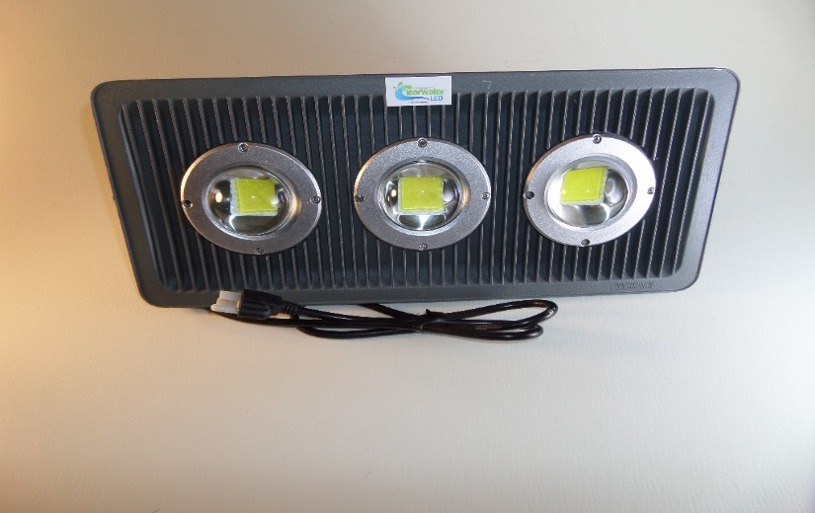00 Ultra 1000

