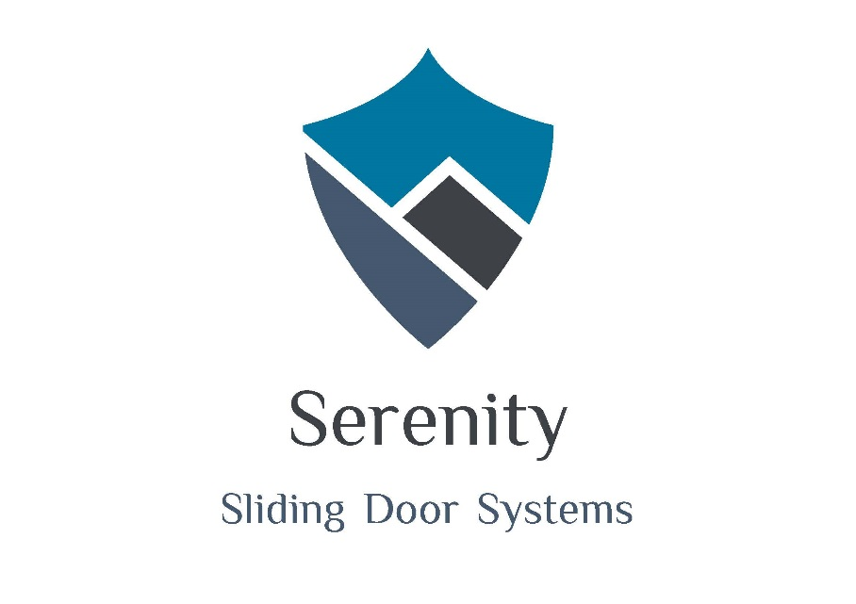
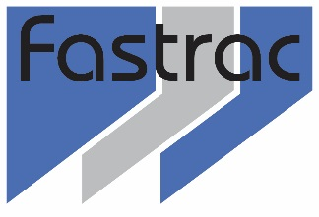
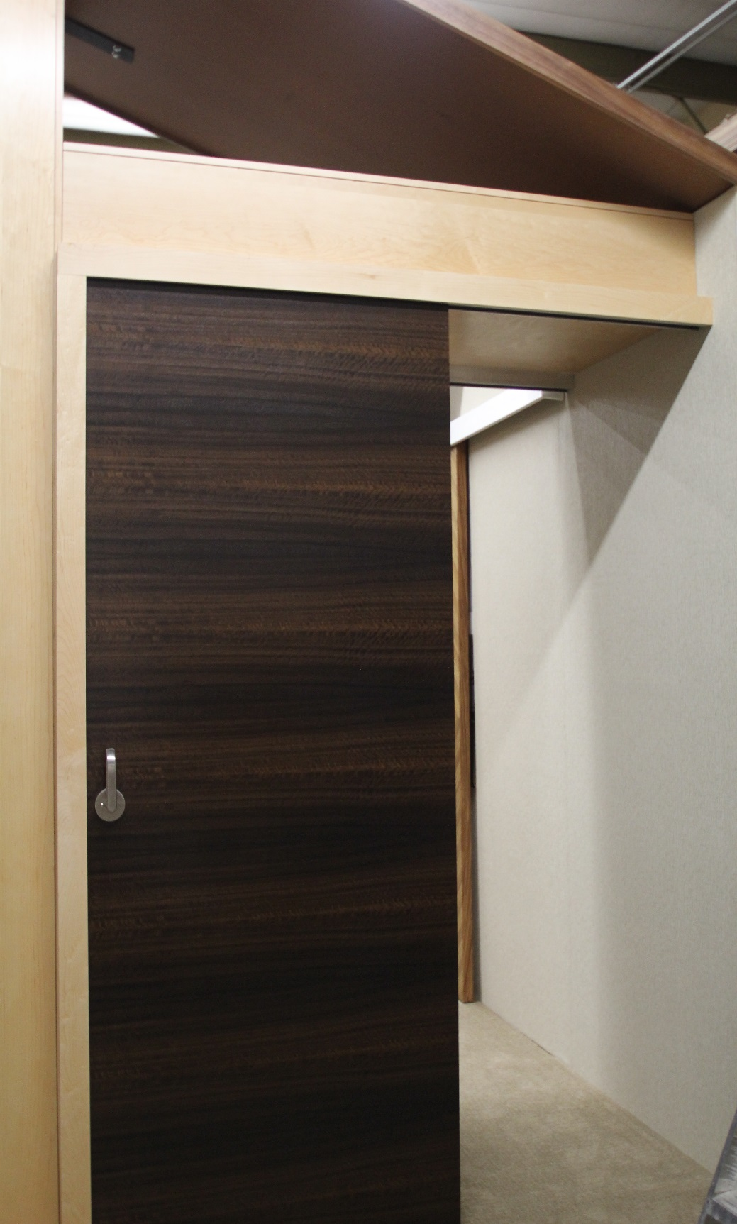
Bill, Hospitality Contractor

“The liability of fingers being smashed in most current slider door systems is quite suspect.
Serenity by Fastrac helps alleviate this with their top of the line soft close system”
Serenity

Serenity

Sliding Door Systems
Safe … Quiet … Secure...
“We didn’t invent the Barn Door, We perfected it !”
Our sliding doors are fully sealed for sound and light, Soft close, Soft open, Quiet and ADA compliant.
No loud banging, no smashed fingers
No visible sight lines
Unlike most systems our Serenity line is LEVER lockable with keys or privacy
Retrofit almost any opening

Fastrac Building and Hospitality Supply. 637 Elkton Drive , Colorado Springs. CO 80907
Colorado Springs, CO. Phoenix AZ. San Jose CA.
719-434-8670 Main office

Stanford Cancer Center , San Jose CA.

