Terrafirma
Detailed Excavations & Earthmoving pty ltd

Brief for company logo:
Business name: Terrafirma Detailed Excavations & Earthmoving pty ltd
ABN: 51 613 392 313
Website: www.terrafirma.net.au
Email: admin@terrafirma.net.au
Phone: 07 5494 2140
Mobile: 04 1116 3892

‘Terrafirma’ is latin for ‘firm ground’ and we would like to include this theme into our company logo. This term is the dominant word in our company name.
As the company name indicates, the main business activities are earthworks with jobs being conducted with the following machinery types: excavators, posi tracks, tipper trucks and drotts.
We would like to use the colours: blue, orange, green, yellow. Black and white where required.
Below are the machinery colours which we would like to incorporate. These are in order of dominance preference:
Blue:
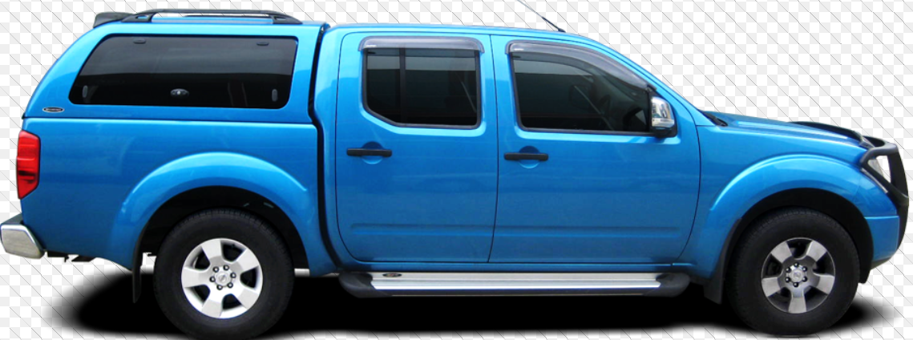
Orange:
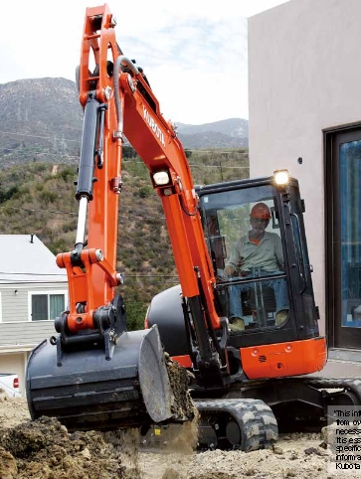

Yellow:
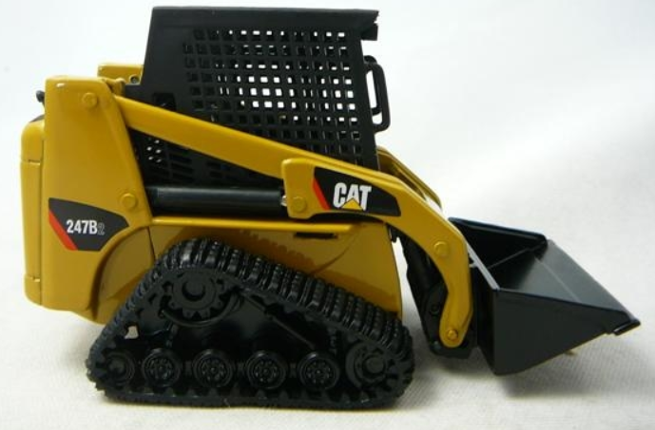
Green:
