COVER PAGE
- Please add “Catalogue for prospective students 2016” in a somewhat subtle style to the bottom of the page. Maybe the light blue theme as seen on page 2 (“Studying Arabic…”) fits.
- Please center the logo
- The “u” in arabandu is somewhat rough-cut. Please fix that or let us know if it is an error with the source file.
- Please change the picture. See point “GENERAL” further down.

WHAT IS ARABANDU
- Let’s include a header which shows the respective chapter. Chapters are below.
- “Our Partners” as a title looks bad. I recommend changing it to the style of “Studying Arabic in the Heart…” as seen on page 2. Please omit the colons.
- The logos are not evenly distributed on the horizontal axis.
- I attached you a new logo for the university. Please swap the blue logo for the one attached. [note: all the pictures were too large to attach, so instead you find a dropbox link at the end of this mail]
PRIME LOCATION
- Please use the italics specified in the text, for example at “[…] or Lac, as locals nickname it […]”
- The blue line on p.3 is not convincing. Please omit that.
- Please use the new, attached map instead of the current one
MUST SEES IN TUNIS → Will be moved to the back!!
- Please change the name to “Your Adventure in Tunis”
- Only the first title for Carthage – delete the “Experience History at its best”
- The page invades the footer. I attached a shortened version for the “Indulge in Gammarth” part. That should do it.
- The last picture is bigger than the others. If possible, let’s have it less obvious. Maybe it looks better if it doesn’t cover the full length of text necessarily.
- New pictures for Carthage, Gammarth and La Marsa are attached. Please use these instead of the current ones.
BETTER LOOK AT TUNIS
- Please rename to “Take a Closer Look at Tunis”
- This is not a subsection – it should be in blue then! (@”What is arabandu”)
WHAT WE OFFER
- Please change the picture to the respectively named one in the attachment.
- Please add “Accomodation” as the last bullet point.
- Please rename “General Arabic” to “High Arabic”
- Please omit the blue box at the top of page 9.
ABOUT COURSES
- Please change name to “About Our Courses”
- Again, italics (e.g. “communicative language teaching approach […]”)
- From this page on (!) the logo does not have the same distance to the page number as on previous (even) pages – I prefer the distance of the first half of the catalogue.
ABOUT COURSES (2)
- Please rename the table to “When will you reach your goal?”
- And, just as in the case of “Our Partners”, I suggest changing the title to the light blue theme used in p2 for “Studying Arab in the Heart of North Africa” (incl. the line).
- I changed the table in my attached file, please use the new one.
  - Changelog: I changed “Courses” to a singular “Course” and added the missing hyphen for intensive. Considering the space he has with his chosen design, I omitted the second column and merged it with the first, where I changed the levels to learning scenarios. The content of the second column is instead now a “note” at the bottom of the table.
GENERAL ARABIC
- Please rename General Arabic to “High Arabic”
- Could we have blue lines underneath each text (or underneath each intensity), like in “About Courses”?
- Please omit the blue box on p. 13
- Please change the picture. I suggest the picture named “High Arabic” and the one named “Learn Arabic”, but feel free to use another one here. We don’t like the current one, however.
TUNISIAN ARABIC
- Again, a blue line underneath the text like in About Courses.
ACCOMODATION
- The text is not in line with the title.
- Please change the third accommodation picture, aka the second picture on p. 17 for the picture labeled “Accomodation” in the attachment.
GET IN – VISA
- Let’s change the title to “How to Get to Tunisia” – subtitle: Visa requirements.
- Please don’t put the list of countries with visa exemption into the running text. You could have it separate, for example, on the second page.
- Please change the picture for the “passport” picture in the attachment.
GENERAL
- Please include a link to our website on the back cover – we should have the link by tomorrow, can you send it to him then, Farah?
- Please include the header where the current chapter is always displayed
- Please change all the specified pictures. Furthermore, we attached you a bunch of stockphotos. Feel free to use them if you feel like they fit somewhere
- Also, please change the picture on the cover. We don’t like it. But neither do we know how to change it well. So feel free to use one of our attached pictures – however we’d prefer not to use a still picture, like “Learn Arabic” or the lamps. If you feel that one of the pictures we planned for another page, as mentioned in this mail, fits the cover the most, then feel free to use one of these. We care a lot about the cover page and hope that we can get it somewhat more exciting than right now. We do have a fotolia account if you want to look for stock photos yourself.
- We like the picture labelled “Mosaic” in the attachment – maybe you can shorten the visa part to one page and have the Mosaic on the last page.

ORDER OF CHAPTERS:
- (Cover)
- (Content)
- What is arabandu?
- Prime Location
  - Take a closer look
- What we Offer
  - About Our Courses
  - High Arabic
  - Tunisian Arabic
  - Accomodation
- Your Adventure in Tunis
- How to Get to Tunisia
- (Mosaic)
- (Back cover)

Please only have the first layer chapters included in the header, neither the second layer chapters nor the elements in the parentheses.

ATTACHMENTS
- You find attached the word file with the changed Gammarth text and course table.
- The pictures were too large to attach. Thus, here is a dropbox link where you will find the pictures:

https://www.dropbox.com/sh/xsfy8wpzf1i3a1i/AAA4q6R4SZx8wrv7CeG8bMWga?dl=0

Due to the large volume of requested changes we will gladly increase our agreed-upon salary by a fair amount if we are satisfied with your second draft.

The deadline is 7 PM Tunisian time today (30.09.) (!) – please send us a new draft before that, so that we can make changes if necessary. If we get the draft before 3 pm we will gladly add another bonus.

Thank you very much,

2. Change the pictures of the section What we offer to this one

- Change some pictures of the section “Must sees in Tunisia” in the order
Exploring the ruins of carthage :
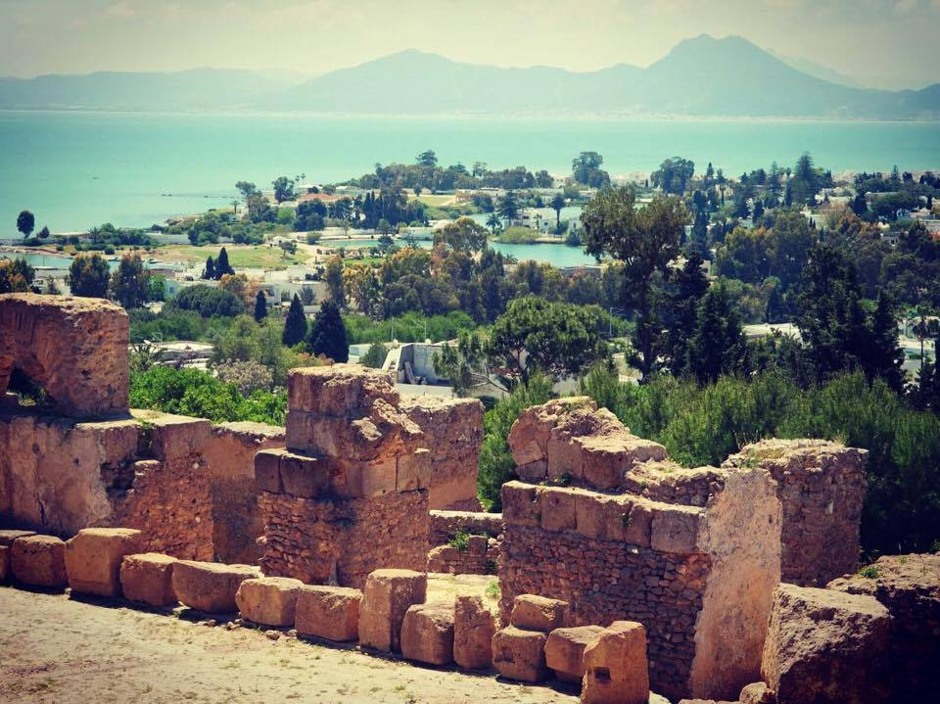
Having Traditional Arab Tea in the Medina :
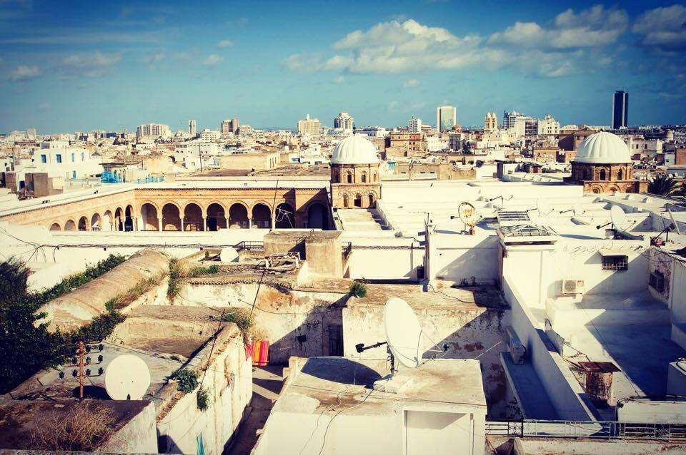
Relaxing at the Beach in La Marsa
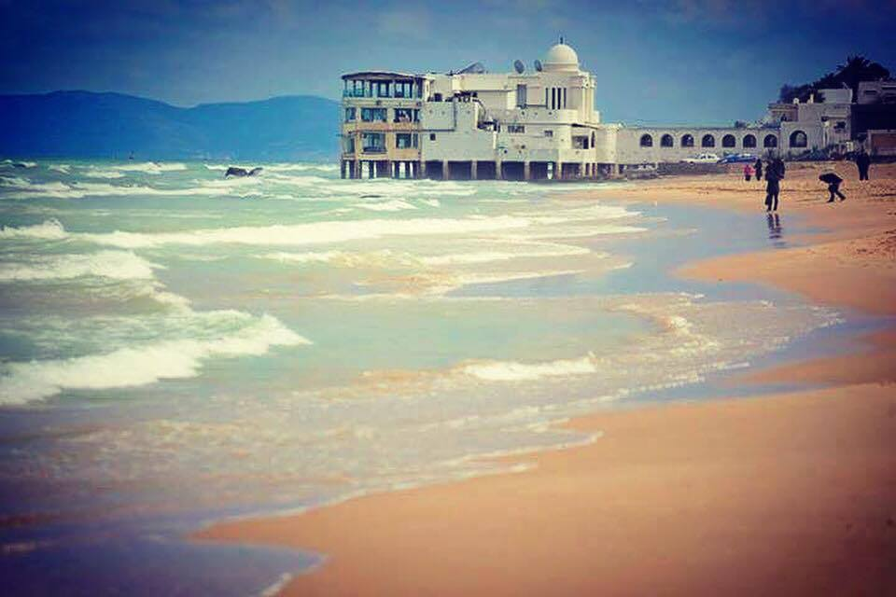
Taking Pictures in Sidi Bou Said
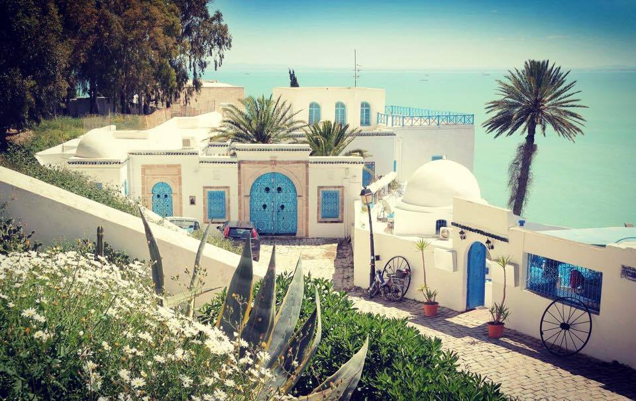
Go Shopping at Avenue Bourguiba
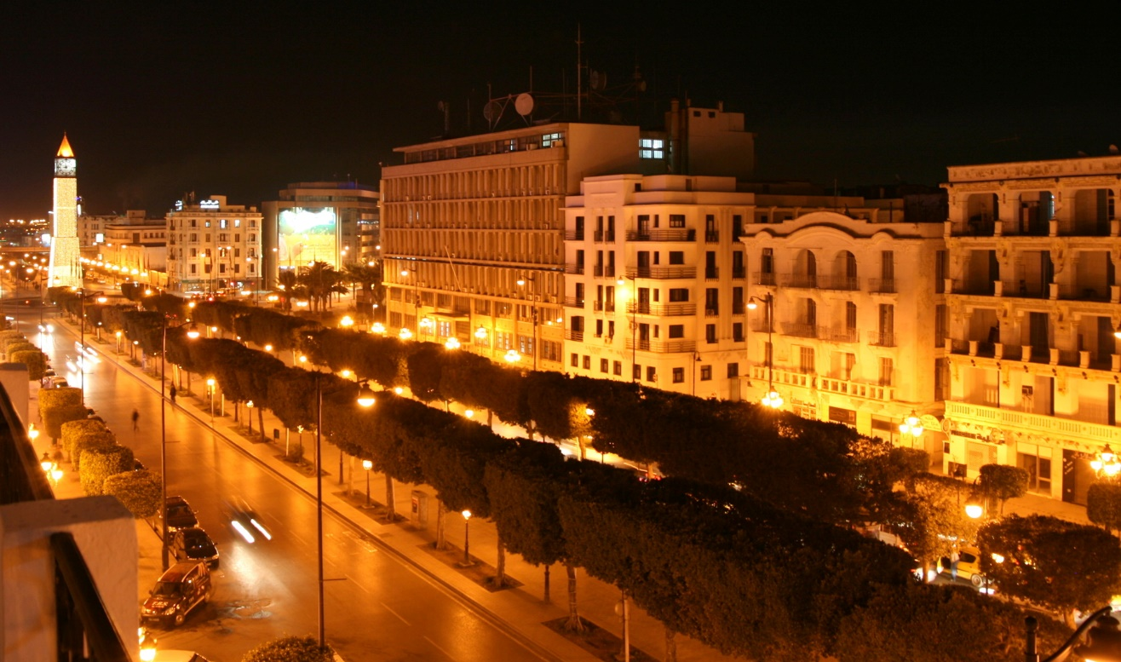

- In the page What is Arabandu
Put the logos into the middle of the page
- Change the picture of the front page

- Change the picture of general Arabic

- Change the picture of Tunisian Arabic


- The sections Bout courses, General Arabic, Tunisian Arabic are wrongly disposed in the catalog. Make it like in the Summary up in that file.
- Change the picture of accommodation
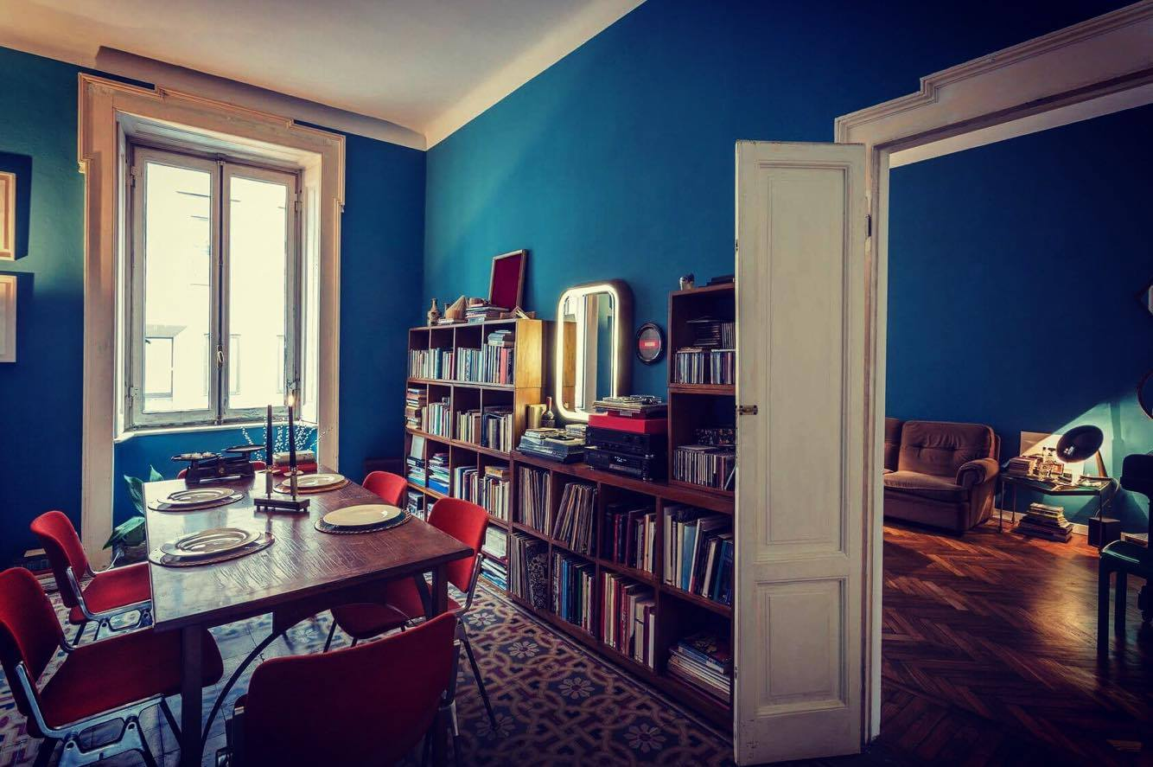
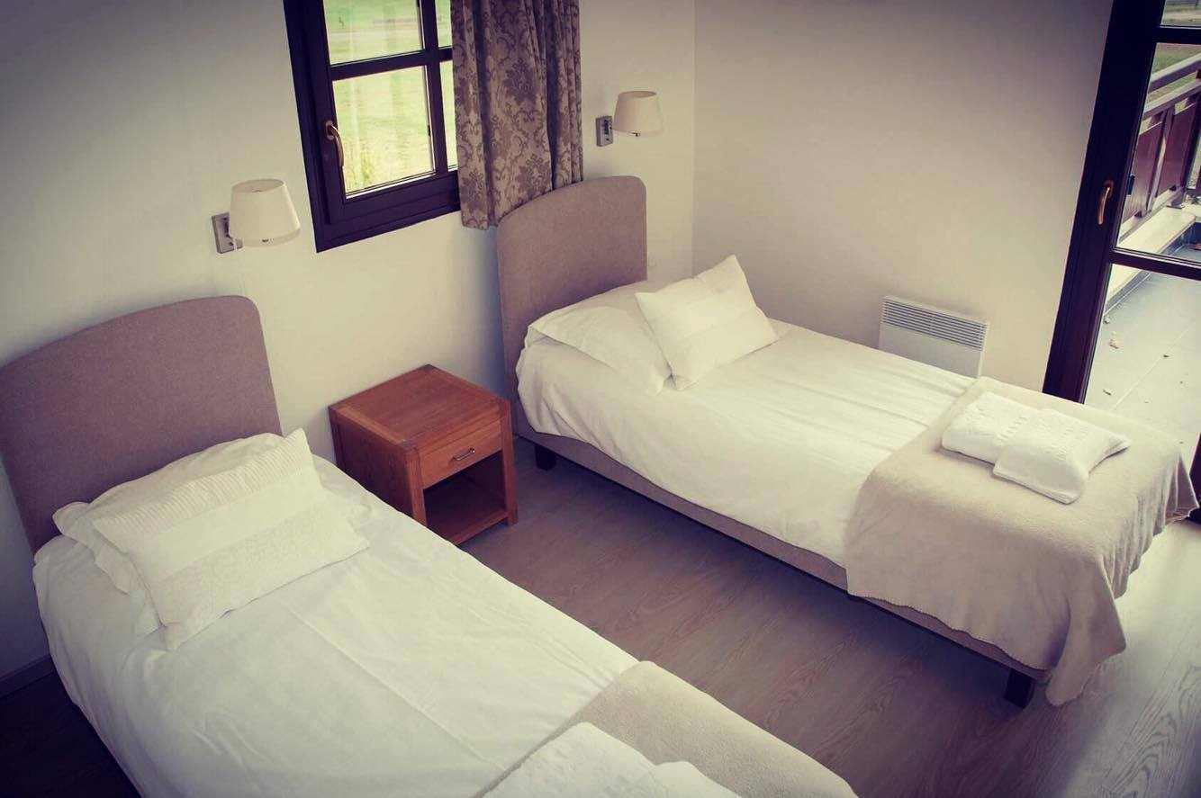
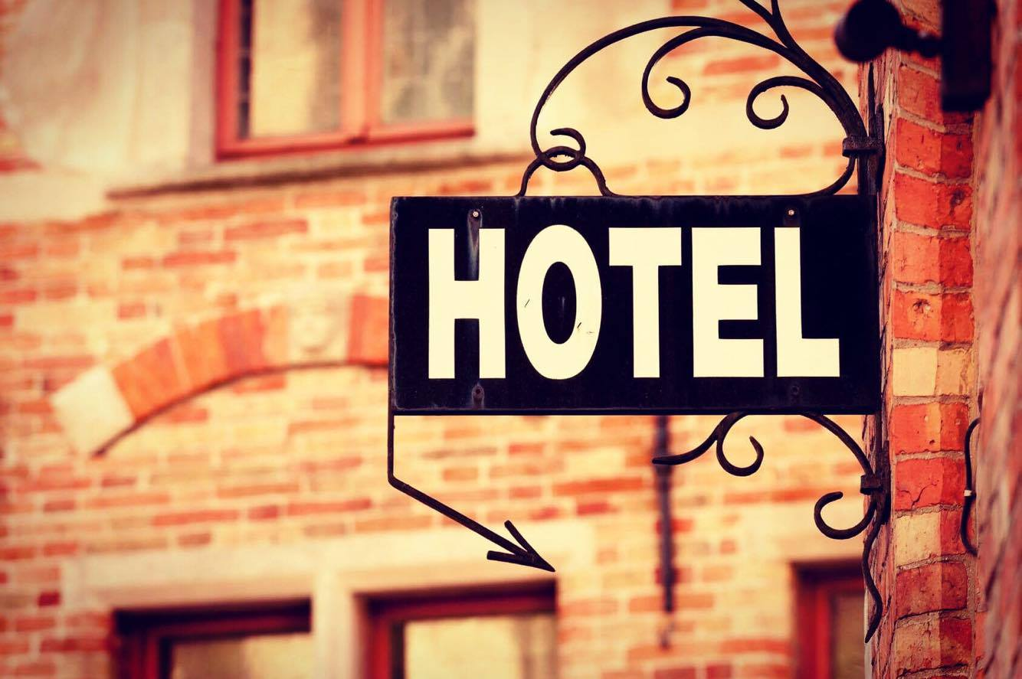
- Change the picture of Get in Visa


