
PAJAMA














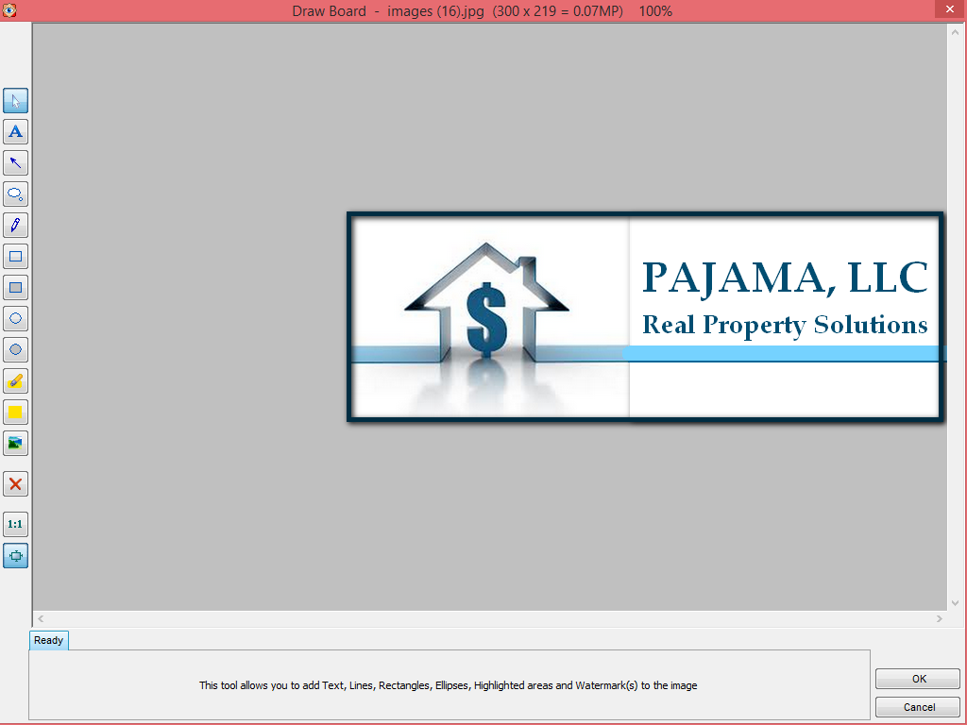





JAMAJA 
Real Property Solutions






Jay Watson – President, CEO
PAJAMA - Real Property Solutions
516.526.3117
JWatson.PajamaRPS@gmail.com

Jay Watson – President, CEO
516.526.3117
JWatson.PajamaRPS@gmail.com








Pajama, LLC develops affordable housing for middle class families. We provide families solutions to complex real property situations. We provide safe, short term, high return investment opportunities for private investors. Our efforts result in employment, and contracts for local, small businesses for services and supplies. We have an affinity for partnering with minority owned businesses.


Pajama, LLC develops affordable housing for middle class families. We provide families solutions to complex real property situations. We provide safe, short term, high return investment opportunities for private investors. Our efforts result in employment, and contracts for local, small businesses for services and supplies. We have an affinity for partnering with minority owned businesses.


Jay Watson – President, CEO
516.526.3117
JWatson.PajamaRPS@gmail.com
PAJAMA – Real Property Solutions


Real Property Solutions
PAJAMA
Real Property Solutions
PAJAMA
Real Property Solutions
PAJAMA

