Brochure

A4 Folded to DLE – 6 panels of 99mm x 210mm
Attached for rough layout.
Please note that content on pages 3 can move to page 4 if there isn’t enough room on page 3 as long as they appear in the same order.
The images included in this document will be supplied hi-res once the layout is sorted. Then any logos need to be covered up with Hygiene Factor logos, so please factor this in.
Copy and Image Guide

PAGE 1 – Front Page
Include Logo
1a Image
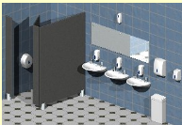
1b Copy
Hygiene Factor are a locally owned professional washroom services company. We work with you to provide the best washroom solution for your business and the people who use your bathrooms.

PAGE 2 Inside Left Page – please advise if you think this needs an image to break up the text.
2a Copy
Professional Washroom Service
Hygiene Factor is a New Zealand company with years of experience in the washroom services industry. We have a smart range of washroom dispensers and consumables that will complement your environment at an affordable price.
2b Copy
Customised Service
We work with you to ensure that you have the most appropriate washroom solution and service schedule in place. This means that you will have the most relevant level of products and visits customised to your organisation. We can work to a flexible arrangement if your business goes through peaks and troughs with visitors to your bathroom so that you don’t pay for products and services you don’t require.
2c Copy
Service Guarantee
Our team are professionals in the washroom services industry and we guarantee the quality of our work with our service guarantee. We are reliable and ensure that all installations, service calls and maintenance are delivered on time, every time.

PAGE 3 Inside Middle Page
3a Copy
Sanitary Disposal Units
The Pod Petite is a new and innovative slim line sanitary disposal system. It’s available in automatic or manual units. The Pod Petite takes up minimal space in each cubicle and is wall mounted for easy cleaning underneath.
3b Image
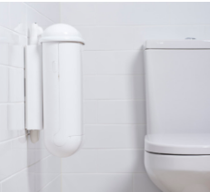
3c Image
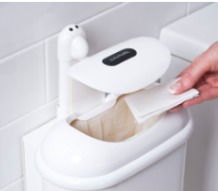
3d Copy
Air Fresheners
Our range of air fresheners include both traditional automatic spray units as well as passive aerosol free units. The range of fragrance and odour neutralisers are extensive and will be matched to best suit your environment.
3e Image
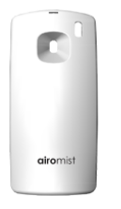
3g Image
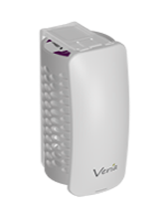
3h Copy
Soap Dispensers
Soap dispensers are available in standard flowing soap and foaming hand soap varieties. We will make recommendations on the most appropriate soap for your washroom users.
3i Image
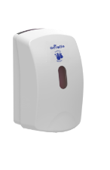
3j copy
Hand Sanitisers
Our hand sanitiser units can be used in washrooms, hallways or office situations. You can opt for alcohol free or alcohol based sanitiser solutions.
3k image
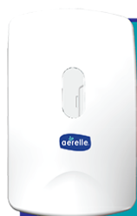
3l copy
WC Seat Sanitising Solutions
For peace of mind for your bathroom visitors we can provide WC sanitisers. These are available in either a solution form that is administered via toilet tissue or a dispenser loaded with wet wipes.
3m image
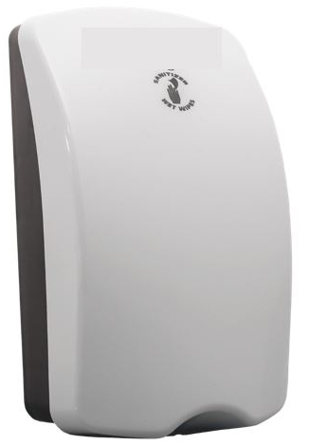

3o image
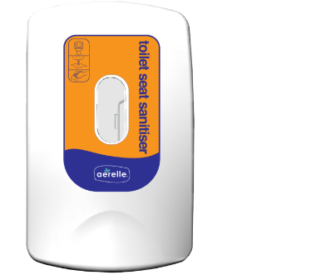
3p copy
WC/Urinal Sanitisers
By fitting a system that pumps a sanitising solution directly into toilets and urinals you will reduce odours and prevent pipe blockages.
3q image
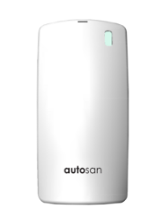
PAGE 4 inside right page
4a copy
Toilet Tissue
We will work with you to identify the most appropriate toilet paper solution depending on the traffic through your site. This could be jumbo rolls, mini jumbos or individual toilet rolls. Don’t worry about the terminology – it’s our job to come up with the right solution.
4b image

4c image

4d copy
Hand Towels
Paper hand towels are available in a range of different types depending on your requirements. As a complementary offering or alternative option we can provide you with a high speed hand dryer.
4e image
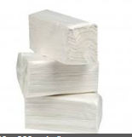
4g image
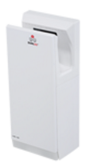

4h copy
Baby Change Station
If you anticipate having babies in your bathroom, then our baby change station is an economical and safe option that you can purchase outright.
4i image
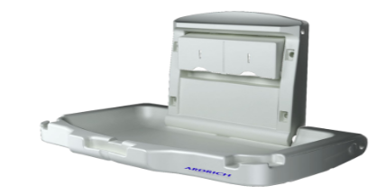
4j copy
Other Options
Our range of washroom dispensers, fixtures and consumables go far beyond the ones we have outlined here. At all times we will ensure that we get a full understanding of your bathroom visitors so that we can make the most appropriate recommendations. If your circumstances change, we will change out products and services as you require.
PAGE 5 Inside right page when folded
5a copy – overview so in largish font.
Washroom Dispensers
We have a wide range of stylish quality dispensers that are all provided to you on a “free on-loan” basis.
We will arrange a site visit to go over your specific requirements to ensure the dispensers provided are fit for purpose as well as complementing the washroom facility.
Our team of professional installers provide installation of all units and dispensers to appropriate specifications for optimal user experience and safety.
5b image
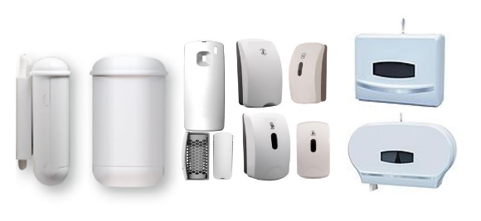
5c copy
Paper Products
Paper products (toilet paper and hand towels) for your washroom come in a huge variety and will be a large component of your washroom inventory.
We will work with you to understand who your washroom visitors are and the best types of products to suit their needs and your budget.
If you need to have different products in different washrooms or switch between products you can. We have a flexible approach to your paper product needs.

5d image
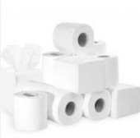

PAGE 6 back page
6a copy
Contact Us to Find out More
Whether you’re just starting out, doing a refurbishment or know it’s time for a new washroom services supplier, contact us. We will come to you to discuss your specific requirements and come back to you with a quote, installation and service plan.
6b large font
It’s our pleasure to make your washroom users’ experience pleasant.

6c logo and contact details
Lynn McCrindle
Director
027 550 4241 or 09 537 2922
www.hygienefactor.co.nz

