Pour Your Cup Infographic – Creative Brief
Note: This brief contains content for two infographics; the organization graphic and the member graphic. The $200 budget is for the Organization Graphic only. The Member graphic will be a separate contract.

Background
Pour Your Cup (PYC) is a Microgenerosity app that makes it easier for people to find others to do 5-45 minute favors based on shared interests, values, and organizations.
People want to help others, but only for the right person, and under the right circumstances.
Doing things for others without expecting anything in return has proven to make us happier, better leaders, more successful, and more engaged. (Sources: Adam Grant, Gemma Robertson-Smith and Carl Markwick)
Organizations are looking for ways to increase meaningful engagement. PYC makes it easier for people to find, connect, and help one another.

Pour Your Cup Scenario/Use Case
Meet Dr. Sally
Dr. Sally went to Small Town High School, and then to Well Known College. She went on to receive her medical degree at A Top Medical School.
Dr. Sally wants to give back to others, but currently cannot commit to a day of volunteer work.
A colleague at Mercy Medical Hospital suggested that Dr. Sally sign up for Pour Your Cup, a platform that makes it easier for people to help one another. She puts in her profile that she is willing to offer career advice to those considering the medical profession (This is a customer pain point, and a good thing to highlight)
Meet Dave.
Dave also went to Small Town High School, and he is currently at Pretty Good College. He is thinking about Top Medical School, but just isn’t sure his heart is in it. Dave is looking for someone to share their experience in the medical profession, perhaps even a mentor. One of Dave’s teachers at Small Town High School suggests that Dave sign up for Pour Your Cup.
Dave browses through the PYC member profiles in his Small Town High School network and sees Dr. Sally’s profile.
When Dave sees Dr. Sally’s profile, he thinks, “We have a lot in common. I think she might understand what I’m going through. I would love to chat with her if I had the chance.” And he clicks “Connect.”
Dr. Sally sees Dave’s profile and thinks “Dave reminds me of a younger version of myself and some of the things I was going through back then – and he’s from my High School! Perhaps he would benefit from my own experience.” And she clicks connect.
Now connected, Dr. Sally and Dave are able to chat in the PYC app.
Dave: I’m thinking about medical school, and am looking to talk to someone about their experience. Would you be willing to share yours with me?
Dr. Sally: I would be happy to Dave. I will be back in Small Town next week, and we could meet at Small Town Coffee Shop if you are in town. Otherwise here’s my number and we can chat by phone.
Dave: Thank you so much!
Sally and Dave have coffee and talk about Best Medical School and what it is like to be a Doctor. During their conversation Dr. Sally suggests to Dave that he might really enjoy studying Public Health and instead of going right into medical school. Dave says he is interested in learning more. Dr. Sally refers him to one of her friends at Helpful Mercy Corporation, and recommends her.
Through Dr. Sally’s connection, Dave gets an internship at Helpful Mercy Corporation. He then goes to get his Masters in Public Health. He sends Dr. Sally a ‘thank you’ on PYC.
Today Dave is the Director of the non-profit Better World Health. He now routinely browses through profiles within his Small Town High School, Pretty Good College, and Masters program networks to see who might benefit from her experience, or even a “nudge” in the right direction. He’s connected with and even mentored several students and can see how far-reaching his efforts have been. Every now and then, he sends Dr. Sally a note, just to see how she is doing.

Objective
Design a set of two infographics that can be used together. The key messages are:
- For members (think individuals) the application is easy to use. Members want to help each other, and would be more likely to help if it were easy. Each member can give and/or take. Pour Your Cup makes it easy for members to connect and help each other.
- For organizations (organizations may have many members), organizations benefit when their members are engaged with each other. By providing members access to Pour Your Cup, it’s easier for members to connect and help each other. The application is easy to set up, there is tons of flexibility, and you can lever your existing networks. There is tremendous value in connecting your stakeholders with each other, and with resources.
Eventually there will be total of six infographics. So the thought is that we change out some text and maybe a couple of images and we will have 3 sets of 2 infographics each. So the infographic must be flexible and generic enough to be applicable to the follows types of industries
  - Non-profits
  - Educational Institutions
  - Large businesses and corporations

Audience
Our audience is made up of the following channels:
- Members (students, adults, professionals)
- Organizations:
  - Non-profits
  - Educational Institutions
  - Large businesses and corporations

Characteristics of our Target Audience
- Aged 27-55
- Primary: Individuals with success or knowledge/experience that want to pass it along.
- Secondary – Individuals who are looking to improve or grow their professional or personal goals.
- Spans across industries, including accounting, engineering, construction, retail, restaurant, education, nonprofit, government, etc.
- Have an average-to-above-average familiarity with technology; use computer software on a regular basis. May be high schoolers, or retired executives
- Are at varying levels in their career, from entry-level to management. Most are not CEOs, rather someone who makes the decisions for the CEO.
- Need Convenience. Our members have small time buckets to do work. They may be sitting in an airport, waiting for a colleague for lunch, etc.

Value Proposition
- No cost to members.
- A technology platform created for an existing community.
- PYC platform is branded for the existing community
- PYC makes it convenient and easy for members to select, engage, and share giving relationships.
- Matches people based on shared organizations, values, and interests
- Convenient
- Taps into the desire for people to help one another
- Favors tailored to your needs
- Different from other social networking avenues
- Non-threatening
- Maximizes Value of contributions
- People contribute as much or little as you want
- Measurable impact

Tone
We’re trustworthy, personable, and professional. We are approachable and friendly at the same time.
We value the following traits:
- Generosity
- Trustworthiness
- Convenience
- Refinement
- Intelligence
- Simplicity
- Inviting
- Inspiring
- Aspiring
- Purposeful
- Willing

Branding Information
Website: https://pouryourcup.com/
Our Logo is in the attached in another file.

Our Fonts are: DIN for the primary font and Gotham Lite is the secondary font.
The color palette is below
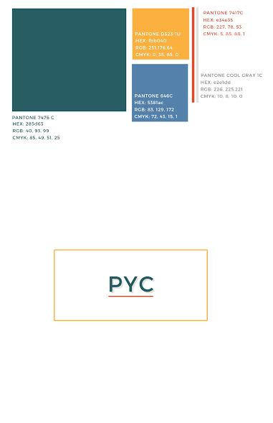

Content Requirements for Non-Profit – For Members Infographic
  - Include our Logo
  - Include tag line: Pour Your Cup: fostering a culture of generosity.
  - Include Secondary tag line: Pour Your Cup (PYC) is a Microgenerosity app that makes it easier for people to find others to do 5-45 minute favors based on shared interests, values, and organizations.
  - Copyright information should be at the bottom: ©Pour Your Cup, A Public Benefit Corporation
  - Contact information should be at the bottom: www.pouryourcup.com, images for Facebook, Twitter, LinkedIn, Google+, Pinterest
  - The concept is we are all givers and takers in the same person. This should be an illustration or a caricature.
  - Part of the infographic devoted to what the giver person and the receiver person can offer each other. We need 3-5 of from the list below. The content is as follows
Receiver | Giver
I’ve just been diagnosed with Cancer. I’m scared and don’t know what to do. What do I do? | I am a cancer survivor. I can help people by sharing my experience and giving advice.
How do I know I’m making the right choice? | I’m an oncologist, and want to volunteer some time giving expert advice to people that may not be able to afford it.
My mom has cancer. I want to help as much as I can. | I am a volunteer and specialize in helping caregivers cope.
I know I’m not going to get better. How do I prepare my family for when I’m gone. | I’m a financial planner (or attorney) and I want to volunteer my time helping those who could use my expertise, but may not be able to afford it.

  - The other part of the infographic explains the Member process. Note, the process is circular, in that you are constantly going through steps i – v. The member process is as follows:
    - Browse profiles of other members with similar, interests, values, and organizations.
    - Connect with other members
    - Share experiences, lessons, knowledge, and contacts
    - Say “Thank You”
    - Give Back to the Network

Content Requirements for Non-Profit – For Organizations Infographic (use this content)
- Include our Logo
- Include tag line: Pour Your Cup: fostering a culture of generosity.
- Include Secondary tag line: Pour Your Cup is a Microgenerosity app that makes it easier for people to find others to do 5-45 minute favors based on shared interests, values, and organizations.
- Copyright information: ©Pour Your Cup, A Public Benefit Corporation
- Contact information should be at the bottom: www.pouryourcup.com, images for Facebook, Twitter, LinkedIn, Google+, Pinterest
- Part of the infographic is focused on the benefits to the organization which are:
- Free to members.
- A technology platform created and branded for an existing community.
- People are matched based on shared organizations, values, and interests
- Taps into the desire for people to help one another; favors are tailored to your needs
- Non-threatening and Convenient
- Maximizes Value of contributions; People contribute as much or little as they want
- Measurable impact
- Social networks are the perfect environments to drive participation for nonprofits, giving them a low-cost, global communication channel
- Seeing good things come from volunteer work gives people the energy they needs to do their regular job. Source: Adam Grant
- Several studies have shown that doing roughly two hours of volunteer work a week makes people happier than volunteering fewer hours than that. One study of more than 2,000 Australians in their mid-sixties showed that those who volunteered at least 100 hours a year were happier and more satisfied than those who volunteered less. In another study, Americans who volunteered at least 100 hours in 1998 were more likely to be alive in 2000 than those who did no volunteer work. Source: Adam Grant
- When people volunteer out of a sense of enjoyment and purpose, they feel much more invigorated. Source: Adam Grant
- Engaged employees are more likely to stay with the organization, perform 20 per cent better than their colleagues, and act as advocates of the organization. Source: Gemma Robertson-Smith and Carl Markwick
- Engagement can have a significant impact on the performance of the organization, driving bottom‐line profit and enabling organizational agility and improved efficiency in driving change initiatives. Source: Gemma Robertson-Smith and Carl Markwick
- Engagement may enable individuals to invest themselves fully in their work, with increased self‐efficacy and a positive impact upon the employees health and well‐being, which in turn evokes increased employee support for the organization. Source: Gemma Robertson-Smith and Carl Markwick
- The other part of the infographic illustrates the Organization process which is as follows:
    - Create Network:
      - Establish Network
      - Create Customized Portals and Landing Pages
      - Invite and Approve Members
    - Moderate Network:
      - Members Download App and Create Profiles
      - Members browse profiles and make connections based on common interests, values, and organizations.
      - Members Share Advice, Opportunities, and Connections
    - Track Engagement:
      - Members thank each other for their help
      - Members facilitate connections through referrals
      - Member engagement is tracked and measured
    - Publish Success:
      - Success stories are published to the portal encouraging other members to join and engage
      - Members can opt-in to share advertising revenues or make gifts to eligible organizations they choose.

Example Infographics we like for the Member Infographic
We like that this is two sided, but doesn’t look like a structured table. We like she is using a mobile device, and the concept that it is convenient.
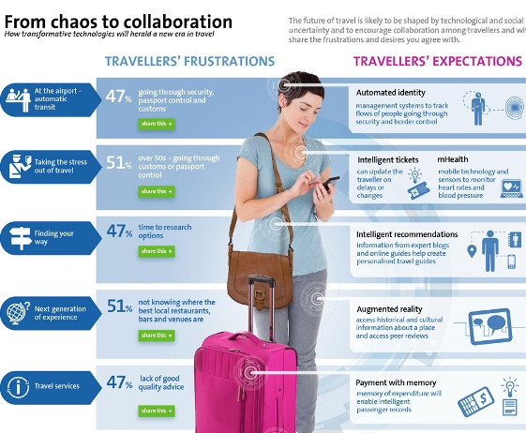

In the below graphic we like that there are two sections, and the art is “fun” and not too stuffy. It would benefit from an image to complement the “fun” factor. There is no clear process or story.

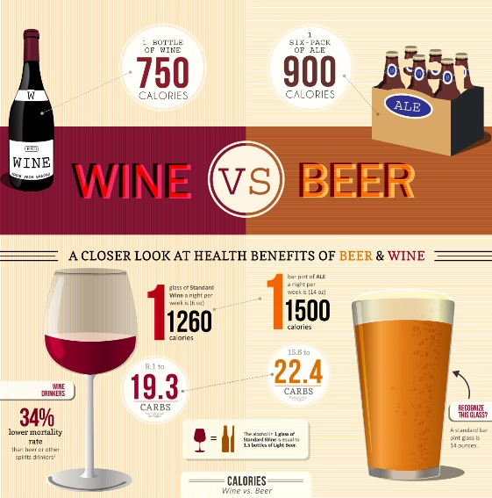

Here are our two attempts at doing an infographic ourselves. We don’t like these, but at least you can see what we did before.
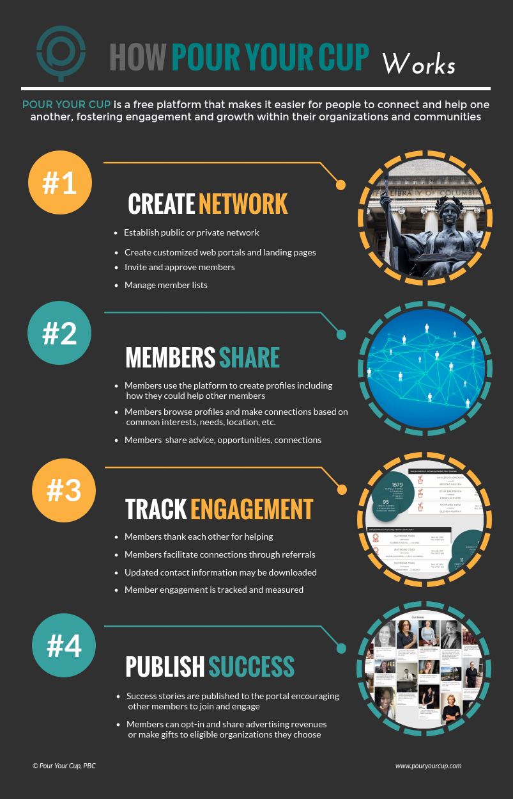

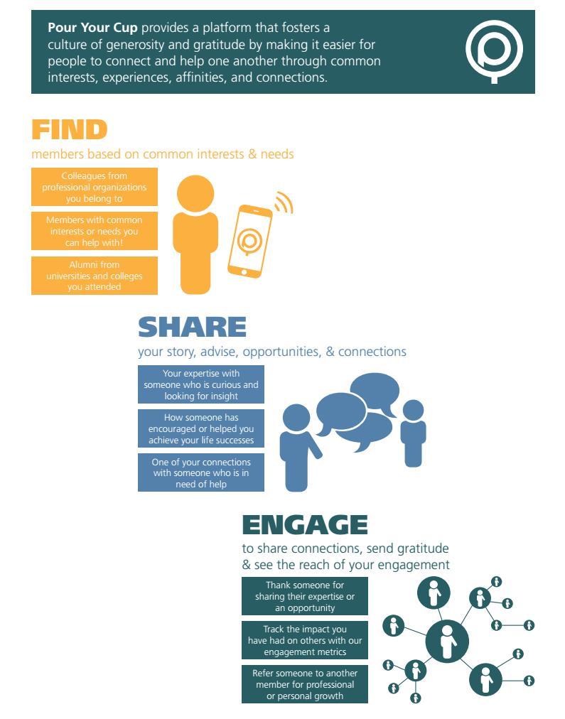

Example Infographics we like to illustrate Organization Experience
There is a central theme, and there are tons of types of benefits that come out of it.
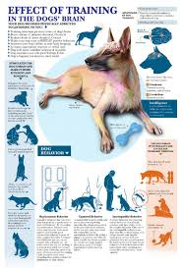

We like the process, and step-by-step journey of this infographic. It is too long and complex. Ours is simpler.
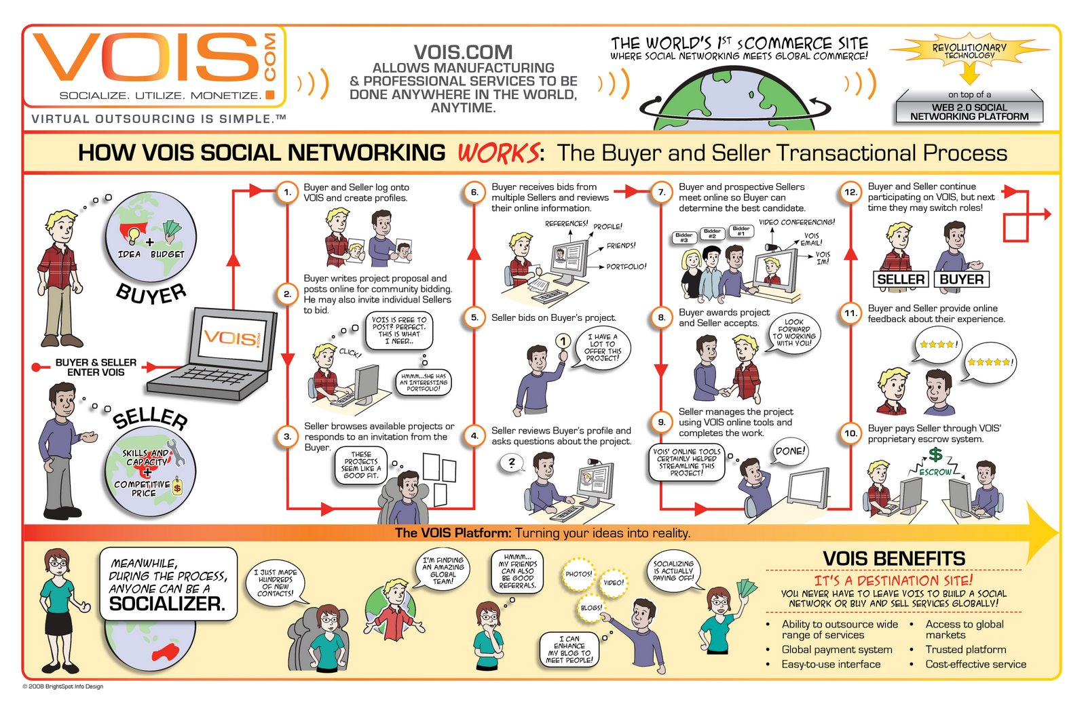
We like the simplicity of this graphic.
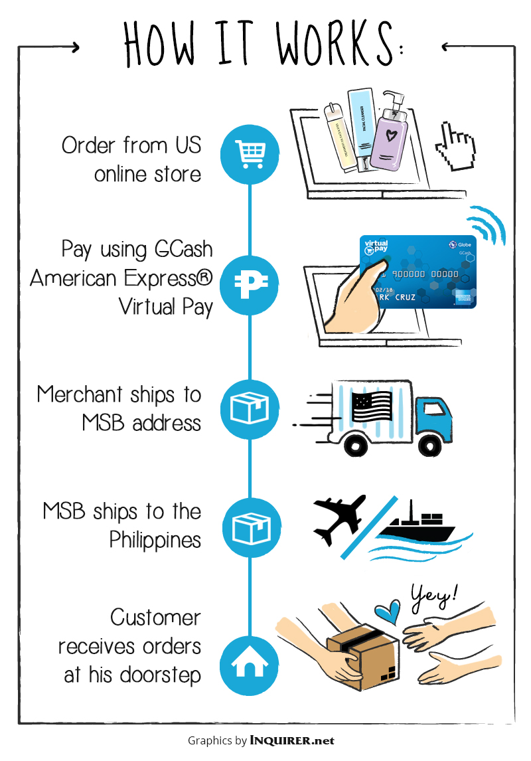
We like the simplicity of this graphic.
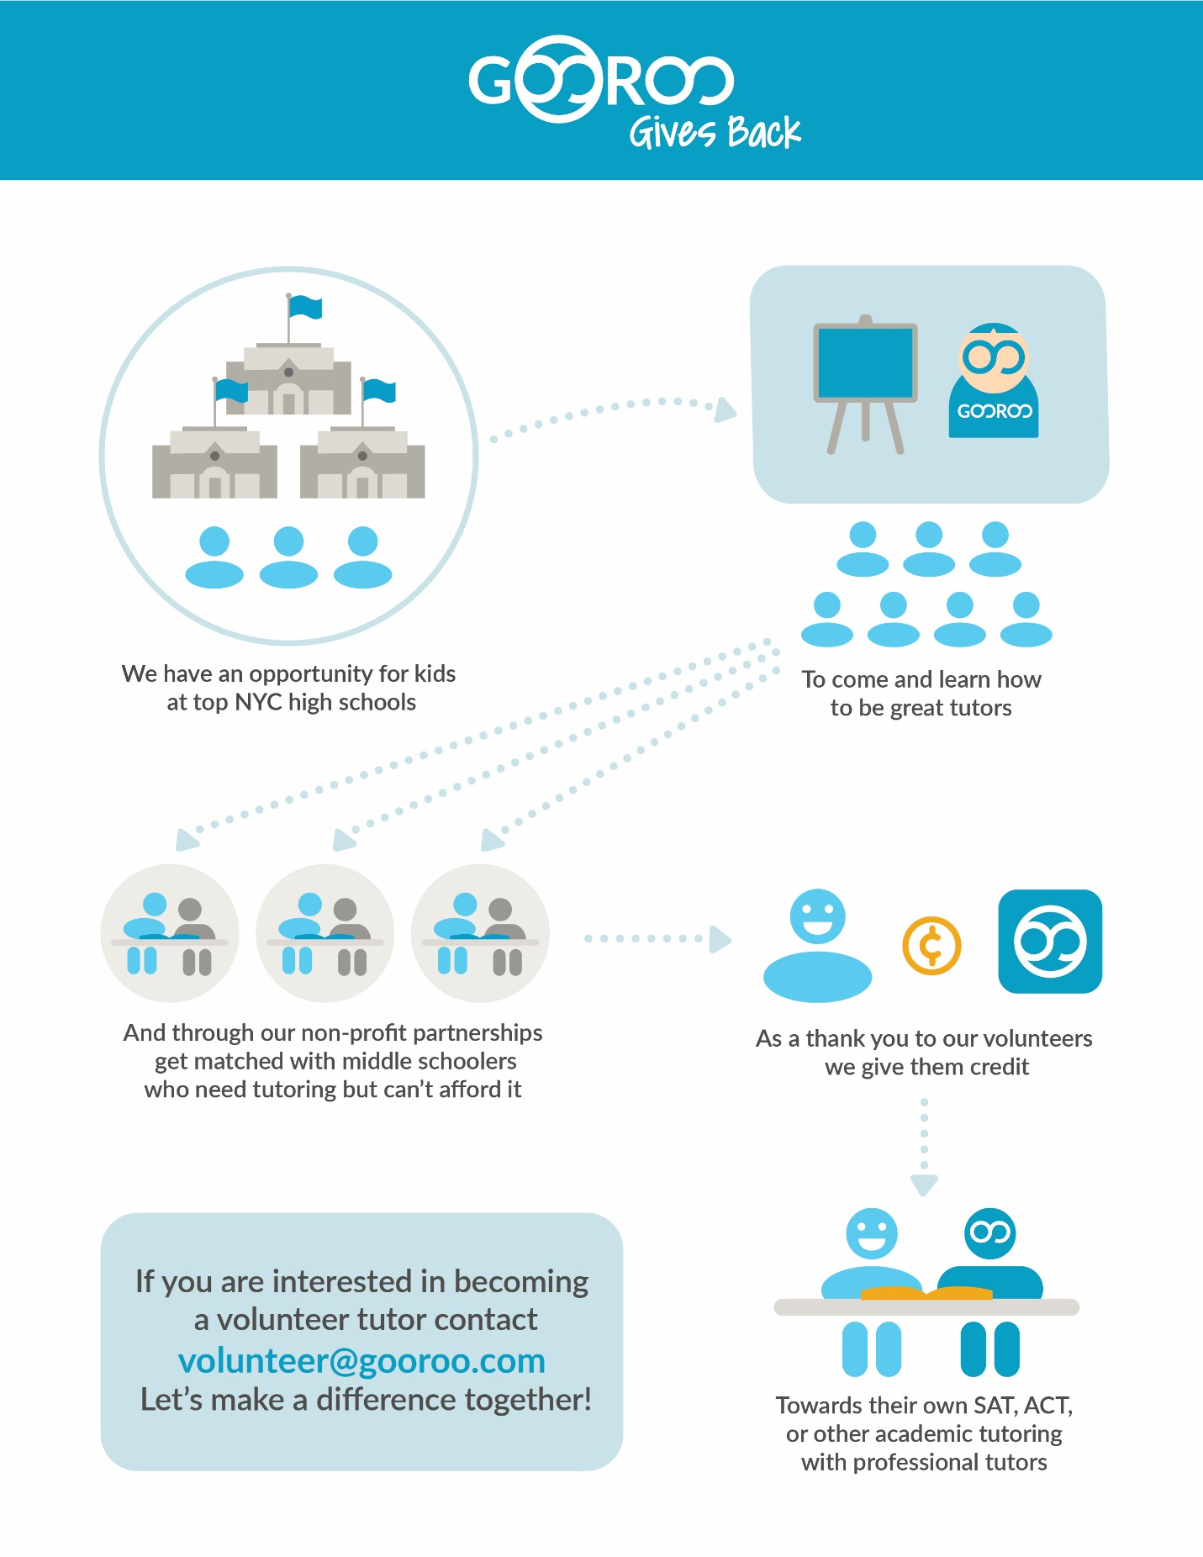
We like the idea of a journey in this graphic. It’s simple, and the detail is subdued. It is a bit busy.
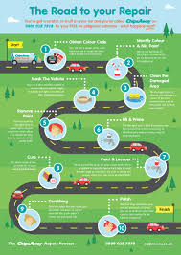

We like the idea that this is a process, but it cycles back because it is the cycle of giving or “pouring it forward”.
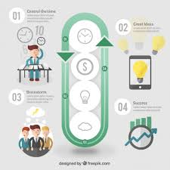

We like the idea of a tree and growth, and developing a network that branches off of something in this graphic.
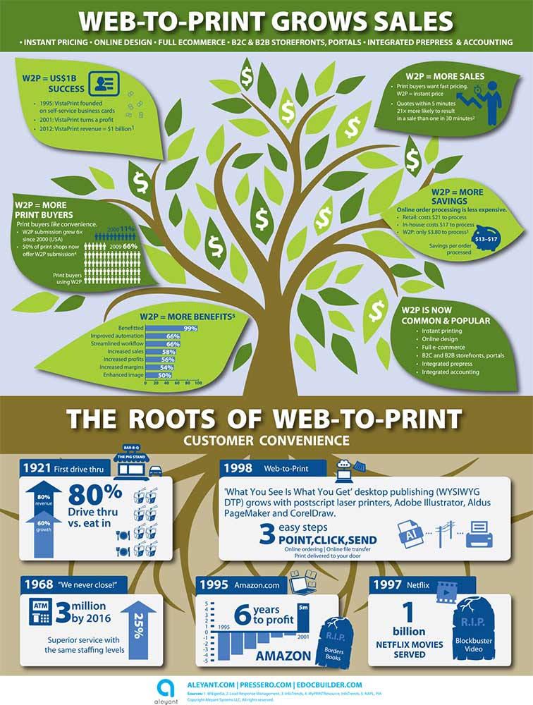

Deliverable:
Deliverable needs to be in Adobe Illustrator and a high resolution .pdf.

