Second Space Ltd.

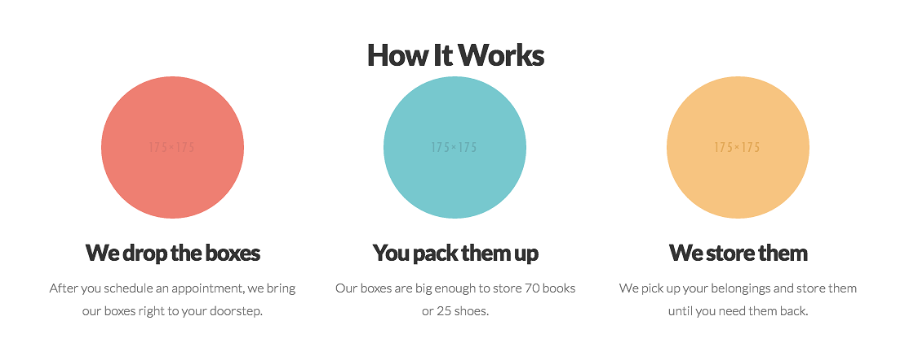

The illustrations required will be for the above 3 items. The descriptions will remain as is, therefore it is our hope that designs are made to suit the headings.
Please take a look at the examples provided with the job to get an idea of what we are looking for.

