

ON GRID SOLAR SYSTEM
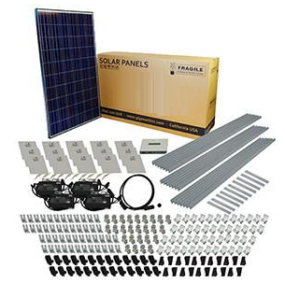

2016

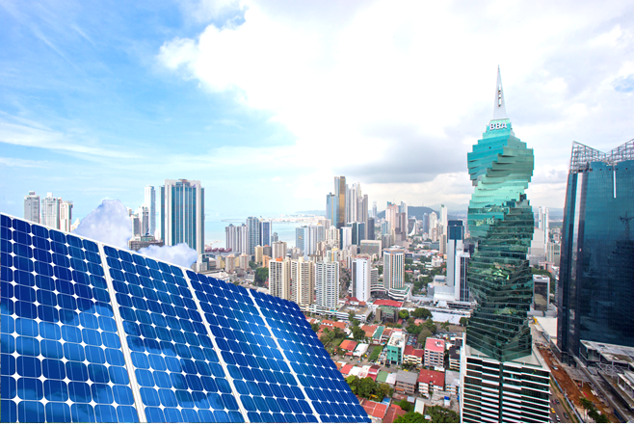

Solartech Solution Inc. is a Panama Solar Company. We distribute top quality product to our Installers partners. We guarantee the best price and performance in market. We will rebate the cost difference if the performance doesn’t match what was agreed on contract. Also we will improve any quotation from competition.

We are dedicated to making the solar more accessible to everyone by increasing the volume on solar powered homes and businesses.

We are committed with the environment. Promoting renewable energy across the world means to put end to their dependence on fossil fuels. We are committed to allow everyone to build a brighter, cleaner tomorrow.

WHY IS IMPORTANT SOLAR ENERGY IN CENTRAL AMERICA?

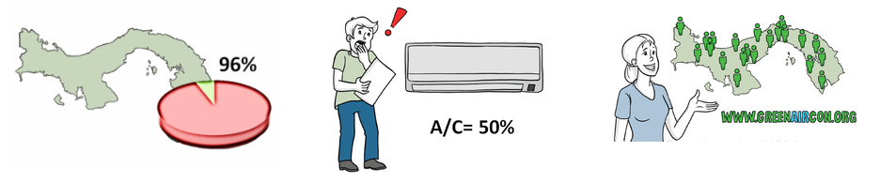

- More than 96% of the energy of Panama is not renewable energy is generated through hydroelectric plants and fuels that damage the environment. Only 0.1 % comes from solar energy and another 4% by wind energy.

- Air conditioners are responsible for 50 % of the cost on your electricity bill if residences, and even more in the shops. (Fenosa Report 2015)

- Panama is a paradise for solar energy because it has one of the highest sun exposure of 5.5 hours on average. This means that the performance of your solar system will be much higher compared to the more developed countries

What does it includes?
All our On Grid Full Kit has all components to install from begging to end the solar system:
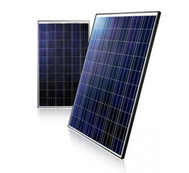 | 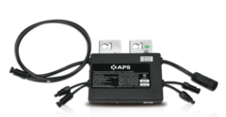 | 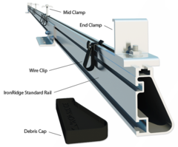
Solar Panels | Micro Inverters | Ironridge Racking and Mounting

- Solar Panels - 255W High performance 60 cell polycrystalline panels with 25 year warranties
- Micro Inverters - Efficient APSystems micro-inverters that connect two PV modules per inverter.
- Racking and Attachments - Industry leading IronRidge racking mounts the solar panels to your roof.
- System Monitoring - Free with every kit purchase! View and analyze your solar energy production in real-time.
- System Design and Financial Analysis - We custom engineer this system for your roof and calculate the payback on your solar investment.
- Others: Wire, conduit, fittings, breakers, AC/DC Disconnects (if required), junction boxes.

Why Micro-Inverters are better?

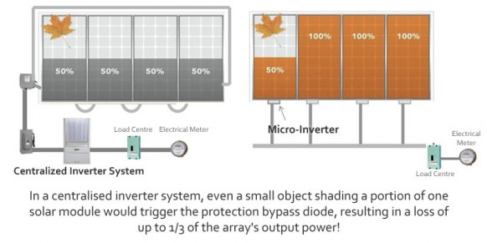
- Safer: The system does not employ dangerous, unprotected high DC voltages, eliminating the risk of potential fires as outlined above. The system’s cabling through the roof to your switchboard is regular 240V AC, the same as all other household cabling, and is circuit protected via a circuit breaker in your switchboard.

- Shade tolerant and fault redundancy: Each solar panel operates independently, as it has its own dedicated micro inverter. The result is that the system does not suffer from the ‘Christmas light effect’ explained above; one shaded or soiled panel will result in a loss of power from that panel only, and will not drag down the performance of the others. The same goes for any fault; in a conventional DC solar system, a complete failure of a solar panel or central string inverter will usually result in an entire system failure.

- Easily expandable: The system size is not ultimately dictated by the capacity of a wall mounted string inverter, allowing for additional panels to be added at any time and only limited by your roof space and budget.

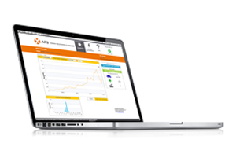
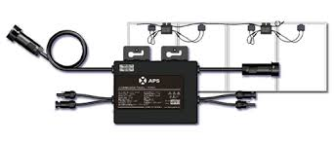
Your Complete Solar Kit is based on high quality micro-inverters in the business. These inverters are backed by world class technical & customer support. They come with 25 year warranty that matches the 25 year performance module warranty. One of the best features of the micro inverter is the ability to size your system in 2 module increments.

Monitoring System Included.
All our Solar Kit include monitoring system each micro inverter with the same you can monitor real-time efficiency and electricity generation of each.

How easy is it to install?

- You can install a 2kW solar system in one weekend.
- Our kits use industry leading solar panels, inverters, and racking systems specifically selected and combined to make do-it-yourself installation possible.
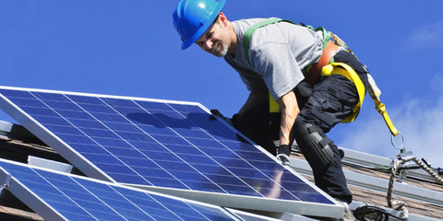
- A homeowner who has wired an AC outlet and is comfortable working on their roof can install our Solar kit.
- The micro-inverters in our kits have significantly improved the safety of installing a solar panel system by generating standard AC power instead of dangerous DC power.
- Micro-inverters allow you to have as few or as many panels as you like and to easily expand your system later. They simplify installation as well as allowing monitoring of each module independently. Since each panel is an individual system they maximize the power output from each panel resulting in an average 15% increase in power generation per panel.
- If self-installation is not for you, we can help you find a local solar contractor to help you with the process.

Systems Specifications:

