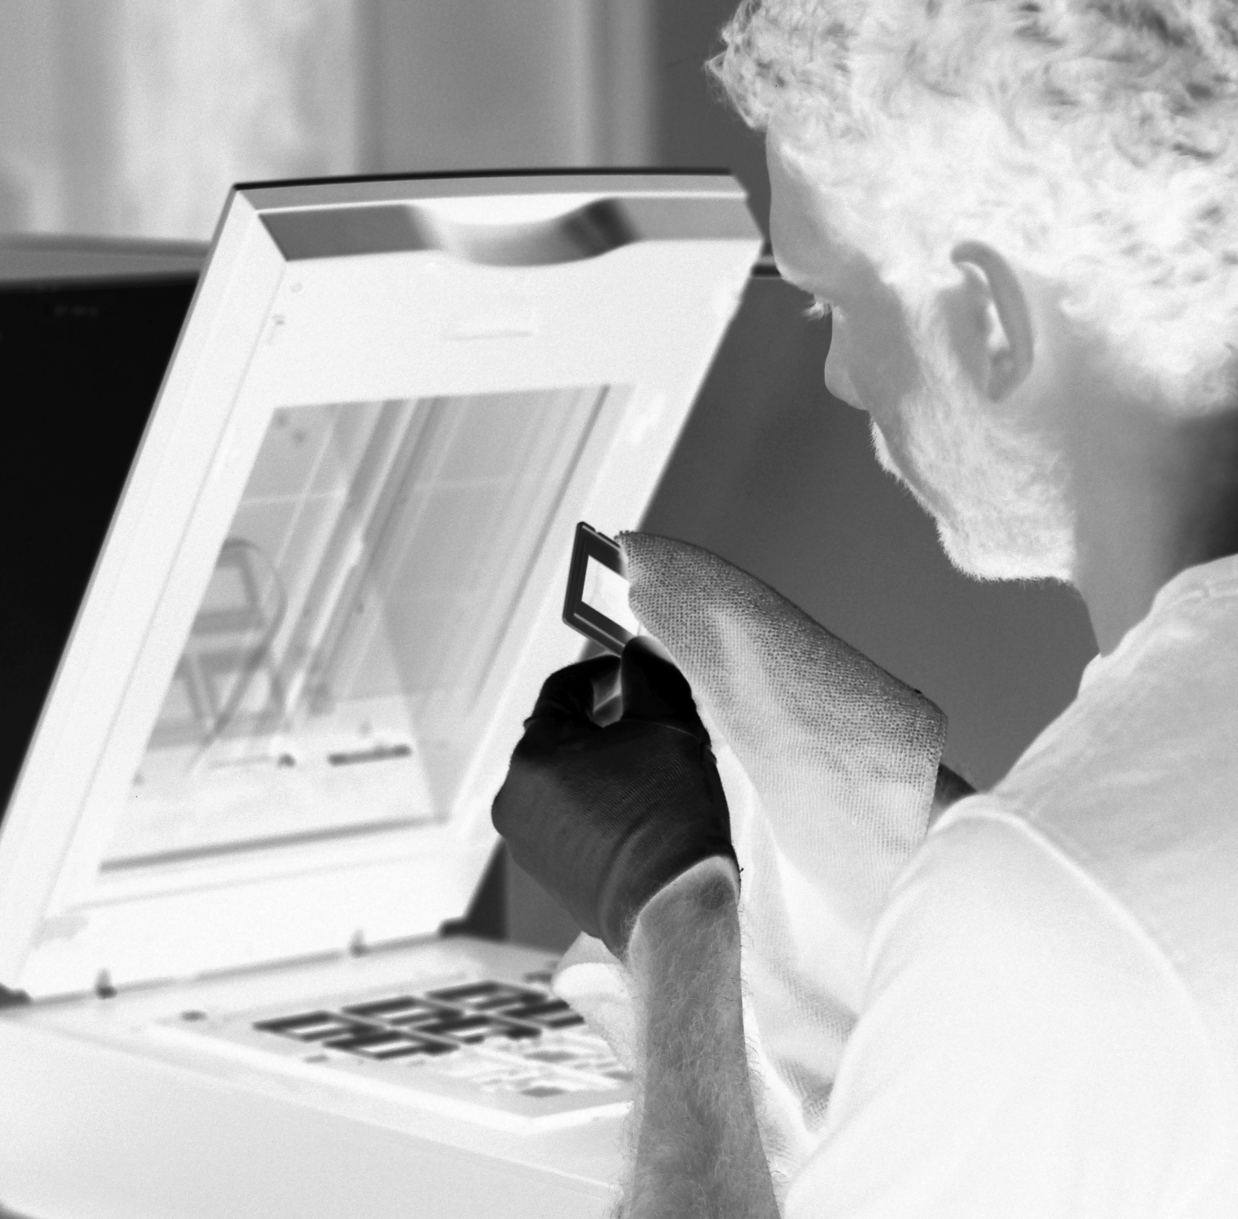

Digitised memories last forever, printed media don't!

Company Profile

ScanCorner is a service provider which is professionally digitizing all popular photo and video formats of the last 60years. The young and internationally positioned outsourcing firm which is serving the markets in Europe and Australia is registered in Switzerland and is running its operational business in Hyderabad, one of the largest IT and trade centers of India.

There, ScanCorner has engaged a team of over 40 specialists, trained in dealing with digital media and image editing tools. The company has invested in professional scan equipment and is pursuing manual, image-optimized processing methods. Thanks to the professional scan and digitization equipment and the optimized logistics and operational workflow in place ScanCorner is able to deliver high quality output at a very affordable cost. ScanCorner is very rigorous in promoting quality it its processes and at the same time strict to adhere to its processes which guarantee a standard quality among all types of media and throughout a series of images.

Images are scanned at 3000 dpi as a standard and a number of manual services for which competitors are charging premiums are included in the standard offering of ScanCorner. Unique for ScanCorner is not only the Online-Gallery which allows customers to review their images and share them with their friends but also the personalized DVDs which can serve as a gift as well as a beautiful treasure of what has been a dusty box of inaccessible memories before.

Besides cost and quality, ScanCorner believes in two more key marketing factors being crucial in successfully market its services: trust and convenience. Due to its outsourcing model, trust safety and discretion are of utmost importance to ScanCorner. On the logistics side ScanCorner has been working only with reliable companies such as Fedex and DHL since 2010 and has never lost a package in the process.

“Since most potential customers are unwilling to sort out their old boxes of photo material the factor convenience is crucial as well. ScanCorner wants to make it as easy as possible for its customer by moving the process of sorting out old photographs to their home computers. Often our customers plan to file through their collection and sort out those images which are worthy to be scanned. Although this is supported by ScanCorner as well it is a very time consuming task which leads for many to postpone their digitization plan. But with ScanCorner customers don’t need to bother, it becomes affordable today to get the material digitized at a high quality and at an affordable cost.“

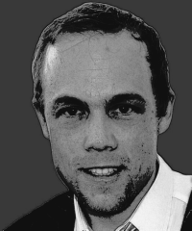
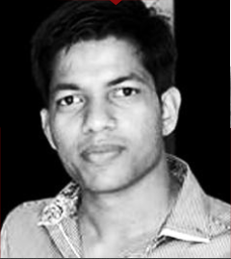
Raja Sekhar Upputuri and Eric Schreiber
Co-founders of ScanCorner

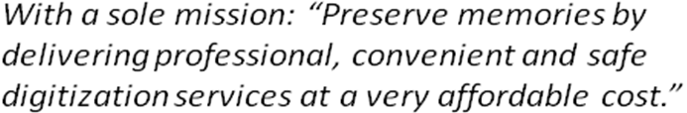



Writing with nib and ink, 1957.
Which memories from the 50s do you have?

This is our standard for printed photos,
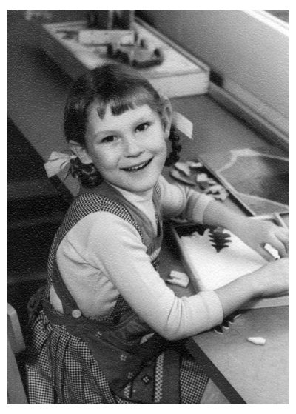
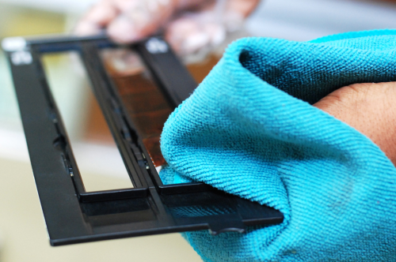
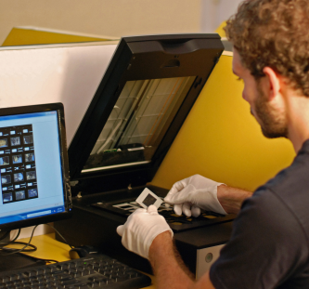

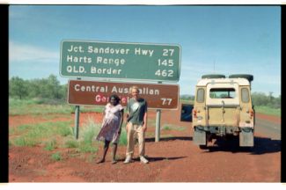
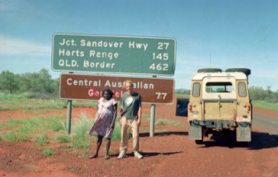
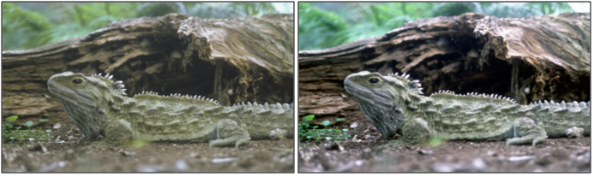
Just like a moment everyimage is unique. For this reason an automatic scan process won’t achieve an optimal result.
ScanCorner is optimizing EACH image MANUALLY!
We rotate
We scan at:
- 3000 DPI negatives
- 3000 DPI slides
- 600 DPI photos
- Superior Scans available
Red-eye removal
where needed
We adjust the colors
We crop
We clean the material
and remove dust
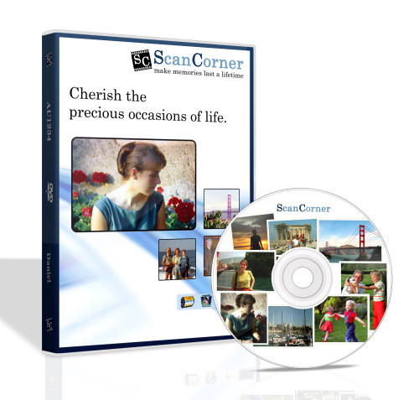
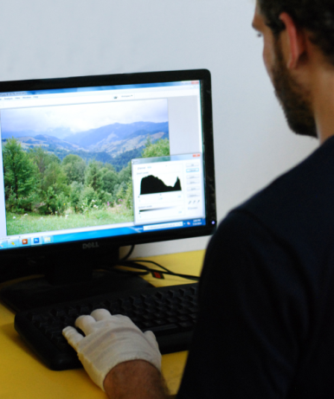
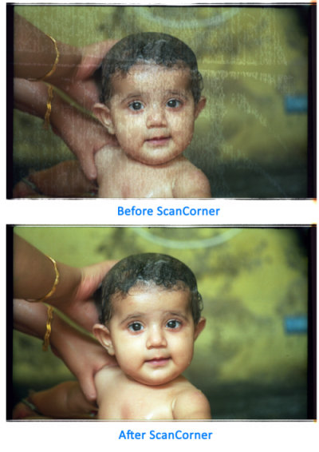
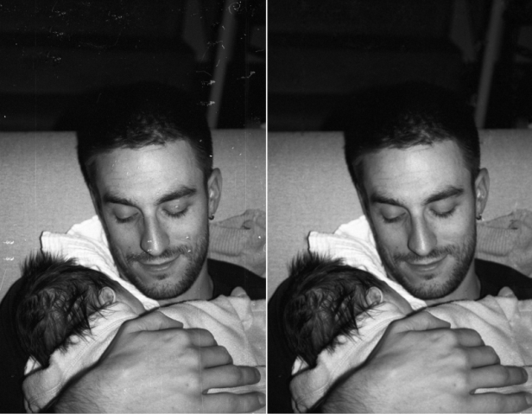
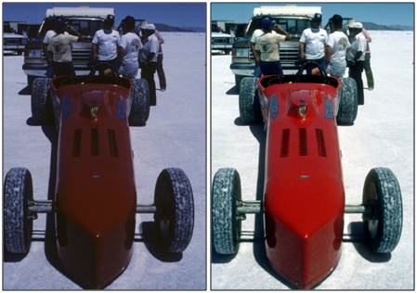
slides and negatives
We can do im age restoration (upon request
The personalized DVDs can serve as a gift as well as a beautiful treasure
We remove finger prints and scratches
Gallery
Download
We adjust the brightness
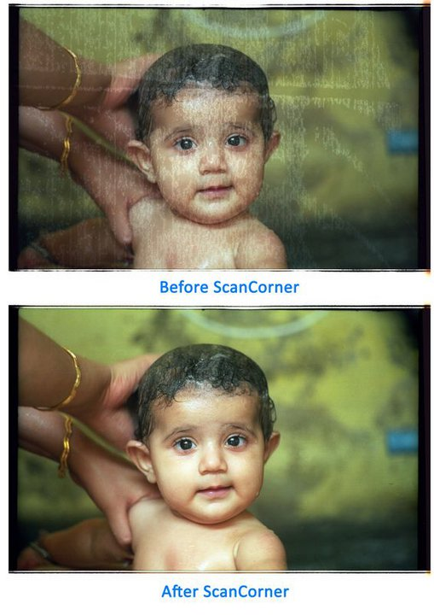
Restore your best memories
These photo formats we do:
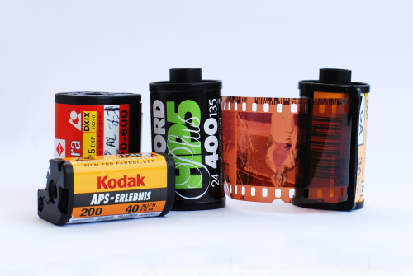
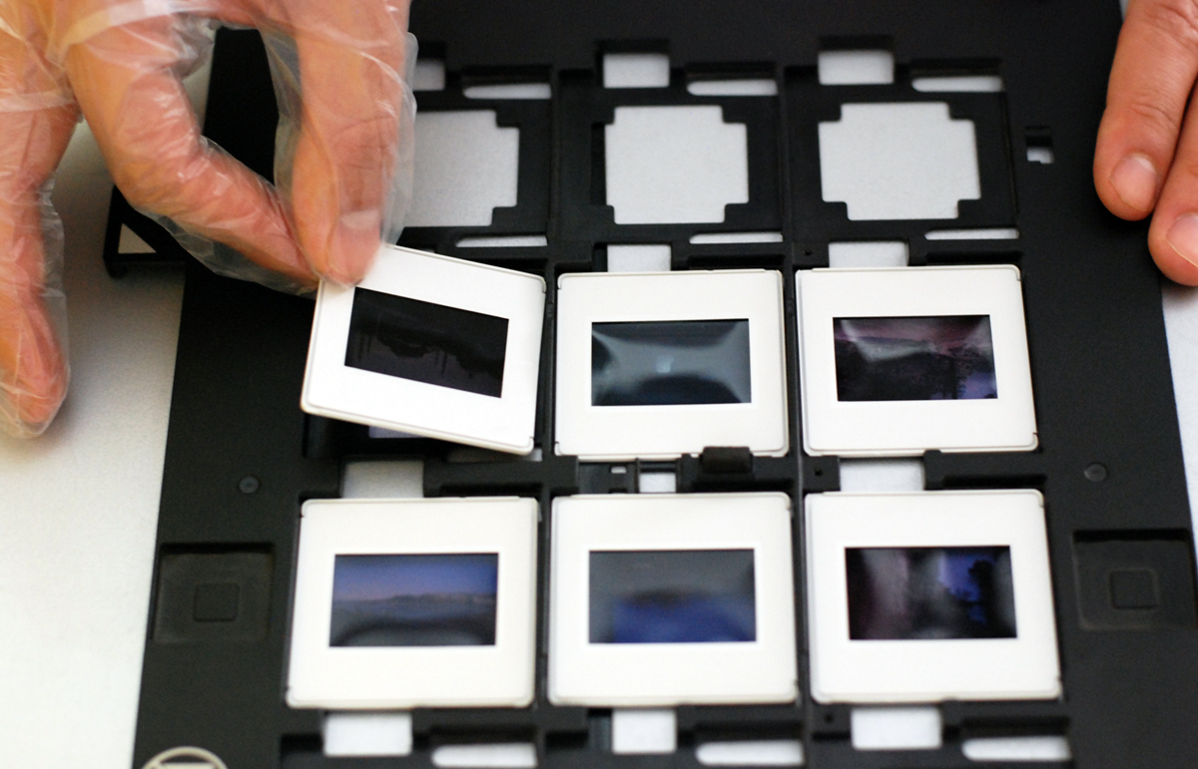
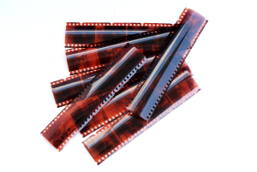
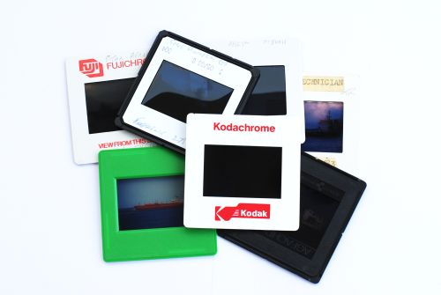
- Printed photos
- Photo albums
- Standard slides 35mm
- Kodachrome slides
- Glass slides
- 35mm colour negatives
- 35mm B&W negatives
- APS films
- Medium format negatives
- Large format negatives
- 126er instamatic colour negatives
- Negatives of 110, 126, 127mm
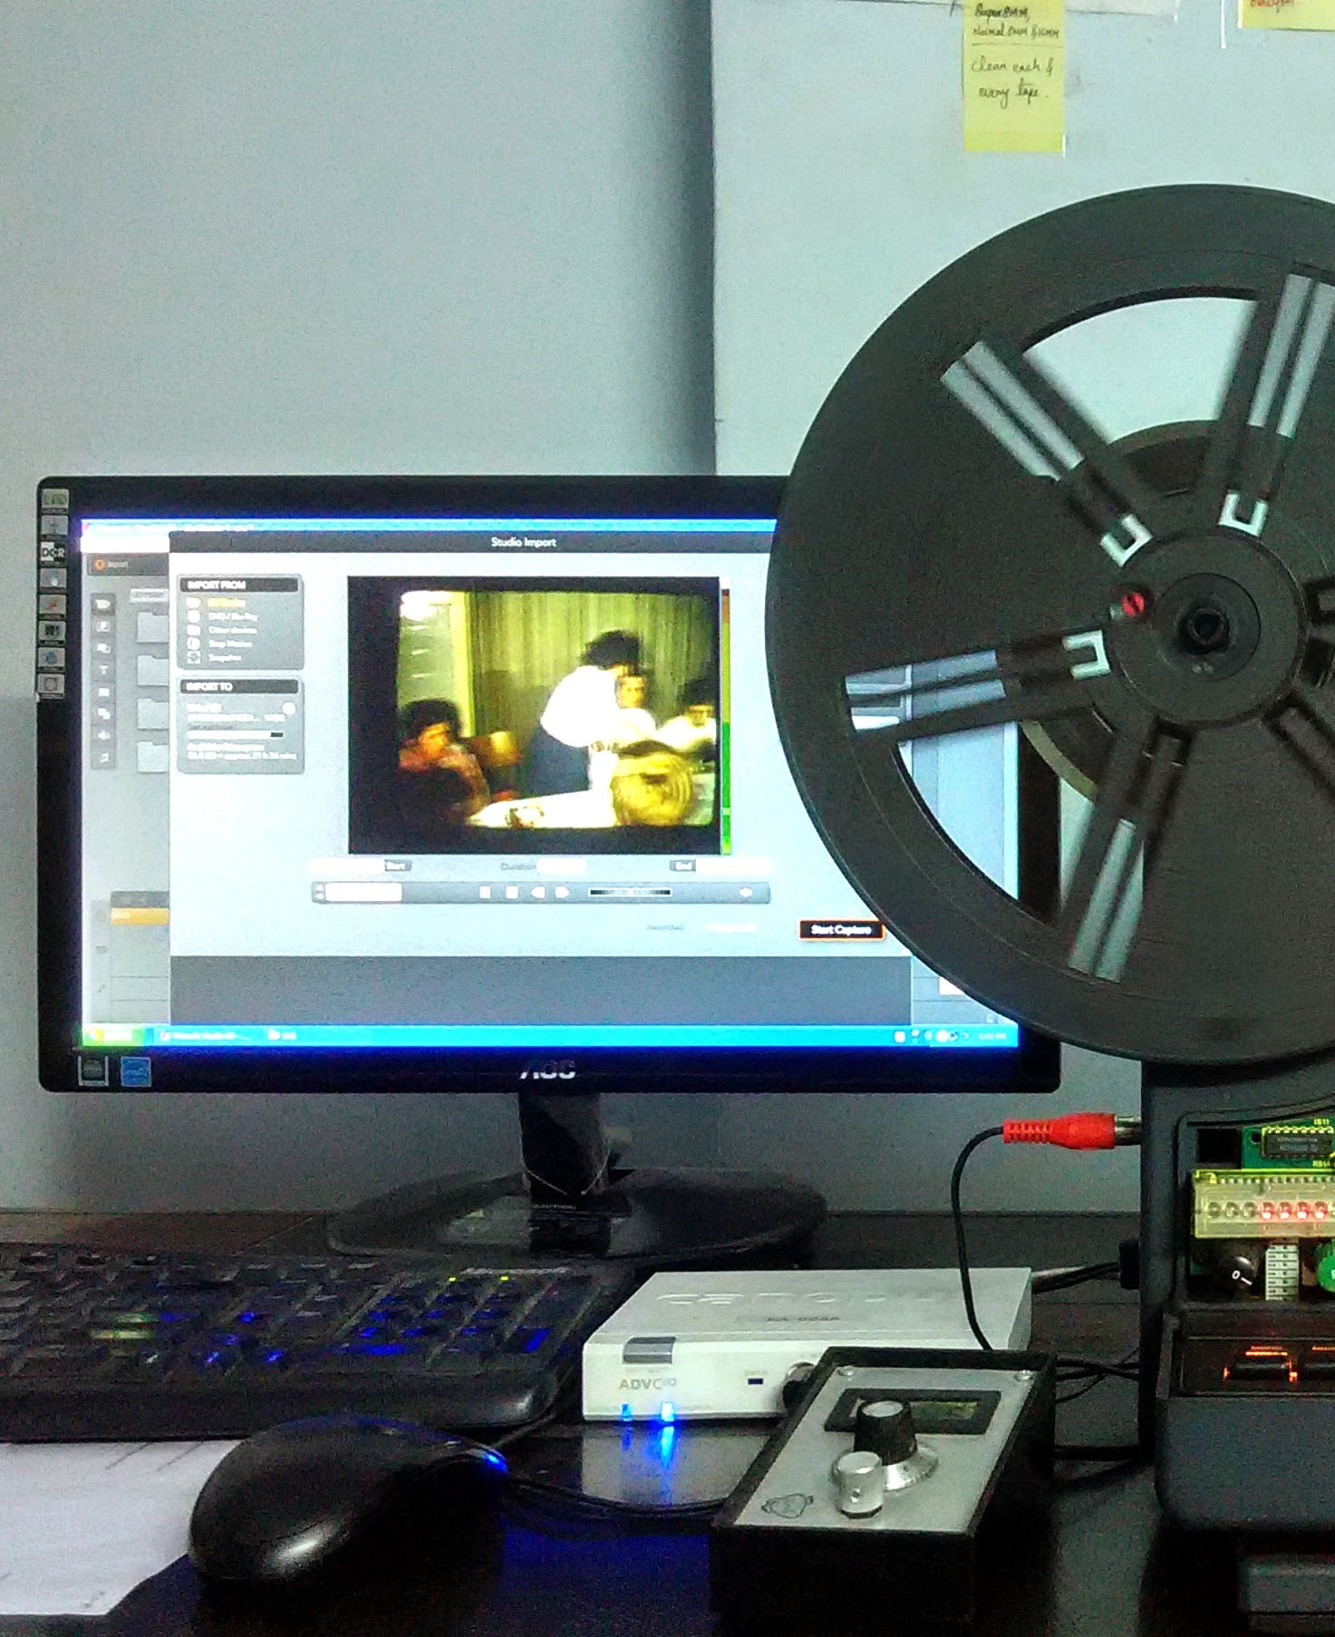
Want to see you old movies again?
We charge only
your records!
(by the minute
not by tapes)
Let us help you to migrate your old movies and films.You can watch them on your TV, your tab or mobile phone and share with your family or friends!

In our film conversion lab we use modern cameras to record your 8 or 16mm movies directly from our modified projectors. This helps to reduce flickering and unwanted reflections.

We digitise video tapes and films with or without audio (if available) and transfer it to the standard MPEG2 format which allows customers to play their films in almost any DVD player!

Likewise, old analogue audio material can be converted into standard CDs or MP3 files.

With ScanCorner the following is included by default:
- Image stabilisation
- Noise reduction
- Flicker reduction
- Sound optimisation
- Online gallery
- Crop (we remove blue/black screens,
for which you won’t be charged)
- Check entire video for disturbances
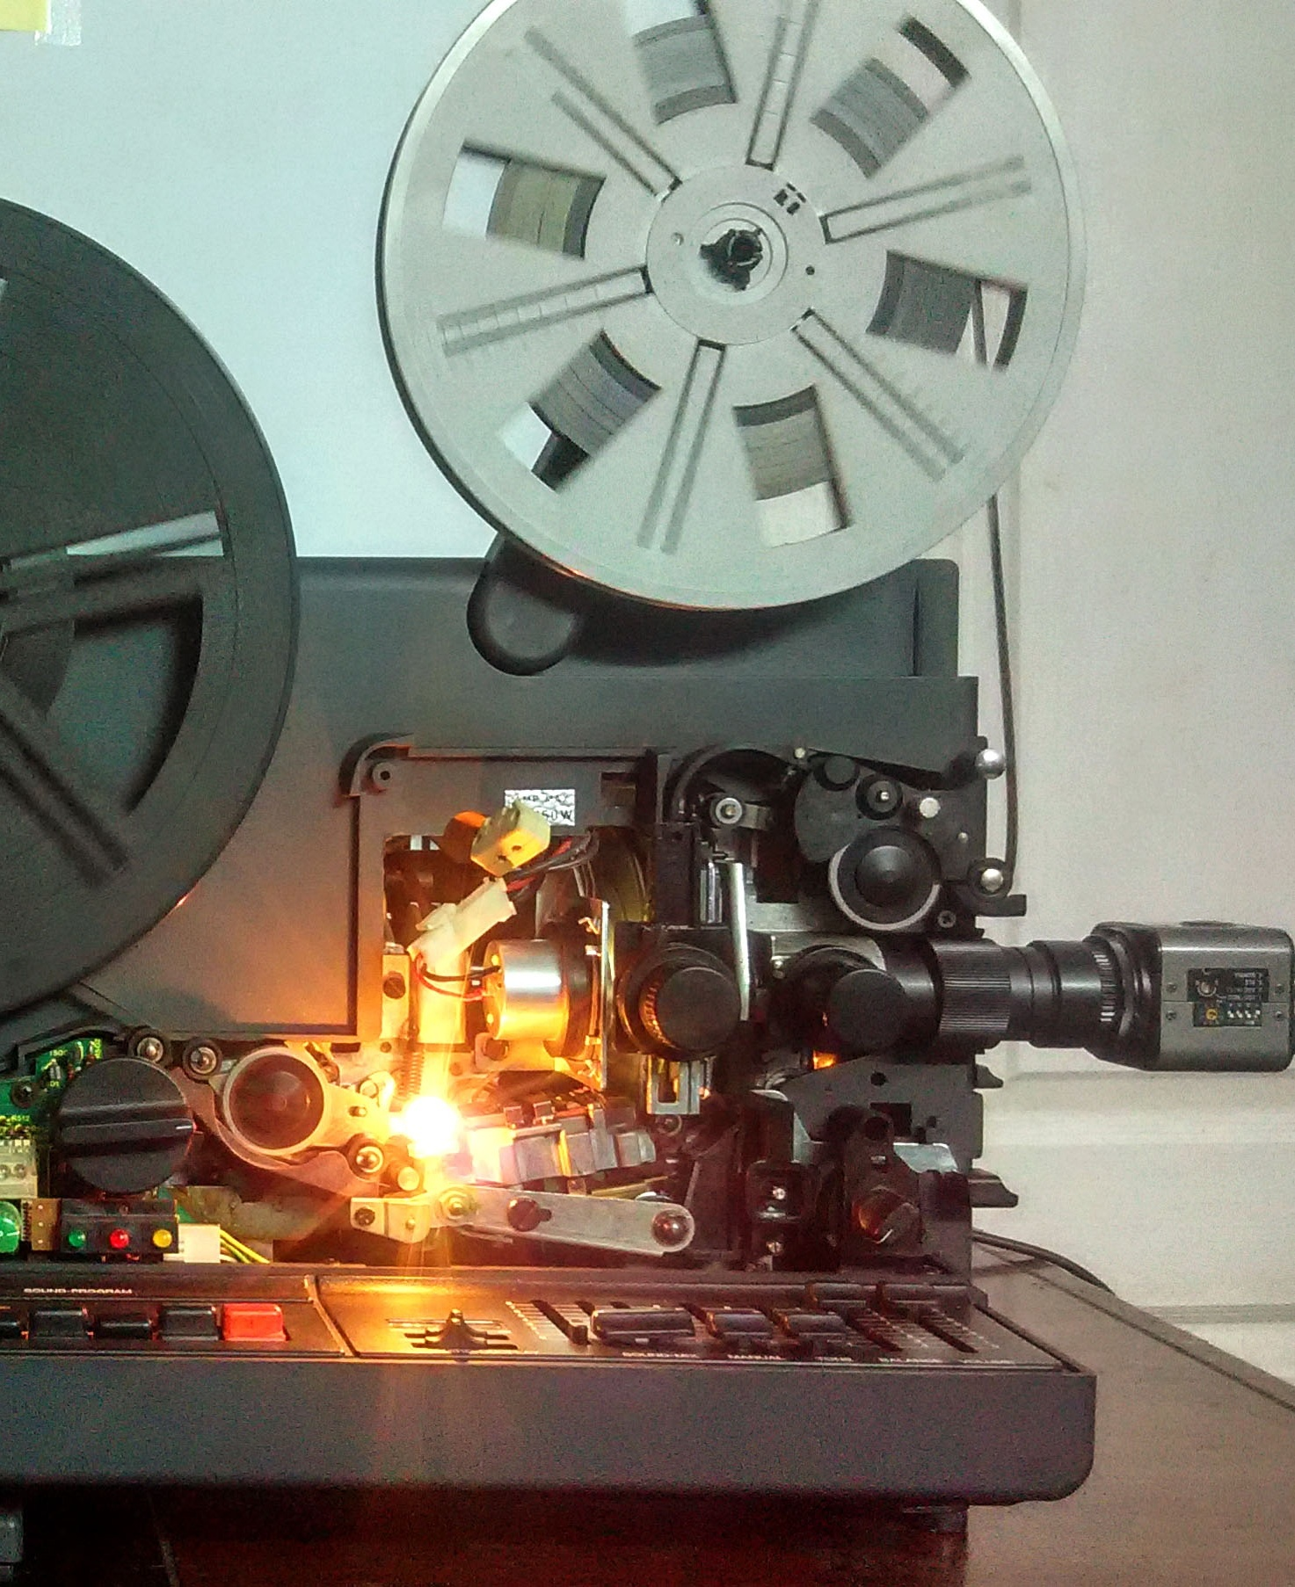
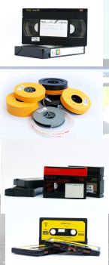

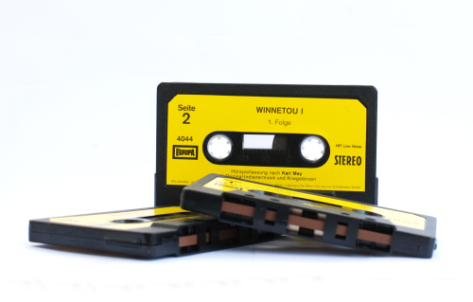
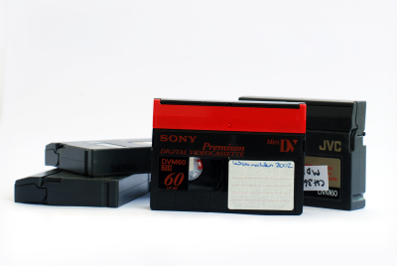
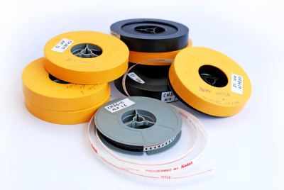
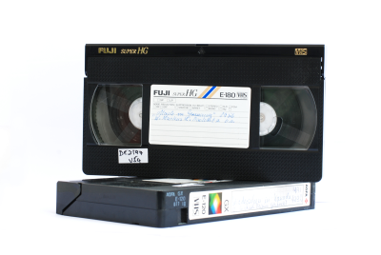
These video, film and audio formats we do:
Video:
- VHS, VHS-C
- Hi8, Video8
- MiniDV, Digital8
- DV Cam

Film:
- Super 8 films
- Normal 8 films
- 16mm films

Audio:
- Cassettes
- Audio tapes
- Vinyl and
- Gramophone plates
We turn this...
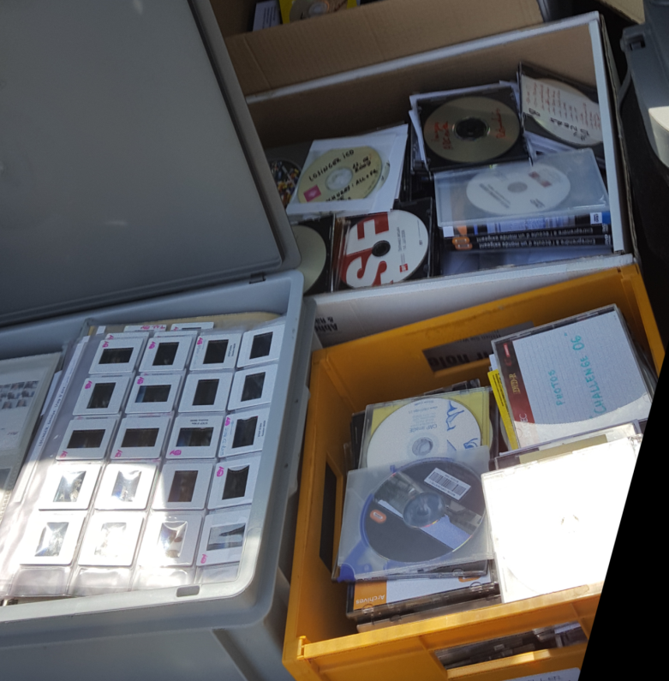
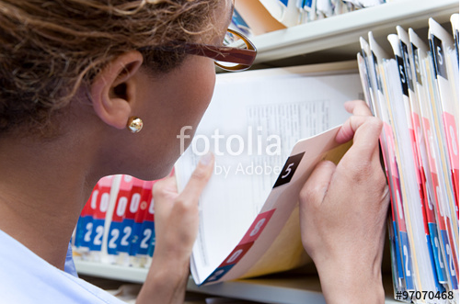
We count
and organize
for you
- Mixed archives (documents, photos, CDs, …)
- You don’t know what you really have in storage!
- You don’t have time to count…
- Yet you know there are some treasures in there!
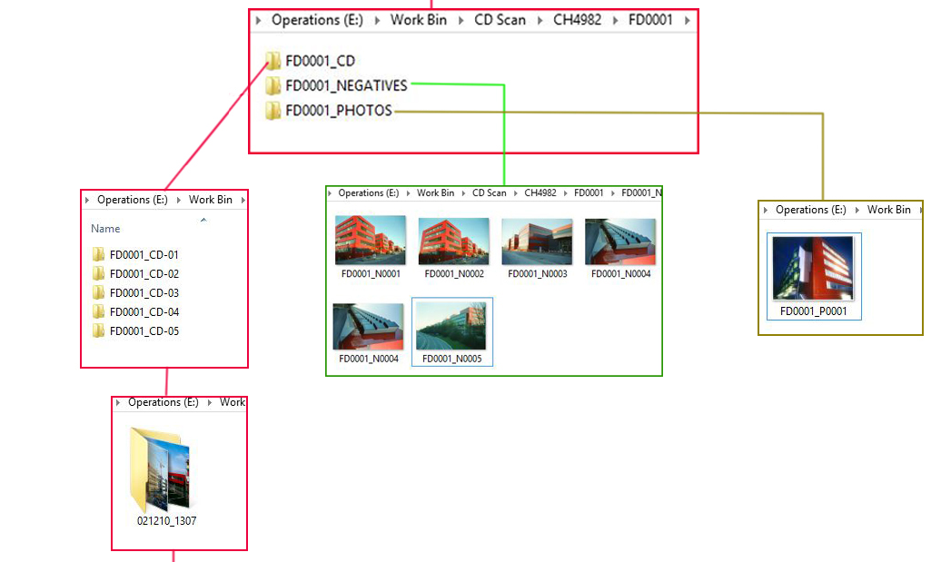
...into this


For larger projects we can provide:
- We organize your data by folder names, years or per customer’s instructions
- We scan your labels, CD covers, etc. and store them along with the content in one folder
- We provide an index overview to make it easy and quick for you to locate a certain media type
- We can organize your data irrespective of media types

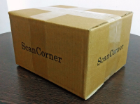

Why your images are save with us
Secure and clear order process
- We inform you at every step in our process by sending you an e-mail.
- Professional customer service
- Track & trace of your shipped order
No advanced payment
Our customers pay after we have completed your order
We ensure the security of your data
- Your order is delivered directly to our digitisation centre
- Only one employee is responsible for your order scanning
- As our computers do not have internet access we make sure that your data will be kept within our premises
Save handling, packaging &logistics
- Our logistic partner not only has one of the highest rates of safe delivery, but also offers in-transit tracking. This allows us to track all the items, so the risk of loss is virtually eliminated
- We make sure of adequate packaging
- Safety warranty for shipments!
5 Million
images scanned
zero lost!
Our references


„Die Qualität der Scans ist für den Preis erstaunlich gut, vor allem Farb- und Kratzerkorrektur können überzeugen.”
13.9.2016PC Magazin


ScanCorner ist für Fotografen und Privatpersonen geeignet, welche Ihre Negative zu einem top Preis und mit sehr guter Qualität digitalisiert haben wollen. Dabei ist zu beachten, dass sich ScanCorner vor allem bei dem Versand von größeren Mengen an Negativen sehr lohnt. In jedem Fall muss man mit einigen Wochen planen bevor man die Bestellung zurückerhält.
Michael Rüegger, 9.07.2016
Review in fotorevier.ch

ch wollte mich für den Superservice herzlich bedanken. Die Bilder sind toll, die Preise echt vernünftig. Es ist super wie man auf dem Laufenden gehalten wird. Alles hat super geklappt und ich werde Euch sicher weiterempfehlen. Grüsse
- Regular Häring, 25.05.2016

Ich habe ScanCorner online gefunden, nachdem meine ersten Versuche meine Bilder digitalisieren zu lassen kläglich gescheitert waren. Zuerst war ich ein wenig skeptisch, weil meine geliebten Erinnerungen nach Indien geschickt wurden, jedoch wurde ich nicht enttäuscht: Die Scans sind fantastisch, die Preise niedrig und ich habe meine Originale zusammen mit einer hübschen DVD wieder in meinem Briefkasten gefunden. Ich werde bald die nächste Sendung schicken und empfehle es auch allen anderen, die mit dem Gedanken gespielt haben ihre alten Negative digitalisieren zu lassen. Danke ScanCorner.
- Marc Hummer, 13.04.2016

erzlichen Dank für ihre grossartige Arbeit beim Digitalisieren meiner Video-Kasetten. Ich habe riesig den Plausch daran nun endlich all die Filme meiner Kinder wieder anzusehen und mich an alte Zeiten zu errinnern. Ich bin sehr zufrieden und glücklich,dass es Ihnen gelungen ist dies zu vollbringen. Gerne werde ich sie auch weiterempfehlen.
- Marianka Lukas, 15.02.2016

Sowohl die Scanqualität als auch die Farbsättigung und der Kontrast waren sehr gut. Das ist was ich von ScanCorner erwartet habe. Ich war und bin mit dem Service sehr zufrieden.
- Ian McKay, 08.01.2016

Over 13’000 satisfied customers

Hyderabad – home to ScanCorner
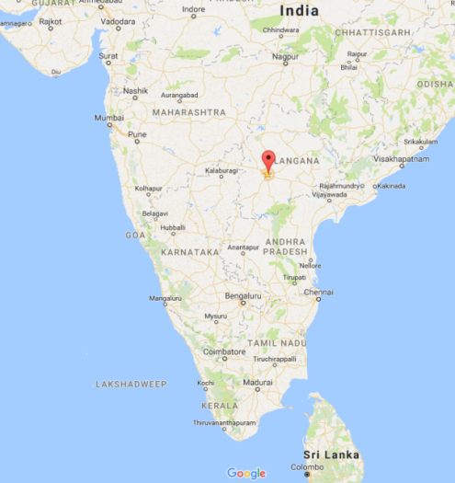
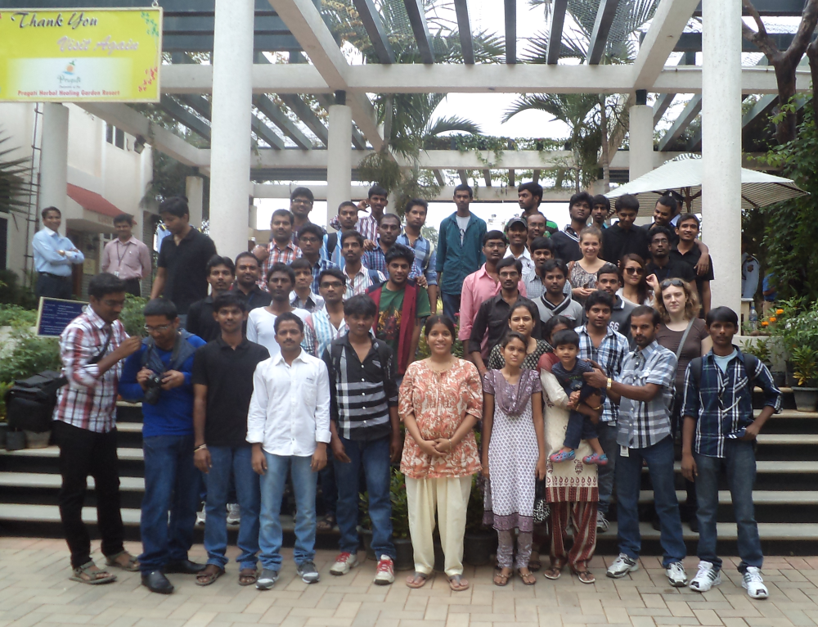
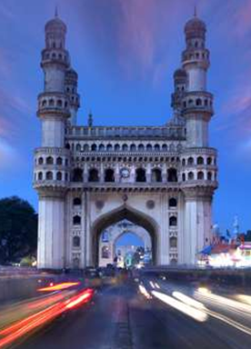
One motivated team
Our location in India
The famous Charminar mosque

Hyderabad is the capital of Talangana, home of about 6.7 million citizens and located 2 hours from New Delhi and one hour from Mumbai by air. The city is not only a treasure of culture and tradition but also India’s technology and healthcare hub. Hyderabad evolved from a traditional manufacturing city to a cosmopolitan industrial service centre where global conglomerates such as Microsoft, Google, IBM , Yahoo and Facebook have set up research facilities. The city is also a knowledge hub with many world class institutions, top universities and colleges.

The blend of industrialization and growth of IT firms makes Hyderabad truly a Cyberabad of India.

In 2010 ScanCorner set up its operational center in the residential zone of Hyderabad and has moved twice since then.

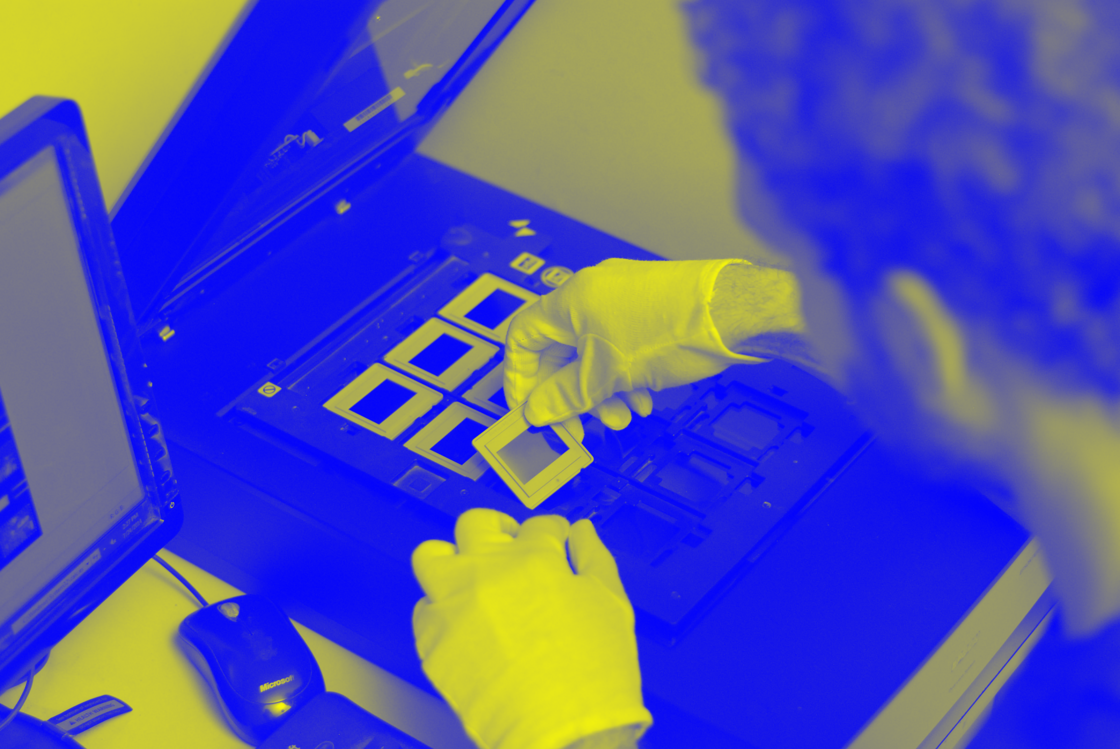


ScanCorner Australia
Suite 29 Subiaco Mews
375 Hay Street
Subiaco, WA 6008
Australia
www.scancorner.com.au

ScanCorner UK
UK; Office 12, 10 Cornfield Lane,
Eastbourne, East Sussex.BN21 4NE
United Kingdom
www.scancorner.uk

Operations Center:
501-Aruna Towers,
6-3-661/10/1&2,
Sangeet Nagar, Somajiguda
Hyderabad – 500082
India
www.scancorner.com

ScanCorner AG
Klostermatt 4
6330 Cham
Switzerland
www.scancorner.ch

ScanCorner Germany
Metzgerstr. 75
72764 Reutlingen
Germany
www.scancorner.de

ScanCorner
Bloemstraat 86hs
1016 LE Amsterdam
Netherlands
www.scancorner.nl



