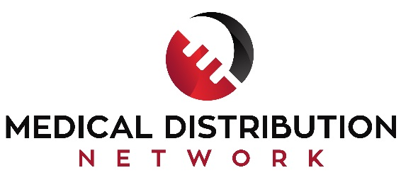
Saving Lives & Reducing Health Care Costs

About Us
We are a network of medical distribution professionals including physicians and surgeons, regulatory and coding experts, patent and trademark lawyers, international fulfillment experts, marketing and advertising professionals, and business strategists all working together in the distribution of promising new medical products. We handle all aspects of new surgical product sales, marketing, and distribution.
Our company was founded in Lewes, Delaware, with distribution locations and support associates and affiliates located throughout the US. We have extensive experience with medical product development, intellectual property, and regulatory and compliances issues.
We partner with medical innovators by providing strategic support with intellectual property and regulatory approval, reimbursement coding, marketing, selling and distributing state of the art medical products. Our clients include highly creative medical companies with strong management teams and consumer-driven growth perspectives.
Our products are uniquely positioned in an evolving health sector to offer benefits to patients, healthcare institutions, medical professionals, insurance companies and governmental agencies. Our evidence-based technologies reduce overall healthcare expenses and empower physicians and surgeons to provide improved practices and standards of care.
Medical Products
We specialize in the distribution of next generation medical products including customized surgical instruments and kits, monitoring and diagnostic devices, advanced wound care products and innovative acute care disposables
Our medical products represent breakthroughs in medical technology, saving lives, reducing health care costs, improving patient lifestyles.
Intellectual Property and Branding
We help our partners get the trademarks and patent claim approvals they need and deserve and at a reasonable price. Our team of patent attorneys and agents is effective and affordable and has gained over 300 client patent approvals. We help our clients brand and position their products for successful product launches and introductions to the US market.
Regulatory Issues
We provide comprehensive services support for global physician inventors who are seeking to distribute their medical products within the United States. We assist in navigating the unique aspects of the US medical market -- including FDA compliance and device returns, US Customs, and reimbursement coding.

(302) 397-3520
www.medicaldistributionnetwork.com

materials for Wound Care:
- http://www.shutterstock.com/pic-366494000/stock-photo-abstract-polygonal-space-low-poly-dark-background-with-connecting-dots-and-lines-connection-structure.html?src=RtGUypNp7o0-Yz-X5EBihA-3-97
• Image ID:366494000

Customized Surgical Tools
- http://www.shutterstock.com/pic-128963504/stock-photo-confident-surgeon-portrait.html?src=_njgXQfYX9hxjkEUSx09NQ-1-87
• Image ID:128963504

- Next Generation Surgical Devices

http://www.shutterstock.com/pic-180281267/stock-photo-core-energy-fractal-computer-generated-background.html?src=LlVsC7TJNZtYSDLVoO1TXA-3-54

• Image ID:180281267

- http://www.shutterstock.com/pic-191736143/stock-photo-modern-tablet-computer-with-medical-interface-on-its-screen.html?src=P77vbxQo8qulhf-cfqwSDw-1-4
Image ID:19173614

Home
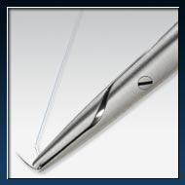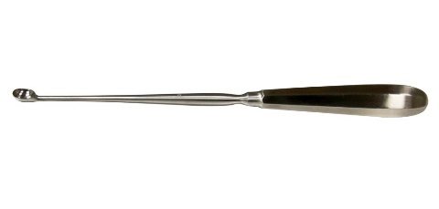
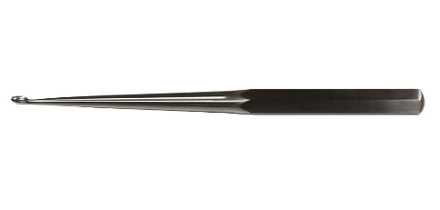
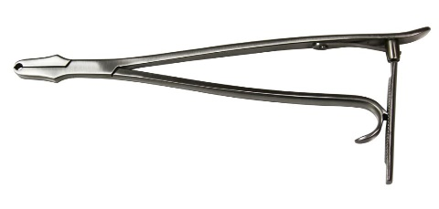
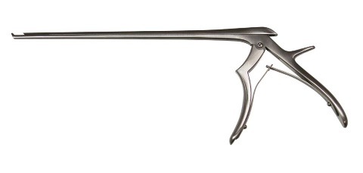
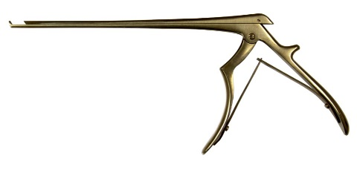
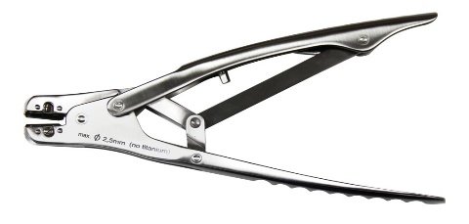
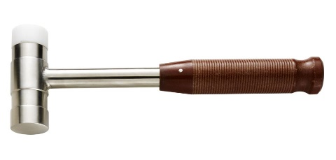
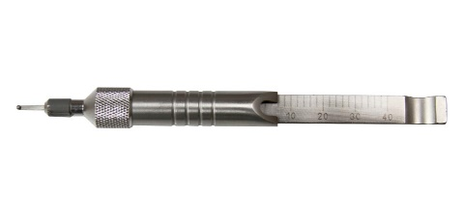

Forceps
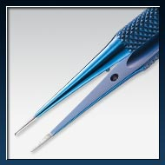

Scissors
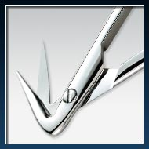

Clamps
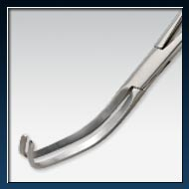

Minimally Invasive
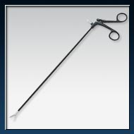

ORTHOPEDIC
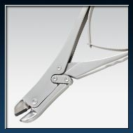

Combination cob elevator and suction device

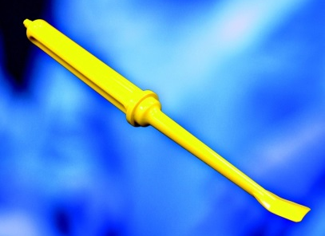

Subcutaneous, closed incision wound dressing
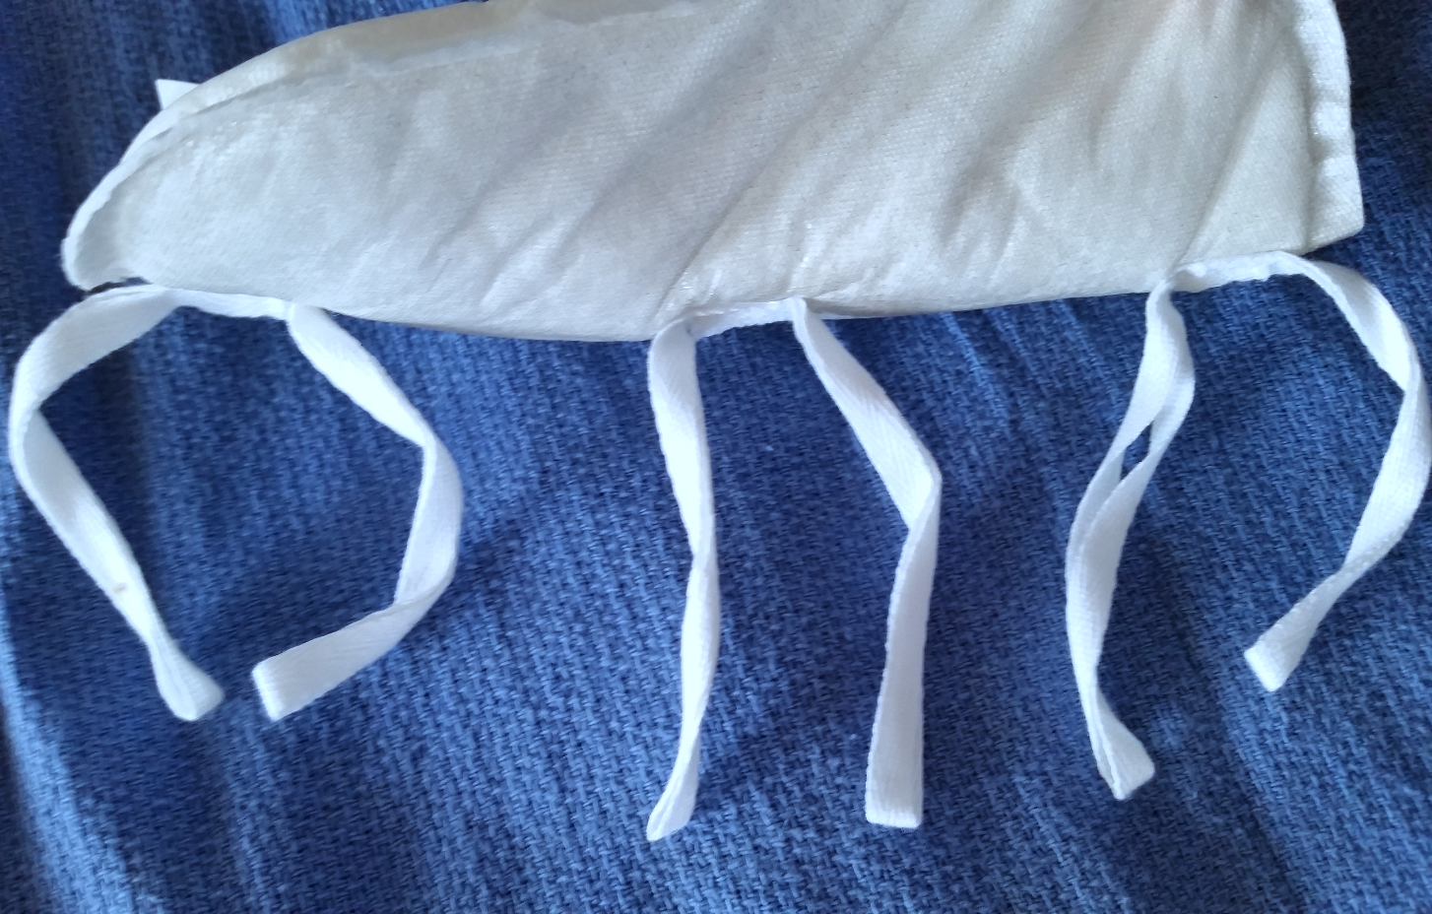

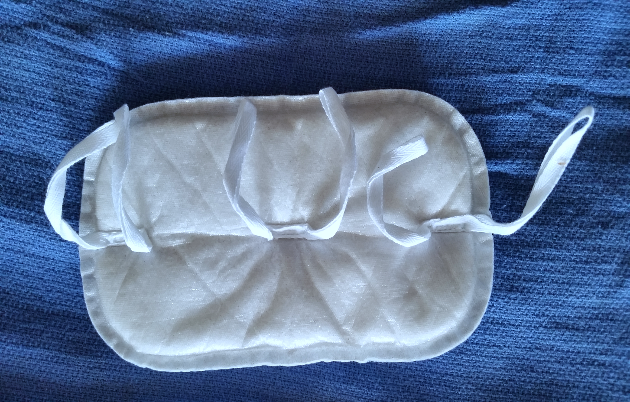
h

