
Internet | Cloud | Voice
1300 KALL ME (525 563)

Reduce your Telephone Costs Instantly.
Transition to VoIP
Full Featured Hosted PBX

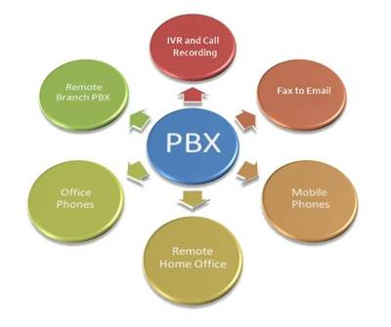
FREE ANALYSIS

Helping Business Communicate for over 25 Years

Internet | Fibre | NBN | VoIP
1300 KALL ME (525 563)

Internet to Suit You
Carrier Grade SLA’s
No Nonsense Support
Change centre to Internet
- Outside – NBN
- Multisite Connectivity
- Metro Ethernet
- Fibre Connections
- Voip
- Muli Vendor
FREE ANALYSIS – SAVE NOW

Helping Business Communicate for over 25 Years

