PLAY ON!
To kick Cancer

Logo ideas

Primary Color schemes = Green/white/black
Secondary colors = Yellow for referee shirt & red for present bow.

Logo to consist of
- Text Play On! to Kick Cancer
- Referee in a “play advantage” pose with a present in between the hands
- A reference to a $2 bill

TEXT:
Playful, energetic font scheme, Simplistic

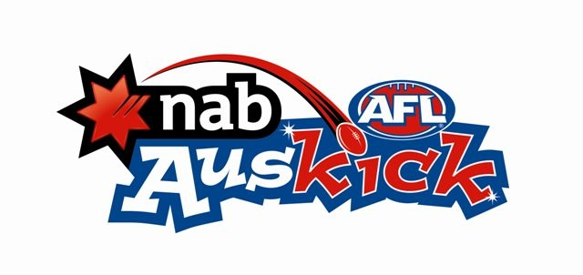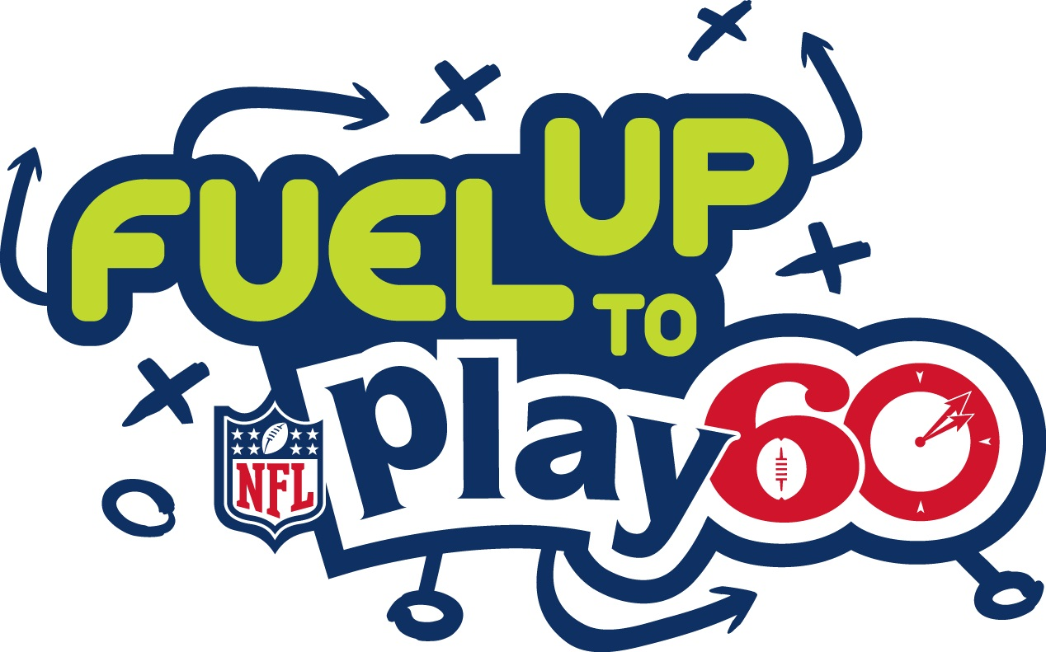

I really like the font style of the “Fuel Up” portion.

REFEREE:

The referee signals for players to “play on” by extending both arms out straight:

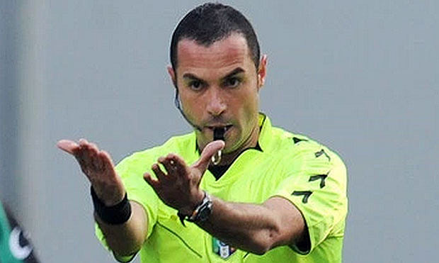

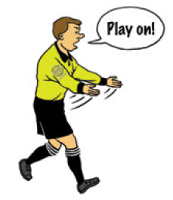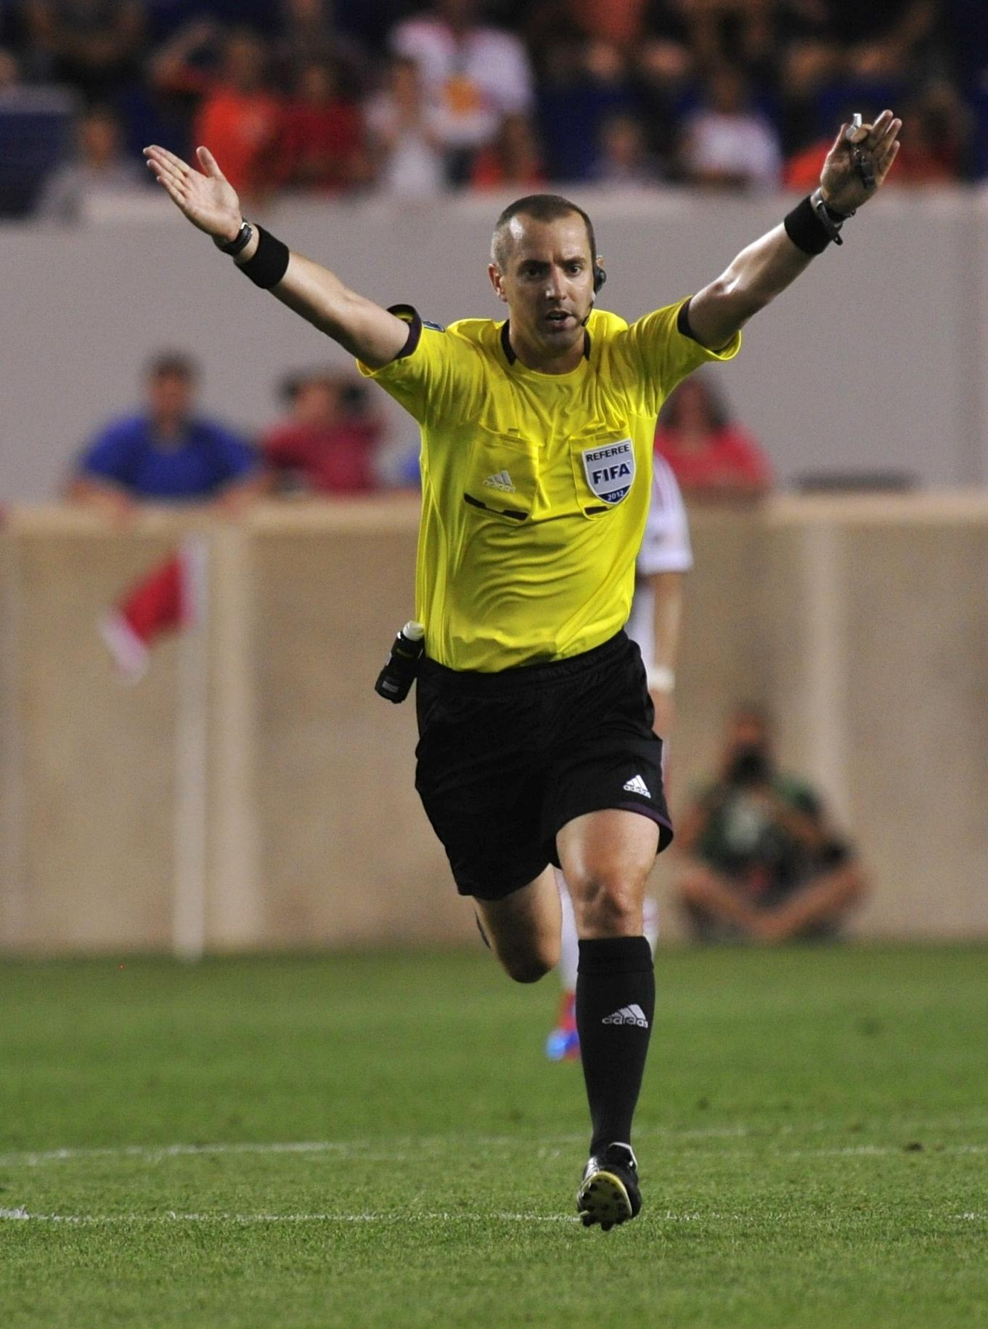

REFEREE CONTINUED

Looking for a simplistic, minimalist, featureless body of the referee similar to that used in airport symbols and Olympic event icons:



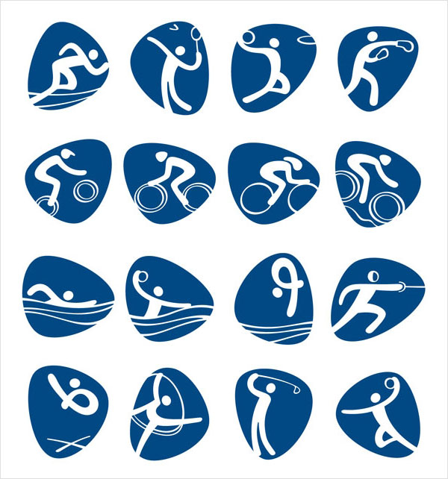

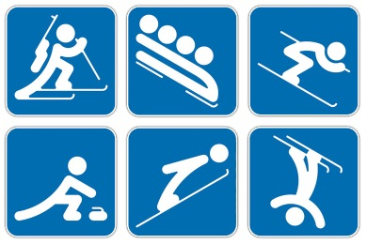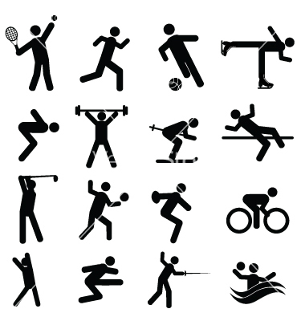

$2 Bill reference

One of the signatures of our donation drive is to have the kids contribute a $2 bill in addition to their toy. We expect the parents to buy the toy and we are encouraging the kids to donate $2 from their savings as well. It would be cool if we can work in either a Thomas Jefferson reference or a $2 reference.
