Job Type
Feminine, Modern Logo Design for Company in France
Type
Wellness
Task Outline
Create a Logo Design

Task Description
Intro
My name is Béatrice and I need a logo designed for my massage therapist business. After 10 years working in home office I am going out on a professional office.
Business
Energetic massages for healthy balance of mind, body and spirit.
Using Chi Nei Tsang (abdominal massage). Californian and Swedish technical. Reflexology, shiatsu and accupression method. Lymphatic drainage and pink quartz stones (for Rose Therapy CV Primary)
My initial formation is Chi Nei Tsang, an abdominal massage which need to practice ki gong (personal practice internal flow of energy), learned in US California. As a Chi Nei Tsang practitioner I also provide classes to people for self-wellbeing.
The feel of the office is warm as a spa concept. Warm colors are used as mole, chocolate, beige, white, grey, a little touch of warm pink.

Targeted customer base:

Women
95% of women have an average age of 35. A third of women attending relaxation between 18 and 65 years. They are active, and conscious of their appearance. They are looking for well-being, relaxation and calmness. They go to beauty salons to experience a unique moment to take care of them. Beauty and the 45-60 years represent a major growth driver, as they are still in business and receive a decent income.

Men
Welfare is attracting more and more men. Although the modeling-being played the card of seduction. Men are an important customer segment, especially in urban hotels and those that cater to business travelers, where the gender distribution is similar to the 50/50.

Seniors
Although the wellbeing attract more and more seniors looking for form and wellness.
General customers: those who have a higher purchasing power and seeking quality and result. The Silent Generation born between 1925 and 1942 is traditional in its approach to massage. She Research the quality of care. She Remain faithful individuals who will provide them with personalized care. This generation of consumers is largely local.

Target market

With a flyer or a visiting card I will introduce my company to:
- Bed & breakfast and hotels
- Hall’s fitness
- Hairdresser
- Psychologist, medical center and doctors (remain belly pain after all exams, stress…)

Wishes for design

Elegant, modern, serious, feminine but also open to man
The design should translate deep relaxation, troubles relief, wellness and vitality.
An invitation to a travel, a nice and great trip through the session.
Natural surroundings
Flowing energy
Feeling of lightness, maybe like dandelion with seeds blowing in the wind, but please be creative I’m open to any idea.
Warm colors as mole, chocolate, beige, white, grey, some warm pink for vitality
The name is “Détente • Bien-être • Vitalité”., which means “Relaxation • Wellness • Vitality”.
I would like include” Massages énergétiques et ateliers” which means “Energetic massages and workshops” above the name of the business (Détente Bien-être Vitalité) in smaller font. The word massages should be very close to the word “bien-être” because in France to be ok with the low, we need to always use the word “massage” with the word ”bien-être”.
Hope this make sense.

You will see underneath I uploaded some logos I liked, it may help with direction.
Dear artist, I am looking forward to enjoy your creativity about my project.
Sincerely yours,
Beatrice

Logo Text
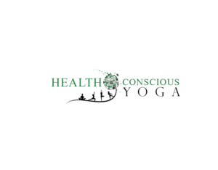

Béatrice Fioleau

Massages énergétiques & ateliers

Bien-être • Détente • Vitalité

Logo Styles of Interest
Character Logo
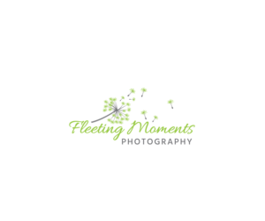
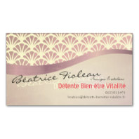
Logo with illustration or character
On this two models on the left,
I like the layout of dandelion,
the hand writing for my name,
then “Massages énergétiques & ateliers”
then the name “Détente Bien-être Vitalité” feels good in warm pink color

Warm pink for me:
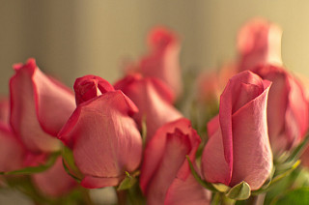
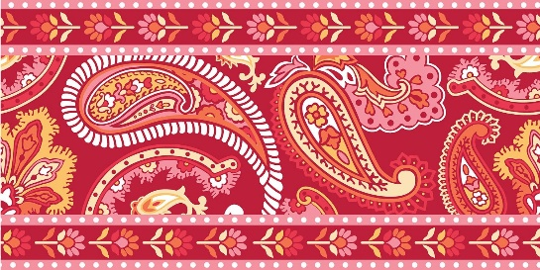
the darkest one

Elegant |  | Bold
Playful |  | Serious
Traditional |  | Modern
Personable |  | Professional
Feminine |  | Masculine
Colorful |  | Conservative
Economical |  | Upmarket

Logo Design Requirements
Should not have:
- Please do not uses Oriental or Asian pictograms, thanks!

