Logo Styles of Interest
Character Logo
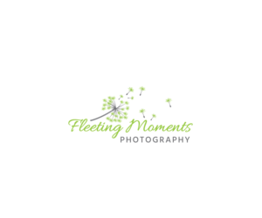
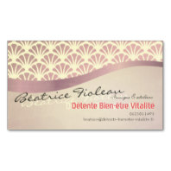
Logo with illustration or character
On this two models on the left,
I like the layout of dandelion,
the hand writing for my name,
then “Massages énergétiques & ateliers”
then the name “Détente Bien-être Vitalité” feels good in warm pink color

Warm pink for me:
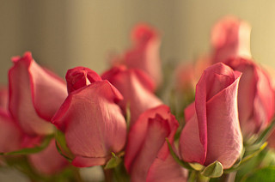
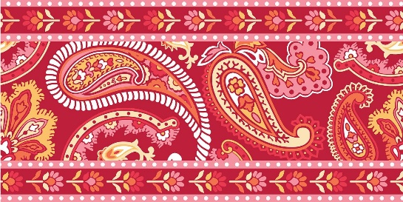
the darkest one

