Mobile Game Company

The company logo, should be able to clearly represented in individual game app icons, as it acts as a stamp of authority on the company making the games please see below.

Company logo
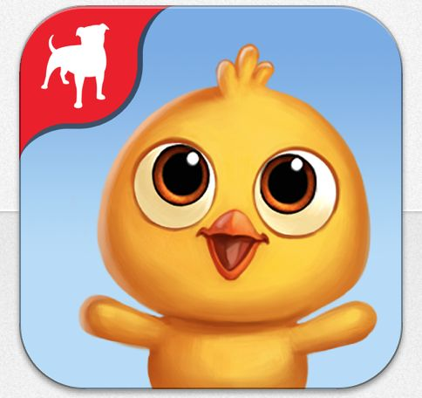
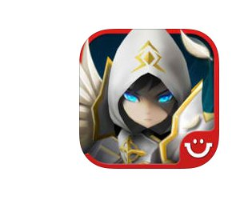
Company logo
Company logo

.

