REQUIREMENTS

We require packaging for our new product, a sleek new massager wand. The packaging needs to be black and white, and needs to represent our brand. The words to describe our brand are:
- Sensual
- Luxurious
- Sleek simplicity

Here is a Pinterest board detailing our preferred style: https://uk.pinterest.com/elisepajackson/packaging-kassandra/

The product looks like the below:

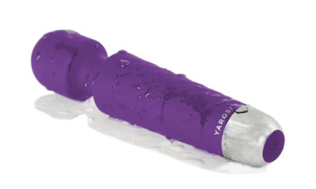

Packaging Design of a competitor product:

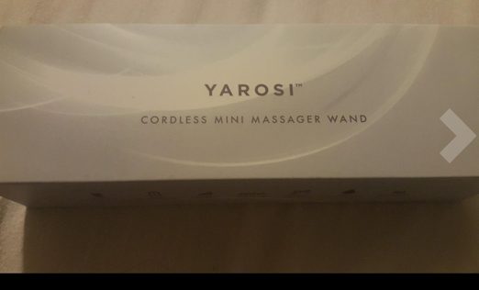

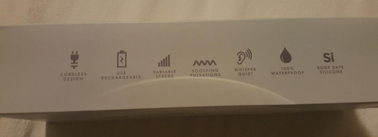

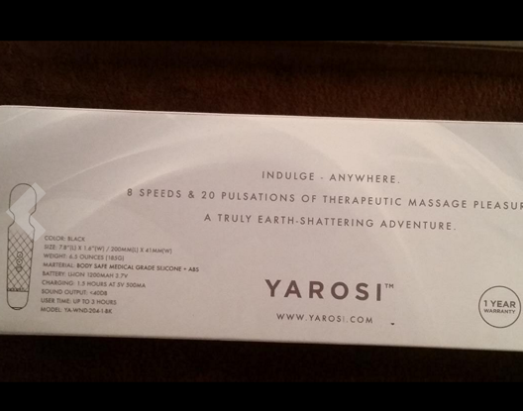

LOGO
Currently awaiting final logo! A working example is attached and below. The final logo will be added as a revision.

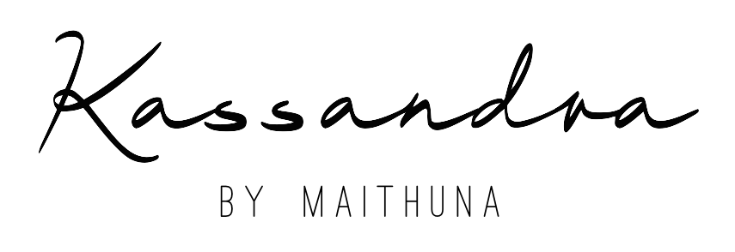

PACKAGING

Dimensions: 22 x 7.2 x 4.8cm

EXAMPLE NET (Not to scale), to act as a guide for what is required on each side. See descriptions of what goes on each side below:

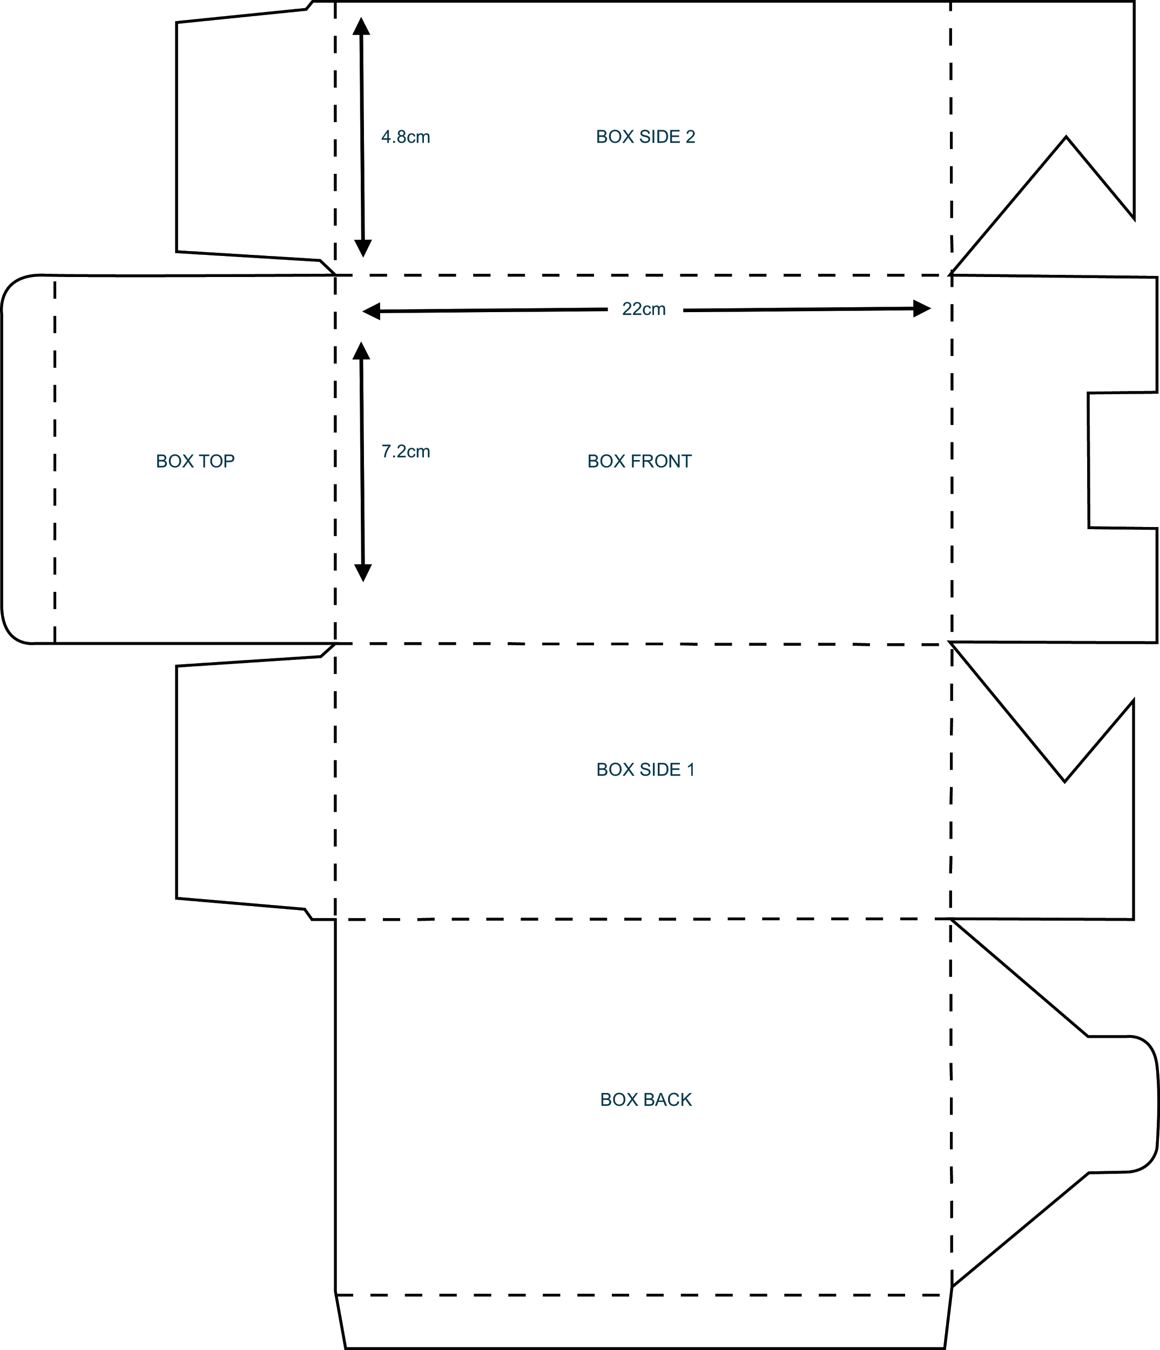

DETAILED REQUIREMENTS

BOX FRONT:

LOGO

CORDLESS MINI WAND MASSAGER

www.maithuna.co

BOX SIDE 1:

ICON
Sleek, Cordless design

ICON
100% Waterproof

ICON
USB Rechargable

ICON
8x Stimulating Speeds

ICON
20x Heavenly Pulsations

ICON
Discreetly Quiet

ICON
Body-safe Silicone

ICON
Phthalate-free

BOX SIDE 2

The Kassandra was created for your theraputic satisfaction.
Delight your body with 8 Stimulating Speeds & 20 Heavenly Pulsations of Massage Pleasure.

Where will Kassandra take you?

LOGO
www.maithuna.co

BOX BASE:

Colour: Aubergine
Size: 7.8” (L) x 1.6” (W) / 200MM (L) x 41MM (W)
Weight: 6.5 ounces / 186G
Material: Body-Safe Medical Grade Silicone + ABS
Battery: Li-oh 1200MAH 3.7V
Charging: 1.5 hours at 5V 500MA
Sound Output: =<40DB
User time: up to 3 hours
Model: 00000000-000000000

LOGO

www.maithuna.co

1 year warranty (ICON)
CE logo + barcode (awaiting)

