Holistic Learning Center
9/16/16
DesignCrowed Edits For SD Infoways
Book: The Awakening

- Move cocooned butterflies left
  - Side Note- these butterflies don’t look as crisp as other’s we’ve seen. Are you using the JPEG we submitted or is this a copy of a Shutterfly photo?
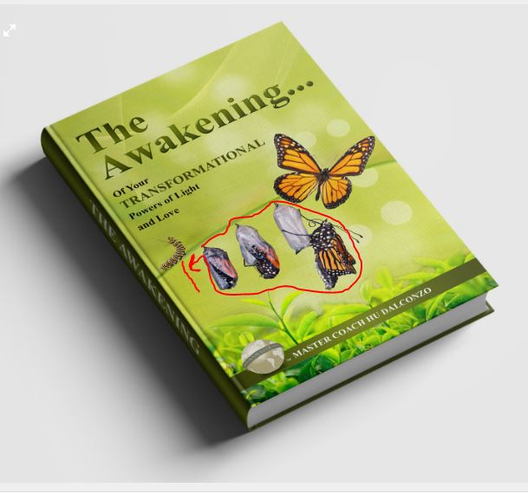
- Remove this plant
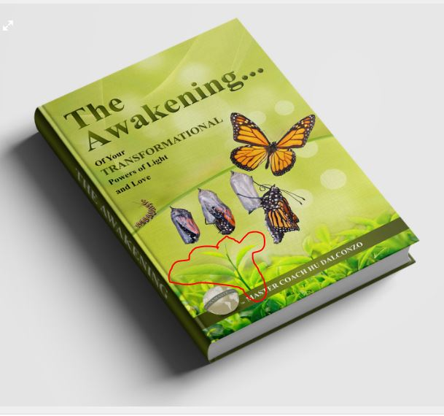
- Move everything down
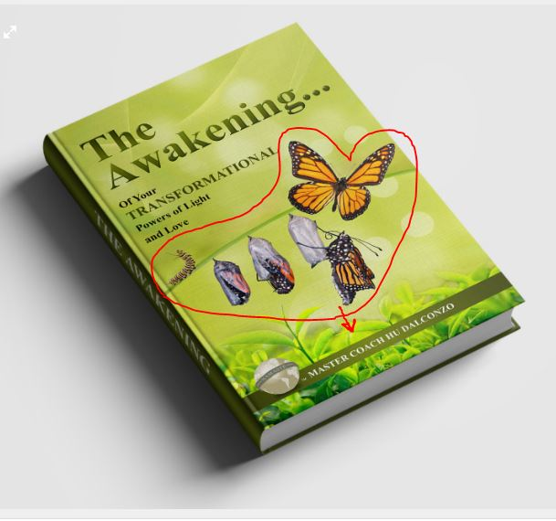
- In the subtitle- the first Of needs to be lowercase- “of Your Transformational Powers of Light and Love”
- Whole subtitle in black

