In spite of the changes wrought over the last 20 years, with its six miles of white, sandy beaches, the Isle of Palms remains as much a place of beautiful serenity for residents and visitors today, as it was for the Seewee Indians and the colonists who followed.

IOP Today
Our Island Turtle Team monitors turtle nests and records the number of hatches each year.
Boating opportunities include kayaks, canoes, sailboats, fishing boats and even luxury harbor cruises. Personal watercraft like Jet Skis can be rented to explore nearby islands.
Fishing contests often originate at Isle of Palms Marina. Or you can just cast your own line from the beach.
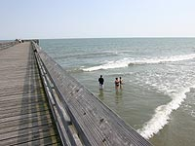
Getting around the island is easy, with most roads having marked bike paths for safety. Bicycle and rollerblade rentals are available on the island.
Golf and tennis are easy to pursue on the island. The island has two world-class golf courses, the intimate Harbor Course and the Links Course (http://www.wilddunes.com/south-carolina-links-course.php) , and the Charleston area has many other well-known courses. Both clay and hardcourt surfaces are available to tennis enthusiasts on the island.

