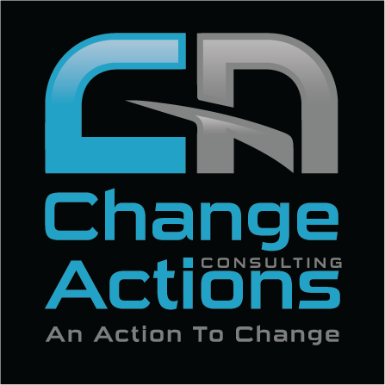

WE CAN HELP YOU TO
MAKE CHANGE HAPPEN
Table of Contents
Who we are? 2
Executive Summary 2
Vision 2
Mission 2
Values 2
Why change Actions? 3
What we do? 4
HR & OD Consultation 4
Professional Training 4
Talent Assessment 5
HR Solutions 5
Partnership 6
(IMA) Implementation Management Associates, Inc. 6
Cullen Scholefield 6
zetalents 6
Coredia Consulting 6
Our Team 7
Waleed Al Ahmadi Consulting Manager 7
Mohammed Hamdan Assoc. Consultant 7
Rasheed Al-Odah Projects Manager 8
Sofian Lamali Assoc. Consultant 8
Certifications 9
Our Clients 10
Contact us 11

Who we are?

Executive Summary
Change Action is professional HR & OD Organization, which is Specialized in Talent and Organizational Development, Career Coaching, Leadership Assessment and Development, Total Reward, HR Technology & providing a wide range of outsourcing payroll and recruitment services with a vision to be the leading HR outsourcing company in the Middle East. Change Action is a local house of HR & OD expertise with global experience, driven by one thought, to raise the bar of local HR practices and knowledge. Change Actions have developed partnerships with various companies and organizations, among those Zetalent will be the strategic partner to provide HR outsourcing services through their platforms.

Vision
“To become the leading HR outsourcing company in the Middle East and stand known of quality services.”

Mission
We have a multi-layered mission statement catering for the needs of our customers in addition to increasing the value of our services and upgrading our standing among our competitors. Our missions are:
      - To provide convenient HR solutions to SMEs so they can focus on the core of their business.
      - To play our role in economic development of Saudi Arabia and other Middle East countries.
      - To develop a professional relationship with our valued clientele and investors.
      - To bring innovation in HR services through technology.

Values
- Integrity: Change Actions will ensure integrity within employees and with clients, investors and strategic partners.
- Workplace entertainment: Change Actions will provide enjoyment of all employees at the workplace to promote work as a passion instead of a profession.
- Accountability: In Change Actions, from MD to staff everyone will be accountable for their actions and decision.
- Pursuit of Excellence: Each employee and stakeholder will strive for excellence in his role and professional activities.
- Quality Control: Change Actions will implement strict quality control to improve the standard of its services continuously.
- Affordability: Services of Change Actions will be affordable to meet the demands of local companies.

Why change Actions?

Success We will deliver reliable results for you, as our services record shows. In the past few years, we have helped a numbers of organizations with a less than 2% rejection rate.

Targeting We understand the importance of targeting the right people and community, the right way. We will work with you to understand the importance of communication and how you can focus the right individual at a good time.

Superior Workforce Our dedicated training professionals have all been rigorously screened and training to perform at their peak level. They know that they represent our company at all times and understand the importance of enhancing your image.

Flexible Multichannel Abilities Our wide capabilities give an extensive reach and the ability to create exactly the right program and deliver it where it will get the best results.

Cost Effectiveness Change Action will train your staff by offering very affordable value-added projects

What we do?

HR & OD Consultation
Our dedicated team of HR and OD experts is on hand to provide professional support for your HR and OD operations and development. Working closely alongside your organization, we will identify gaps in your current situation, and propose solutions to overcome these issues.
- HR Strategy Alignment
- Organizational Design & development
- Talent Assessment & Management
- Learning & Leadership Development
- Communication & Change Management
- Compensation & Benefits
- Work-life initiatives
- Performance & Recognition
- Development & Career Opportunities
- Coaching & Mentoring Program

Professional Training

Our vocational training services will enable people and organizations to optimize the skills, knowledge, and abilities of its workforce. We deliver a broad range of training courses, including professional qualifications, short courses, and customized training.
In-House Custom Training: We are committed to provide a high-quality training that adds value to our client’s employees and their business processes. Too many reasons make our training programs different and deserve the attention given from too many professionals.
Professional Qualifications: We are proud to introduce a golden portfolio of prestigious vocational qualifications that are globally recognized for its significant benefit to the knowledge, skills, and competencies of certificates holder. The majority of them are introduced in Saudi Market.

Talent Assessment
Our carefully developed assessment solutions allow you to assess the skills, aptitudes, and abilities of your workforce, enabling you to identify and fill any skills gaps.
Talent Assessment: Assessing people for best performance is the most important task of any organization. The quality of assessment ultimately determines the performance of new hires as well as the ability of the organization to deliver on its promises in the market. Using various assessment tools and methods, we can help you devise an assessment strategy linked to job competencies and assessing talent for the purpose of selection and development.
Talent Management: As an organization strives to meet its business goals, it must make sure that it has a continuous and integrated process for recruiting, onboarding, developing, and managing talents. We can help you: Identify and implement “best fit” key processes such as performance management, succession management, and employee development, engagement and retention.

HR Solutions
Outsourcing: A trusted HRMS solution, combined with regional expertise, now brings you HR Administration and Payroll outsourcing for the Middle East region. Either you are a customized small company with special payroll requirements, or a larger SME seeking confidentiality, accurateness, and timeliness, we have proven ourselves to be a reliable business partner. Our strength in payroll lies in the controls and governance that is put in place.
- Employee Relations
- Payroll and Pay
- Merit Increase Processing
- Incentives & Bonus
- Recruitment & Hiring
- Performance Management

Success Partnership

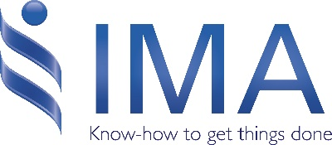
(IMA) Implementation Management Associates, Inc.

IMA Implementation Management Associates, Inc. (IMA) is an international consulting firm that guides organizations through all types of complex or large-scale change and implementations. Our proprietary Accelerating Implementation Methodology (AIM) has b een applied extensively in Fortune 500 companies and around the world.​

Cullen Scholefield
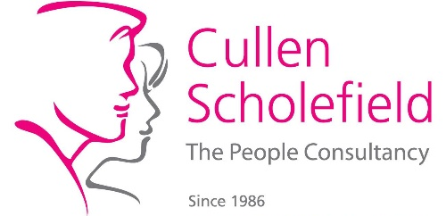
Cullen Scholefield is the only CIPD HR distance learning center that offers ALL modules and ALL units at ALL CIPD qualification levels; They are also approved to offer ILM qualifications in Coaching and Mentoring and Leadershipcenteranagement at ALL levels; They have been qualifying HR professionals since 1987, and all our advisors are practicing professionals and Chartered Fellows of CIPD.

Riverwaves
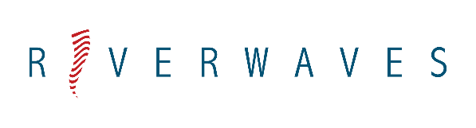
With over 20 years industry experience working closely with HR Directors and Managers, we can help your organisation achieve its goals by developing stronger, more engaged and sustainable workforces.
Our bespoke and flexible Competency Solutions give you the focus and skills to succeed in today’s challenging times – and put you in excellent shape for the future. We back this up with a range of support services through our multi-national network of highly experienced consultants.


zetalents
zetalents HCIS is a comprehensive Human Capital Management System that streamlines your HR processes. It efficiently administers applicant tracking, benefit programs, workforce training and development, dues calculations and benefits, and ever-changing governmental regulations. The Employee Self-Service (ESS) portal is designed for employee satisfaction as well as operational efficiency

Coredia Consulting

Coredia Consulting is an organization specialized in providing customized Leadership Development solutions to companies in the Middle East and Africa. Recognizing the inability of imported models and solutions to solve problems that face companies in our region; Coredia Consulting builds on international best practices and customizes them to create best-fit solutions that are capable of addressing challenges effectively.

Our Team


Waleed Al Ahmadi - Consulting Manager
Certified HR Practitioner with more than 15 years of exceptional local and International Business track record in talent & OD; combines worked in several industries including textile, F&B, Construction, Retail (Carrefour), Pharmaceutical, Education and Chemicals Manufacturing (Ecolab-Nalco); Diversified educational achievement starting from computer programming, Business Administration, CIPD diploma in HR Practices and other relative certifications.


Mohammed Hamdan - Senior Consultant
Certified HR Practitioner with more than 12 years of experience working in Saudi Aramco and Sadara Chemical Company as well as in the private sector as an independent consultant. Mohammed holds a B.S. in Chemical Engineering and holds certifications in Coaching, Change Management, O.D, and Leadership Assessment & Development. Mohammed’s areas of strength are engaging teams in profound change interventions either through coaching or facilitative learning in workshops specifically in Leadership development and personal mastery.


Rasheed Al-Odah - Projects Manager
Certified SAP Portfolio Manager and an IT Professional with more than ten years of experience and in-depth understanding of SAP Project Implementations, mainly leading HR, Training, Recruitment and other affiliates projects. Rasheed has performed Implementations of SAP Business Packages for EP namely; ESS/MSS; SAP BO BI, SAP BO upgrade to BI 4.0, SAP BO Access Control, SAP Enterprise Learning Solutions, SAP EHS, Primavera Implementation with SAP Integration, Medium Implementation and Intranet on SharePoint. Rasheed has also participated in the SAP rollout to 13 affiliate companies in TASNEE all around the Kingdom.

Certifications















SOFIAN LAMALI

Our Clients
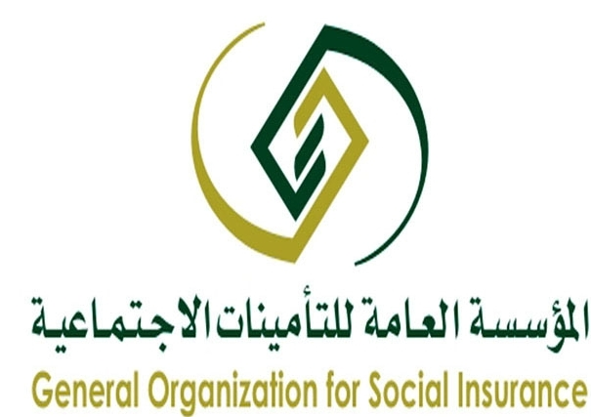





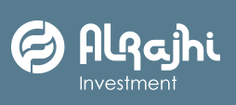

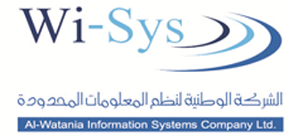

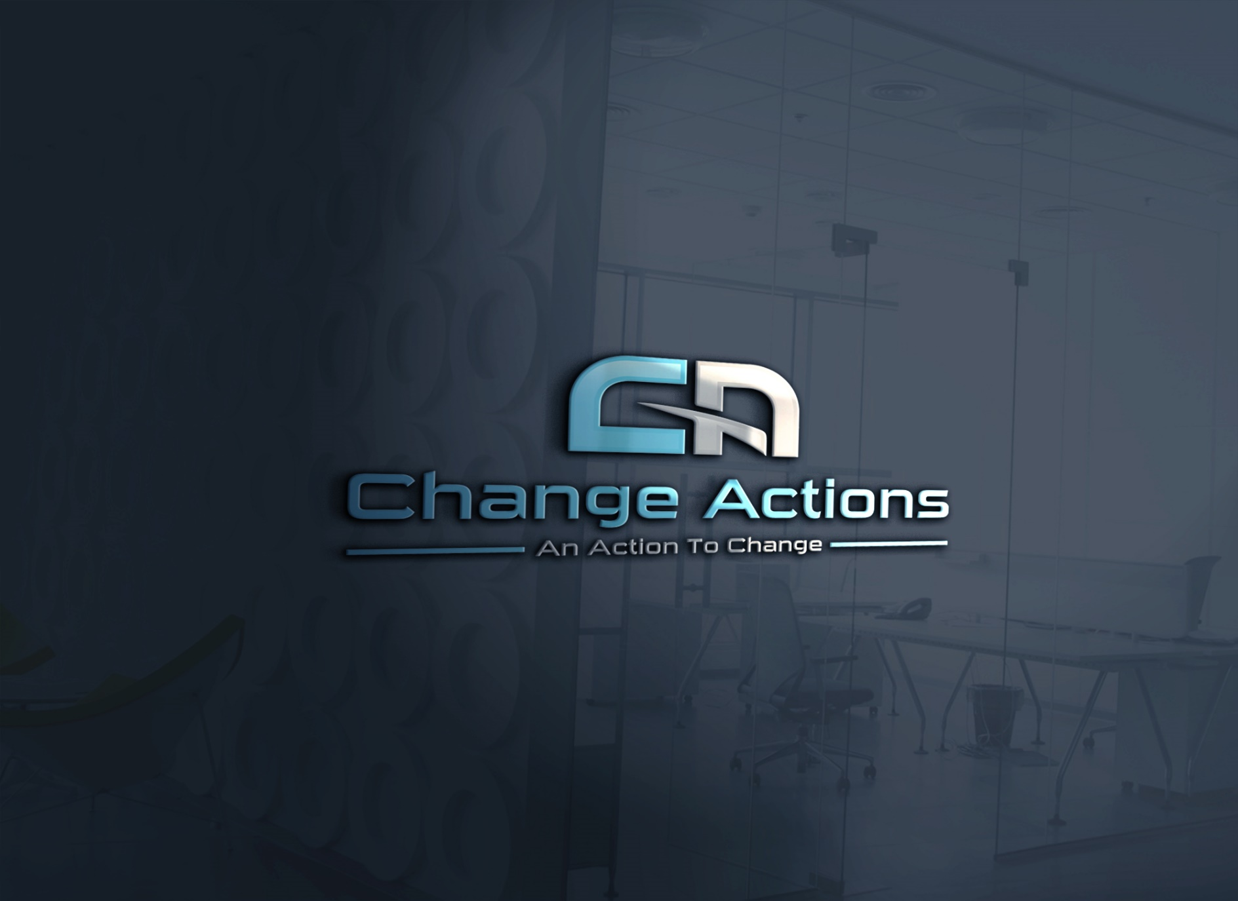 | Contact us  Dubai  PO BOX 124342, Dubai, UAE  23rd Floor, Boulevard Plaza- Tower 2, Emaar Boulevard.  T 00971 4 409 6966  F 00971 4 409 6850  E info@changeactions.com  Khobar  PO BOX 31523, Khobar 31952, SAUDI ARABIA  21st Floor, Alkhobar Gate Tower, King Abdulaziz St.  T 00966 13 330 8578  E info@changeactions.com

