Team VR Application
Contents
System Overview 2
Features and Functionality 2
App Experience 2
Room Detailed 3
Admin Website 4
Admin Website Sketch 5

System Overview:
A team based virtual reality app will be made for fans to view 360 degree videos of their favorite teams. Clients will provide the video content for fans. The app will be skinned for each team with team colors and logos. From here on out the term “Clients” will be referred to as “teams”
Each team will own their own app. The app will be a room designed to look like a team fan room. 360 degree video choices will be displayed on a large screen TV and when chosen the video will launch into full 360 view. The app will be available for fans to download in the various 360 app stores.
Fans will be able to download the app for free in the various VR stores: Oculus, Samsung Oculus, HTC Vivepoint, ect. Fans will be provided unique team content to view in 360 degrees.
The videos will primarily be streamed but there will be a choice of downloading the videos as well.
There will be a backend “Admin” website for the teams to use for administration purposes. The teams will be able to choose wall color. The teams will also be able to load pictures or logos onto the walls of the room. The teams will be able to load text into one place in the room.

Application Features and Functionality
The application will be one to be used with a VR 360 Headset. The purpose of the app is 360 degree video watching. The app will be a free download in the app stores. Features and functionality include:
  - 360 Video Viewing
  - Navigation controls for moving to next or previous videos
  - 360 Degree Fan Room
  - Stream or Download Videos
  - Team Content
  - Free from any VR store

App Experience:
User opens the app and enters the room. They are seated in a lounge chair. Directly in front of them on the front wall will be a large screen TV hanging on the wall. There will be a button located below the TV with the text “Start Video”. When that button is pointed at with the headsets pointer and clicked the user will be prompted to either download or stream. The user will select one by pointing and clicking. Once that choice is made the first video will begin. The TV will disappear and the user will be immersed into the 360 video. The video can only be played all the way through. There will be no need for fast forward or reverse while viewing the video. Once the video is done playing the user returns to the room sitting on the lounge chair and is looking at the TV once again. The video just viewed will be in focus on the TV screen.
On the left of the TV a button to move backwards will be visible. On the right of the TV a button to move forward will appear. These buttons will let the user select which videos they want to see. This is how the videos will rotate. If the user clicks the button on the right side of the TV the next video in line will be in focus. If the user clicks the button on the left side of the TV the previous video will be in focus. When the video the user wants to view is in focus they will again point at the button to “Start Video”

The Room: Detailed

FRONT WALL:
When the user starts the app it will open into a room. That user is seated in a recliner and there is another empty recliner to the right and another to the left of the user. Those recliners are right next to the user who is seated in the middle recliner. They will be within arm’s length of the user. In front of the user is a large screen TV hanging on the wall. On the top half of the screen will be a dynamic placeholder for a picture or a logo. Looking at the supplied picture of the admin site (Item #1) below this is #4 of the dynamic placeholders. Below that placeholder will be static text. “These videos are brought to you by” After the word “by” is another dynamic placeholder. This placeholder is for text. Looking at the supplied picture of the admin site below this is #5 of the dynamic placeholders. The text is supplied by the team from the admin site.
LEFT WALL:
When the user turns and looks at the left side of the room there will be a pool table. On the wall behind the pool table will be a picture frame. This picture frame is a dynamic place holder for a picture or a logo. Looking at the supplied picture of the admin site below this is #1 of the dynamic placeholders. The team will decide what is in that picture frame by using the admin site.
RIGHT WALL:
When the user turns and looks right there will be a foosball table. On the wall behind the foosball table will be a picture frame. This picture frame is a dynamic place holder for a picture or a logo. Looking at the supplied picture of the admin site below this is #2 of the dynamic placeholders. The team will decide what is in that picture frame by using the admin site.
REAR WALL:
When the user turns and looks behind them there will be a bar. There will be 4 bar stools at the bar. There will be nothing on the bar. Behind the bar on the back wall will be a larger picture frame. This picture frame is the third dynamic place holder for a picture or a logo. Looking at the picture of the supplied admin site below this is #3 of the dynamic placeholders. The team will decide what is in that picture frame by using the admin site.
Carpeting and Ceiling:
The room is carpeted. The carpet will be a light brown color. The ceiling is white.

Team Backend: Admin Website
Teams will need an admin website created for the ability to upload videos. They will also need the ability to change five different dynamic placeholders. Four of those placeholders will be for pictures/logos. The other will be for text. The team will need credentials to logon to this site. This webpage will need to be opened via username and password. There will be four sections to this admin website. Below are the details for each section.
Section 1 - Videos:
Teams will create their own video content with their own 360 degree camera. The team will edit the video as they choose with their own editing software. They will upload the video clips for the app from an admin website provided by us.
Section 2 - Pictures/Logos:
Teams will also be able to load logos or pictures into 4 different areas in their apps room. Those 4 areas are dynamic placeholders. Three of the areas are picture frames. The first one is behind the bar, the second is behind the pool table and the third is behind the foosball table. These frames will be hanging on the walls. They will have the team logo in them by default. The frames should be a neutral color. The fourth placeholder for a picture/logo will be in the top section of the TV screen. The admin site will have a section where the team is able to change each of the 4 dynamic place holders. The place holders are labeled by location. Examples below.
  - Behind pool table – Dynamic Holder # 1
  - Behind foosball table – Dynamic Holder # 2
  - Behind bar – Dynamic Holder # 3
  - Top Section of TV – Dynamic Holder # 4

Section 3 - Text:
Teams will have the ability to add text in one area of the room. The text will appear in the bottom half section of the TV screen. The purpose of this text placeholder is for the teams to use for sponsorship or messaging. The placeholder will be labeled by location.
  - Bottom Section of TV – Dynamic Holder # 5

Section 4 - Palette Chooser:

The final section of the admin site will have a palette chooser for the team to select a color for the walls. Teams will be able to change the color of the walls if needed. When the app is first purchased we (Global Apptitude) will ask for a color choice and logo from the team and will preload the app with the colors and logos in all dynamic placeholders.

The picture below is a rough sketch of the admin site.
ITEM #1
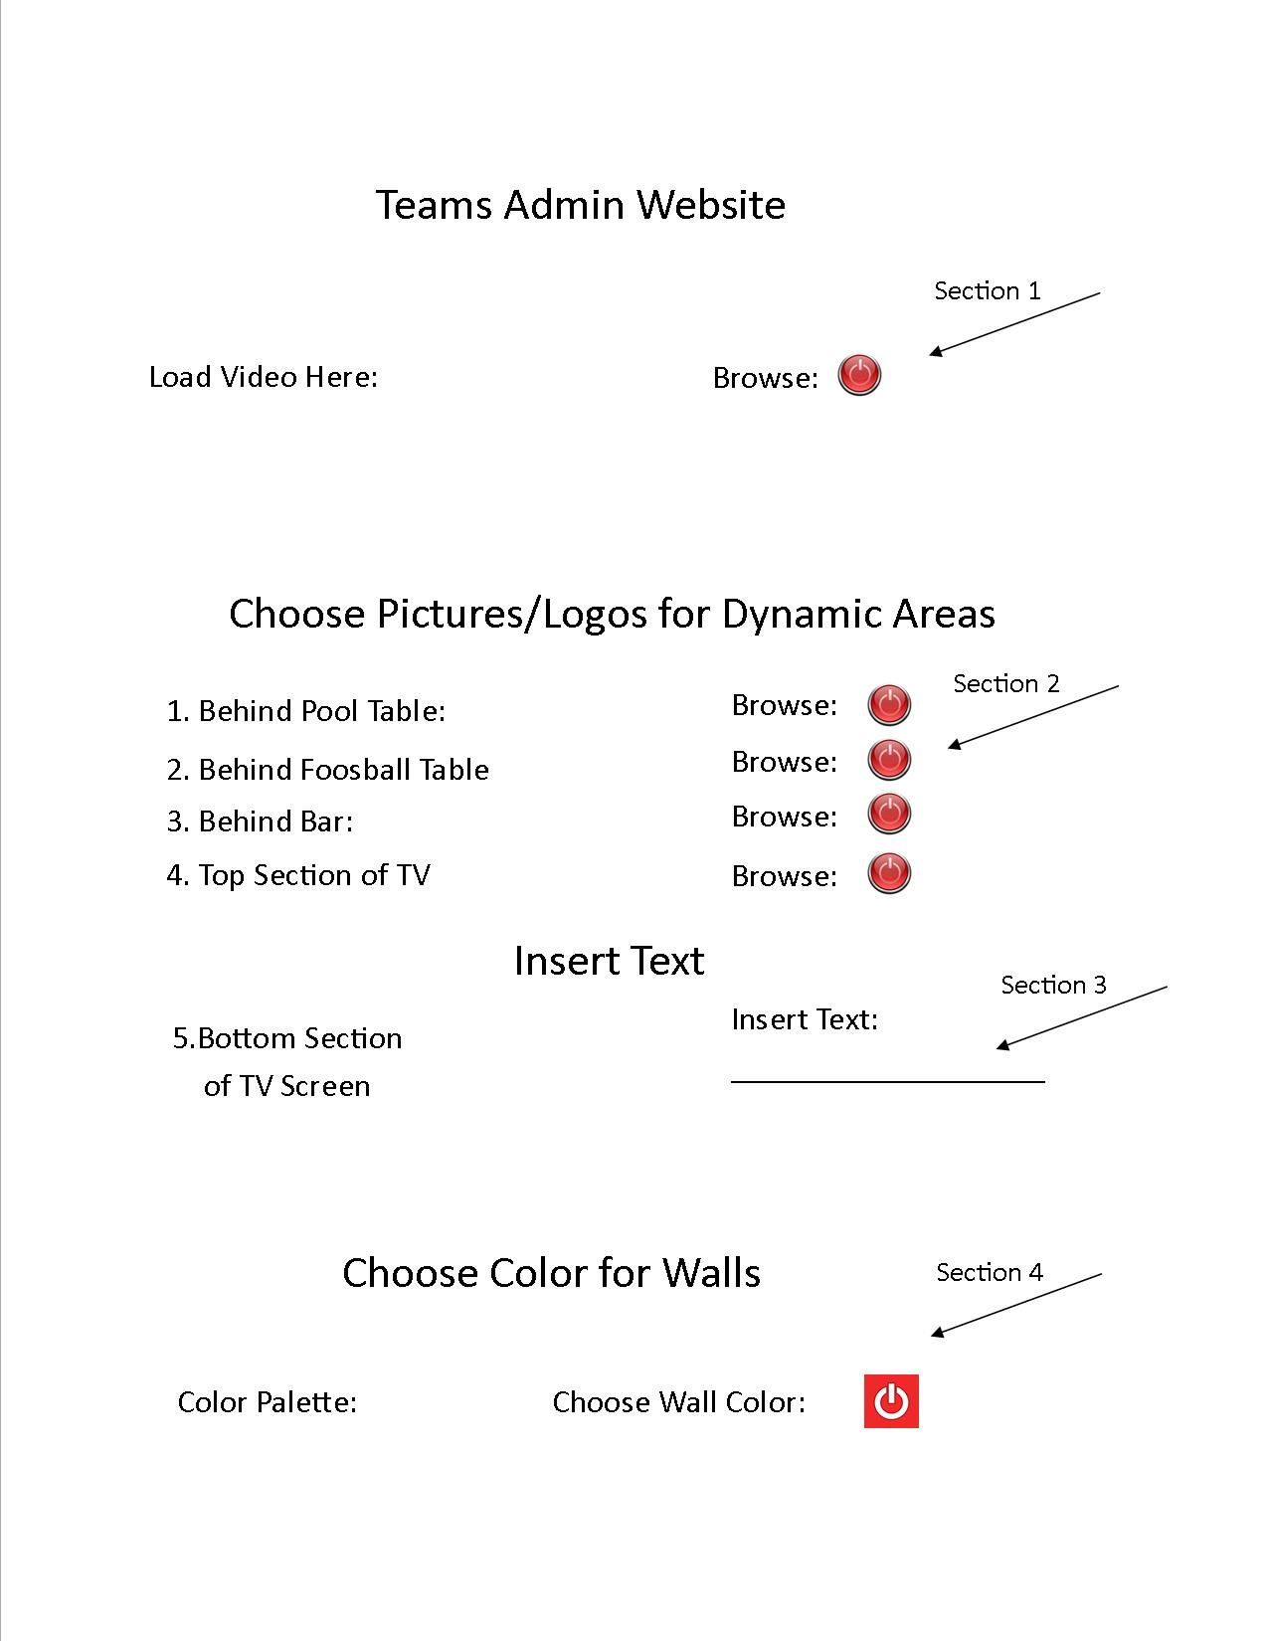
SAMPLE ROOM CONCEPT (Not workable just to give some idea of what a player lounge typically looks like)
