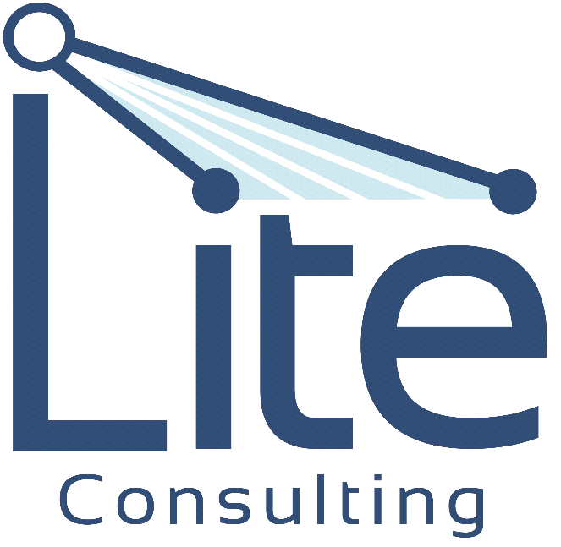

KRIS FRANKLIN
Chief Scientific Officer &
Managing Partner

CELL (732)543-6891
kfranklin@lite-consulting.net

.

-

What we do for you:
Mass Spectrometry: Applications to the Clinical Lab Conference 2016 (MSACL)

Small Sample Volumes Are Small Problems
Kris Franklin

February 24, 2016
Corporate Workshop, 2 p.m.

- Clinical Method development and validation (LC-MS/MS, Immunoassay and others)
- Process Optimization
- Project Planning
- ICP-MS, GC-MS, GC method development for industry
- GAP analysis
- Regulatory Review
- Endogenous Biomarker Quantification
- Quality Management System
- Laboratory Setup

L.I.T.E. Consulting LLC exists to empower clinical, agricultural, petroleum, and forensic laboratories through the use of technology and equipment, so that processes can be leaned out to reduce operating cost without compromising quality. L.I.T.E. Consulting LLC has the technical skill and medical licensure to guide a potential client from collection of sample to collection of revenue.

…shining Lite on today’s Analytical Chemistry

