The Matrix of Toxicology
For the better part of a decade urine toxicology has been a cornerstone of compliance monitoring for pain management groups and addiction treatment centers. Urine testing has been foundational in reducing liability for physicians and ensuring patient compliance. The simplicity of testing urine has been its greatest draw; less expertise is needed in order to implement the laboratory method, and the collection is sometimes seen as less invasive than blood. The simplicity of the analysis is where the advantages end for urinalysis. On top of the known issues with sample tampering – any values quantitated from urine give no “real time” information about drugs or metabolites currently circulating within the patient.
The quantitative values in urine toxicology have little value for the following reasons:
Critical factors that limit the value of quantitative urine toxicology
- Analytes in urine most often exist as glucuronide conjugates. In order to analyze them appropriately – a hydrolysis step is required. The recovery from this step can vary substantially from analyte to analyte.
- Analytes have been extensively metabolized undergoing both phase 1 and phase 2 of metabolism which causes the concentration of the active metabolite to become more convoluted
- Concentration of analytes in urine are measured as ng/mL which means the drug concentration is a function of volume that could fluctuate based on the hydration level of the patient.
Oral fluid toxicology minimizes the risk of adulteration and the impact of glucuronidation. Drugs found in saliva have crossed the mucosal lining and have often not had the impact of extensive metabolism. While this correlates closer to blood than urine toxicology does, the drug concentration in oral fluids is effected by multiple factors. Figure 1 illustrates how differences can impact concentration in oral fluids.
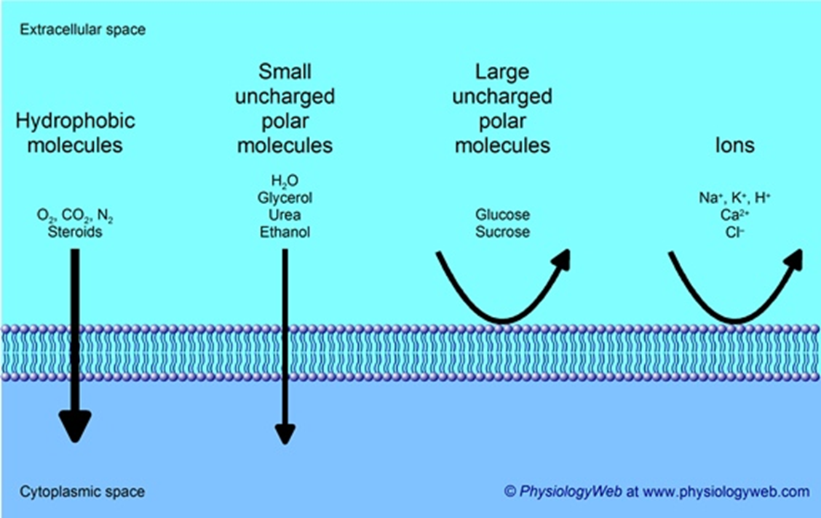
Figure 1We either cite it,make our own - or get sued :(
The following factors cause differences in the concentration of the 2 different matrices:
- Salivary pH
- Chemical properties of the drug
- Drug metabolism (varies by drug class)
- Concentration of unionized drug
- Any drug/protein binding
Quantifying drugs and metabolites in blood has long been the gold standard for understanding the pharmacology and toxicology of drugs. The quantification of analytes in blood is the means to understand drug clearance and circulating levels of active metabolites. This is why certain medications (e.g. anti-seizure, immunosuppressant, etc) are required to be monitored in blood. While blood may be the gold standard – it also has some substantial hurdles. Blood analysis requires a high degree of technical expertise from the method designer. The designer must overcome a truly complex matrix, and a develop a highly sensitive method. On top of this, historically, blood toxicology has required a phlebotomist in order to collect the sample. While those challenges can be formidable; the wealth of information available from blood makes it a worthy prize to improve the care of patients. Sanis Biomedical has developed proprietary methods in order to overcome these hurdles, and to provide the most advanced patient care technology. The Sanis Solution is summarized below.
 | Challenge | Sanis Solution
1 | The need for medical professional to make draw. | Small Volume Blood (SVB) allows for a point of care type collection - similar to oral fluids.
2 | The complexity of the matrix. | Sanis uses the latest in LC-MS/MS technology coupled to robotic sample preparation to ensure clean samples & reproducible results
3 | The need for expanded linear ranges. | Sanis utilizes a technique known as variable resolution tandem mass spectrometry coupled to the strategic use of isotopically labeled internal standards
4 | Shortened time frame of detection. | Sanis has created a comprehensive panel that quantifies parent drug and metabolite with enhanced sensitivity. Enhanced sensitivity results in longer plasma detection windows in terms of compliance

The need for medical professional for a venous draw
The science and technology that Sanis develops reduces the volume of blood required to less than 300 μL of whole blood. This creates the opportunity for a capillary blood draw, instead of a need for a venous puncture. The only requirements for blood, are a minimum volume of 300 μL, and some refrigeration.
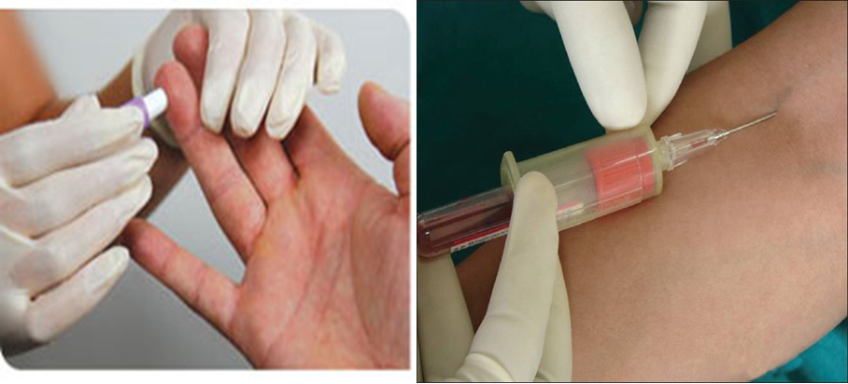
Figure 2Proper Citation need.
Given the relative ease of a capillary puncture, there is no need for an additional medical professional. The puncture may be completed either by the clinician, or by properly trained patients. This pivotal breakthrough allows providers across the board to tap into the benefits of next generation toxicology where quantitated values give insight into patient metabolism, circulating plasma concentrations and steady state concentrations of prescribed medications to determine the best course of treatment.
Complexity of the matrix
Blood is a complicated matrix, that contains a number of compounds that can interfere with analysis. Those compounds are often in much greater concentration than things that are clinically relevant. In order to ensure that samples are properly cleaned and analyzed every time – Sanis Biomedical uses cutting edge laboratory automation and the latest LC-MS/MS technology. Our process not only achieves increased sensitivity, but also reduced run times for analysis, which leads to higher sample capacity.
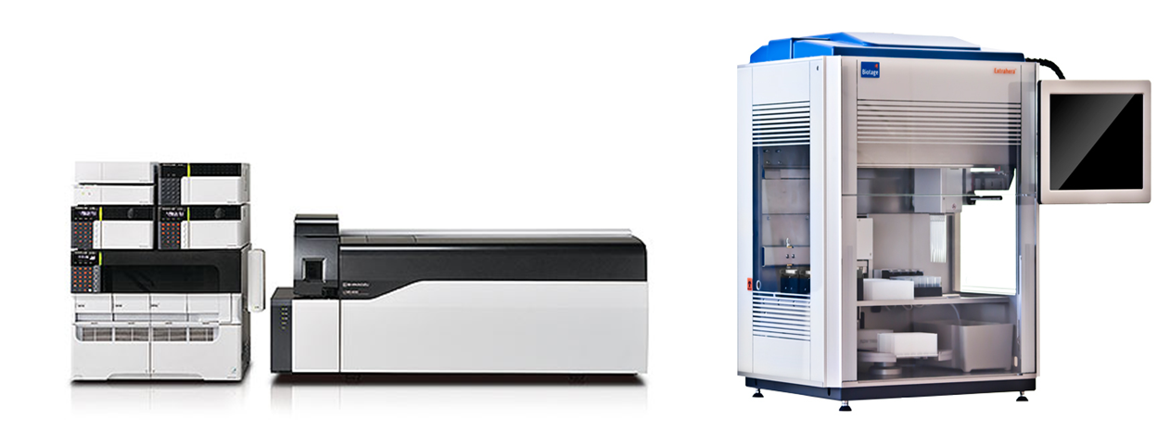

The Need for Expanded Clinical Ranges
Drugs have clinically established therapeutic ranges, that vary substantially from compound to compound. In order to accurately measure a patient’s sample; a set of linear ranges that span the therapeutic window must be established for each drug contained in the panel. Since different drugs can have therapeutic ranges that differ by several orders of magnitude, this increases the expertise needed to create a reproducible method. Sanis Biomedical’s proprietary method covers a diverse series of reportable ranges in a single multiplex method. This increases the confidence in the quantitative value, and creates a new generation of toxicology results grounded in pharmacology and solid science.
Table 2 – A few Examples of Linear Ranges of Compounds within the Panel
 |  | Therapeutic Range | Sanis Biomedical’s Reportable Range
1 | Lamotrigine | 2500 – 15000 ng/ml | 6.25 – 5000 ng/ml
2 | Zolpidem | < 250 ng/ml | 1.5 – 120 ng/ml

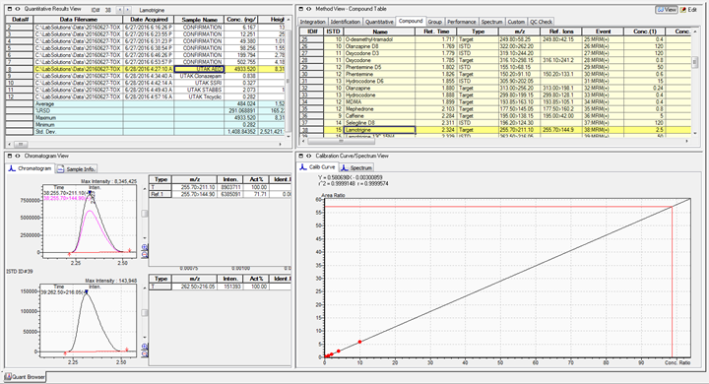
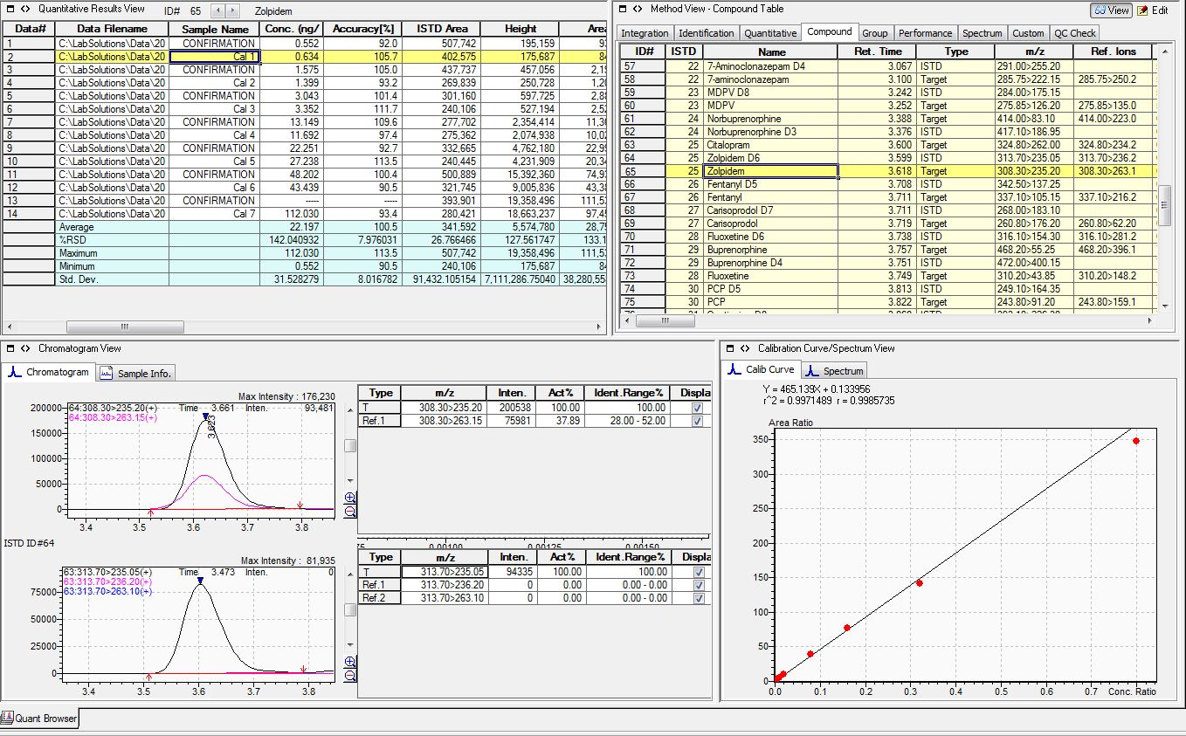

The Shortened Window of detection
One of the criticisms of utilizing blood as a compliance tool is the perception that there is a reduced window to confirm a positive result. The shortened window of detection is only true if a urine method were utilizing the same cutoff concentration as the blood method. Furthermore, the use of active and inactive metabolites of parent drugs allow for patient compliance to be monitored for much longer windows than normal blood toxicology.
Typical prescription regimens require single or multiple doses of controlled substances each day. In the event of therapeutic drug monitoring, blood toxicology can readily demonstrate patient compliance, as well as a window into the patient’s actual dosage regimen. For example, a patient prescribed pain medication may take their prescription more often than their guidelines. This information could allow the clinician to re-evaluate not only the dosage amount and prescription, but may also alert him or her to some other underlying issue (e.g. the patient’s metabolism for the drug may be an allelic variant).
Figure XX: Metabolism of Diazepam
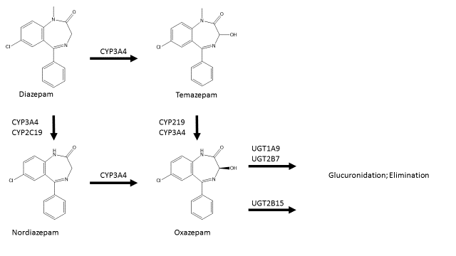
Table XX – Analytes and Lower Limits of Detection:
Name | Lower Limit of Detection (ng/ml) |  | Lower Limit of Detection (ng/ml)
6-MAM | 0.6 | Meprobamate | 0.8
7-aminoclonazepam | 0.6 | Methadone | 0.2
7-hydroxyquetiapine | 0.4 | Methamphetamine | 0.32
Acetaminophen | 2.5 | Methcathinone | 0.4
Alphahydroxyalprazolam | 0.8 | Methylphenidate | 0.2
Alpha-hydroxymidazolam | 0.8 | Morphine | 0.8
Alprazolam | 0.8 | Naloxone | 0.6
Amitriptyline | 0.8 | Norbuprenorphine | 0.8
Amphetamine | 0.8 | Nordiazepam | 0.8
Aripiprazole | 0.8 | Norfentanyl | 0.16
Benzoylecgonine | 0.6 | Norhydrocodone | 0.72
Buprenorphine | 0.6 | Normeperidine | 0.6
Bupropion | 0.6 | Noroxycodone | 0.6
Caffeine | 5 | Nortriptyline | 0.8
Carisoprodol | 1.6 | O-desmethyl-tramadol | 0.4
Citalopram | 0.4 | Olanzapine | 0.24
Clonazepam | 0.5 | Oxazepam | 0.8
Codeine | 1.2 | Oxycodone | 0.8
Cotinine | 0.4 | Oxymorphone | 0.8
Cyclobenzaprine | 0.8 | PCP | 0.32
Desipramine | 0.4 | Phentermine | 0.6
Diazepam | 0.8 | Quetiapine | 0.6
EDDP | 0.2 | Selegiline | 2
Fentanyl | 0.12 | Sertraline | 1.2
Fluoxetine | 1.6 | Tapentadol | 0.12
Hydrocodone | 0.4 | Temazepam | 1
Hydromorphone | 0.8 | Tramadol | 0.16
Imipramine | 0.8 | Zolpidem | 0.6
Lamotrigine | 2.5 | MDPV | 0.4
Lorazepam | 1.6 | Meperidine | 0.6
MDA | 0.72 | Mephedrone | 0.8
MDMA | 0.4
The additional benefits of next generation toxicology utilizing Sanis Technology
- Clinicians now have a clear picture of circulating drug levels as well as additional insight into how drug regimens are affecting their patients. The figure below illustrates the basics of drug disposition within the body. For the first time in clinical practice providers have the ability to see drug distribution and hepatic clearance from a large comprehensive panel of drugs from diverse classes. This allows doctors to make more informed decisions about their patients, and personalize treatment based on their pharmacological profile.

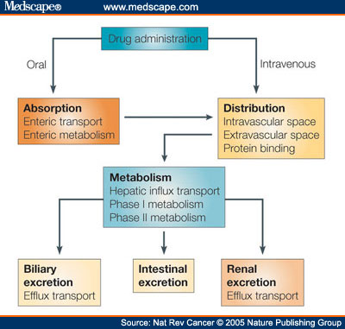
Figure 3Caption, change, or get sued. :(

- Easy monitoring of steady state concentrations for patients on periodic dosing regimens. 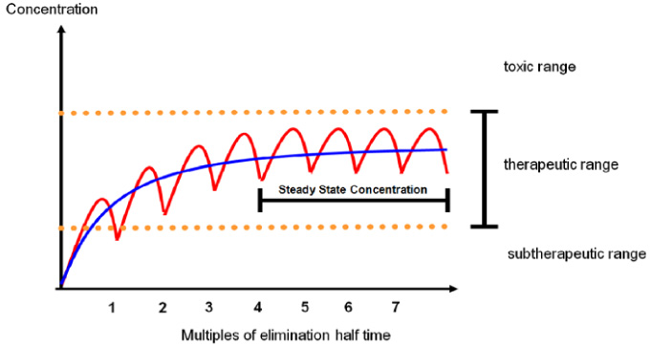
- The quantification of circulating concentrations of both parent and metabolites allows a more in depth review of how that patient is metabolizing the prescribed medication. A very practical example exist with the commonly prescribed opiates containing hydrocodone. Hydrocodone is either metabolized by CYP 3A4 converting Hydrocodone into norhydrocodone which only possesses 1/70th of the activity of hydrocodone at the opioid receptor, or hydrocodone is converted into hydromorphone by CYP 2D6 which is 6x more potent than hydrocodone at the opioid receptor. By quantifying the parent drug along with the metabolites providers now have a glimpse into how that prescription protocol is impacting a patient. The table below outlines the parent drug / metabolite relationship that exist within the next generation toxicology panel created by Sanis Biomedical.
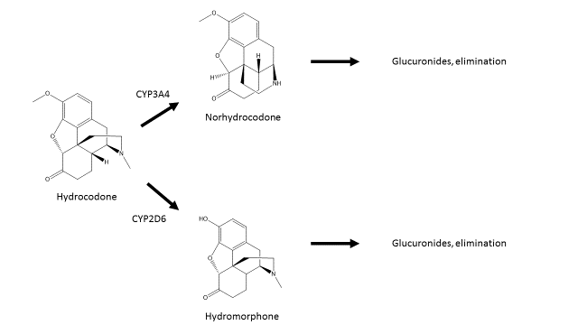
Table XX – List of Parents and Metabolites:
Parent Drug | Metabolite 1 | Metabolite 2 | Metabolite 3
Alprazolam | Alpha-hydroxyalprazolam
Carisoprodol | Meprobamate
Clonazepam | 7-aminoclonazepam
Diazepam | Nordiazepam | Temazepam | Oxazepam
Nordiazepam | Oxazepam
Temazepam | Oxazepam
Buprenorphine | Norbuprenorphine
Codeine | Morphine | Hydromorphone | Hydrocodone
Hydrocodone | Hydromorphone | Norhydrocodone
Fentanyl | Norfentanyl
Meperidine | Normeperidine
Methadone | EDDP
Morphine | Hydromorphone
Oxycodone | Noroxycodone | Oxymorphone
Tramadol | O-desmethyl-tramadol
Amitriptyline | Nortriptyline
Imipramine | Desipramine
Quetiapine | 7-Hydroxyquetiapine
Selegiline | Amphetamine | Methamphetamine
3,4-Methylenedioxymethamphetamine (MDMA) | 3,4-methylenedioxyamphetamine (MDA)
Methamphetamine | Amphetamine

- Most toxicology panels are designed to be limited in scope (e.g. a benzodiazepine panel). Our panel has a diverse pharmacological profile – ranging from opioids and benzodiazepines, to over the counter medication and various illicit substances. This is gives the provider confidence that the medication they are prescribing can be monitored. To insure the prospect of a comprehensive panel Sanis also has many of the most common illicits as well as many of the newer synthetics that have been reported by the news.
- With Sanis Biomedical, uncompromising science is at the heart of everything we do. Our methods adhere to the most stringent requirements of the CLSI guidelines to ensure reproducible accuracy with every result. Our panels undergo extensive validation and establishment protocols that meet or exceed all of the regulatory guidelines.

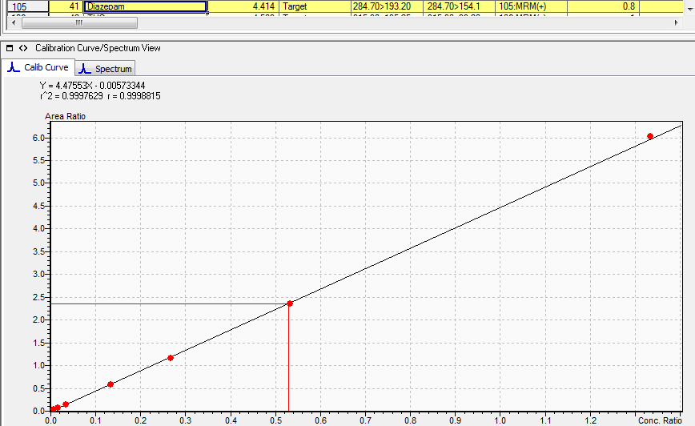
Image 2 – Fluoxetine curve.
