What is SVB Sample Collection?
Small Volume Blood (SVB) for our testing platform is defined as any collection that is less than 0.5 mL of whole blood. By utilizing the latest in tandem mass spectrometry and robotic sample preparation; the total volume needed to generate accurate and reproducible results has been significantly reduced compared to traditional blood testing methodology. With our current technology, the hormone panel only requires 0.15 ml of serum/plasma, and our toxicology panel requires only 0.1 mL of serum/plasma to achieve precise and accurate clinical results. Despite using less sample volume, our method has shown to correlation very well against traditional methods.
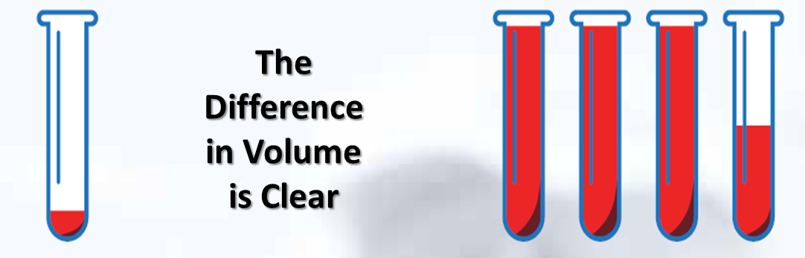

Advantages of SVB collection & testing
The power of being able to use smaller volumes of blood is demonstrated by the ability to utilize different forms of collection. Traditional chemistry requires a venous puncture by a medical professional in order to satisfy the volumes needed. Sanis Biomedical has been able to drive the required volumes down significantly. This minimizes the need for a phlebotomist, or a medical professional to make the collection. The sample can be collected by either a medical assistant, or by a properly trained patient. The SVB difference could allow a patient to collect the sample at specific time of day or from home if needed.
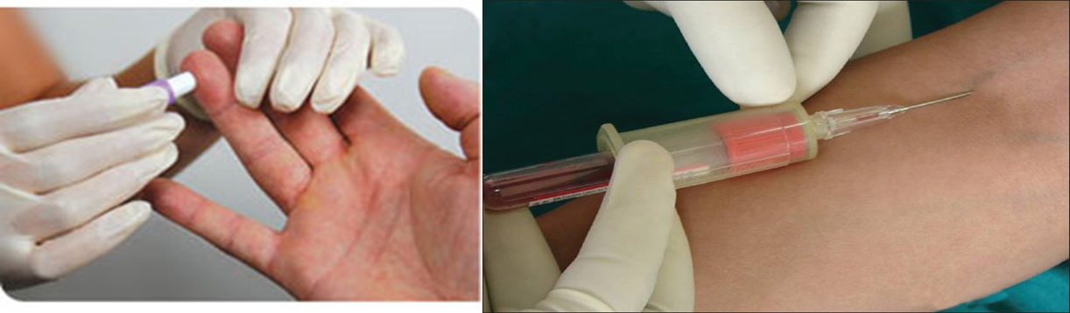

Will the technology work with a traditional blood draw?
The technology requires only a small volume, so the test gives equivalent results from both venous and capillary draws. The graph below represents the correlation between a venous and capillary draw of 20 healthy patients. The X-axis has the results for the vein and the Y-axis for the capillary. The linear correlation and R² value of 0.987 demonstrates both vein and capillary yield comparable results.
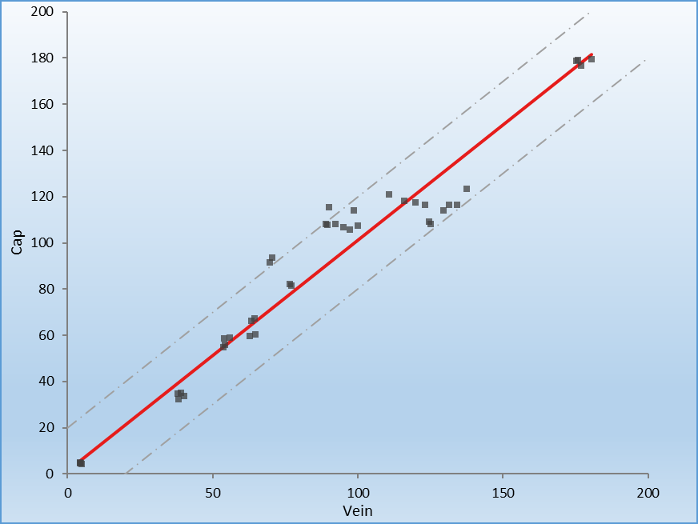

Are the Test accurate?
Sanis Biomedical lab developed test undergo extensive validation, establishment testing, as well as and rigorous peer review. Results are compared to traditional clinical chemistry results, as well as external controls whenever available to insure results are accurate and reproducible every time. Patient samples are tested in a highly complex COLA accredited laboratory.
Figure 1 is a correlation study performed with Mt. Sinai Hospital in Toronto. This compared our method against traditional clinical chemistry. The R² value of 0.995 indicates a 99.5% correlation between Mt. Sinai and Sanis Biomedical for Cortisol. Figure 2 is a graphical representation of the CDC results for testosterone compared to Sanis Biomedical. Notice the high degree of correlation between results. Sanis Biomedical employs rigorous external checks and audits to ensure the accuracy of every clinical result.
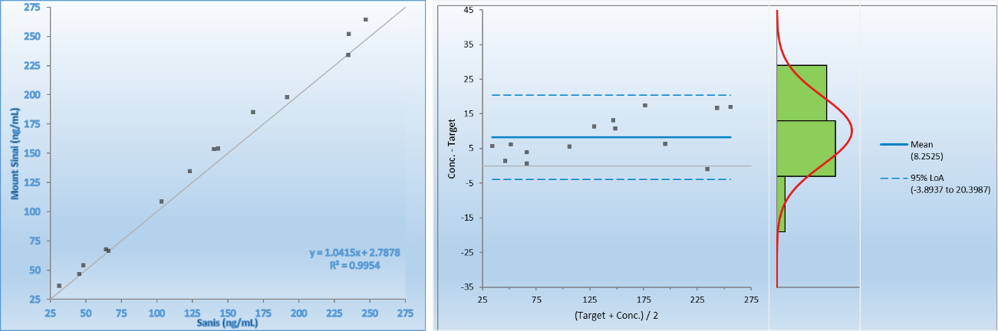
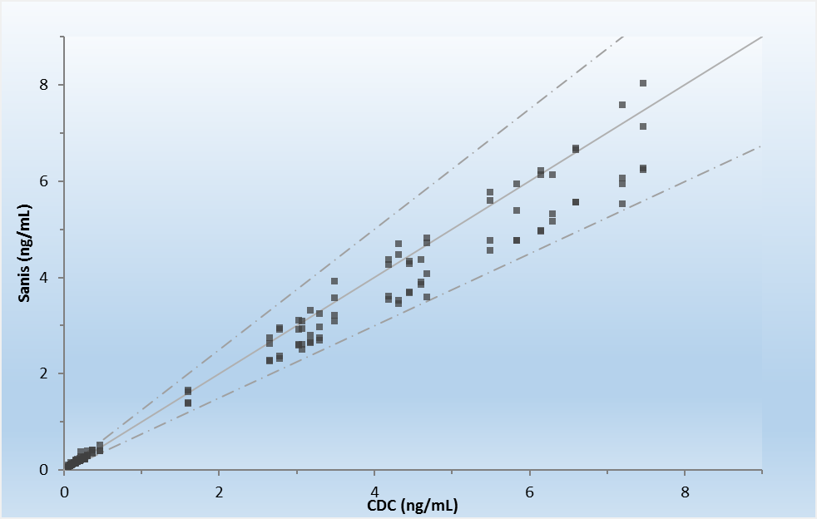
Are the Test accepted by Insurance and Medicare?
All of the tests currently offered by Sanis are reimbursed by Medicare, and the clinical lab is in network with private payers which insures private payer reimbursement. Many of the tests offered by Sanis Biomedical have been a part of clinical chemistry and/or toxicology for years. The scientific advancement only reduces sample volume requirements and allows for easy collection of sample. With “in-network” solutions for this diagnostic test your patients can have peace of mind over receiving the latest in diagnostic care
How long does it take to receive my results?
Results are available electronically or by fax within 72-96 hours of the sample arriving in the lab. Sample collection kits and shipping materials are provided to the office and samples are shipped via FedEx overnight. This means actionable results faster, so that the best care is provided to the patient. A web based requisition and reporting function reduces the turn-around time and facilitates the awesomeness of stuff?

