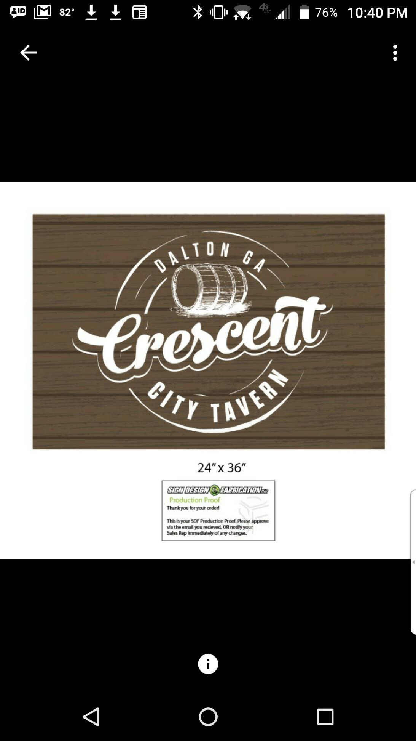
Sports Bar and Grill
Starting Line up
Appetizer Sampler
Choose any 3 starters for 11.95 or choose any 4 for 15.95
Corn nuggets 6.95
Creamy corn and jalapeño mixture battered and fried golden brown
Fried Mac n Cheese bites 6.95
Creamy mac n cheese battered and fried and served with your choice of dipping sauce
Chili cheese fries 6.95
Waffle fries topped with our Crescent City Chili, queso, shredded cheese blend, diced tomatoes, and jalapenos
Loaded Potato Slabs 7.95
Potato slices topped with BBQ pork, cheddar cheese, and green onions served with a side of ranch
Southwest Spring Rolls 8.95
Chicken, black beans, corn, peppers, jalapeños and jack cheese wrapped inside a tortilla and fried golden brown served with a homemade chipotle ranch sauce
Chips and Queso 4.95
Creamy 4 cheese blend topped with diced tomatoes and jalapeños and side of salsa
Mozzarella Triangles 5.95
Mozzarella cheese battered and fried light brown served with marinara for dipping
Tavern Nachos 6.95
Your choice of chicken, steak, or chili on a bed of tortilla chips topped with queso, shredded cheese, shredded lettuce, Pico, and jalapenos
Add chili 2.00
Add chicken 2.00
*Add Steak 3.00
Chicken Tenders 7.95
4 chicken tenders served with your choice of sauce
Cheese Quesadilla 5.95
Flour tortillas stuffed with cheese, onions, tomatoes, and peppers
Add chicken 2.00
Add steak 3.00

Salads and wraps
(Can be ordered as a salad or wrap)
Add chicken 2.00| Add *Steak 3.00
House 5.95
Romaine lettuce topped with cucumbers, tomatoes, onions, cheese and your choice of dressing
Classic Caesar 5.95
A bed of romaine lettuce topped with creamy Caesar dressing, parmesan cheese, and croutons
Buffalo Chicken 7.95
A bed of romaine lettuce topped with buffalo chicken, bleu cheese crumbles, and your choice of ranch or bleu cheese dressing
Dressing: Thousand Island, Italian, Honey Mustard, Blue Cheese, Ranch

Soup
3.95 per cup
5.95 per bowl

Crescent City Chili
Five-bean beef chili served with cheese, sour cream, and crackers
Cheddar and Brew
Creamy beer cheese blend topped with green onions and served with grilled sourdough bread

Sandwiches
All sandwiches are served with the choice of one side
Monte Cristo 7.95
Sliced ham, turkey and Swiss cheese layered between bread slices, battered and deep fried sprinkled with powdered sugar and served with Raspberry Preserves
Chicken Tender Sandwich 7.95
Chicken tenders tossed choice of your sauce and placed on Texas toast with choice of ranch or bleu cheese
Grilled Chicken Sandwich 7.95
Grilled chicken served with cheddar cheese, onion, lettuce, and tomato on Texas toast

*Patty Melt 7.95
Beef patty topped with cheddar cheese and Thousand Island dressing served on toasted sourdough bread
Adult Grilled Cheese 6.95
Four cheese blend stuffed between two buttery slices of Texas toast
*Sweet Hawaiian Sliders (3) 9.95
Mini burgers topped with cheese and served on mini Hawaiian sweet rolls
French Dip 8.95
Thinly sliced roast beef served on a French roll
Fish sandwich 9.95
Your choice of fried, grilled or blackened
All-star Dog 6.95 (add chili and cheese for 1.50)
All beef hot dog served on a bun

Burgers
*Build your own Burger
Single 8.95
Double 11.95
Choose from a single or double patty topped with lettuce, onion, tomato, and pickles.
Add on: jalapenos (.50), bacon (1), fried egg (1), onion rings (1)

Swiss Turkey Burger 9.95
Turkey patty topped with avocado and Swiss cheese and served with lettuce, tomato, onions, and pickles.
*BBQ Cheddar Burger 10.95
Our thick all beef patty topped with BBQ sauce, bacon, cheddar cheese, and crispy onion straws served on a corn dusted bun.

Wings and Tenders
Sauces: Mild, Medium, Hot, BBQ, Lemon Pepper, Teriyaki, Sweet Chili, Hot Sriracha
Chicken Tenders:
4 for 9.95 or 6 for 11.95
Wings:
6 for 6.95
8 for 7.95
12 for 10.95
Served with your choice of side and ranch or bleu cheese.

Sides 2.95
Waffle Fries
Sweet potato Fries
Onion Rings
Chips
Steamed Broccoli
Pasta Salad
Side Salad (+1.00)

Dessert
Key Lime Tart 3.95
Tart and tangy key lime filling inside of a graham cracker crust topped with whipped cream
Brownie a la mode 5.95
Our house made brownie filled with chunks of chocolate, topped with vanilla ice cream, and drizzled with chocolate syrup
Coke Float 3.95
Creamy vanilla ice cream mixed with refreshing Coca Cola. Try it spiked for an upcharge

Drinks
All Soft Drinks and Teas 2.25
Coca Cola, Diet Coke, Coke Zero, Sprite, Dr. Pepper, Root Beer, Lemonade, Mello Yello

