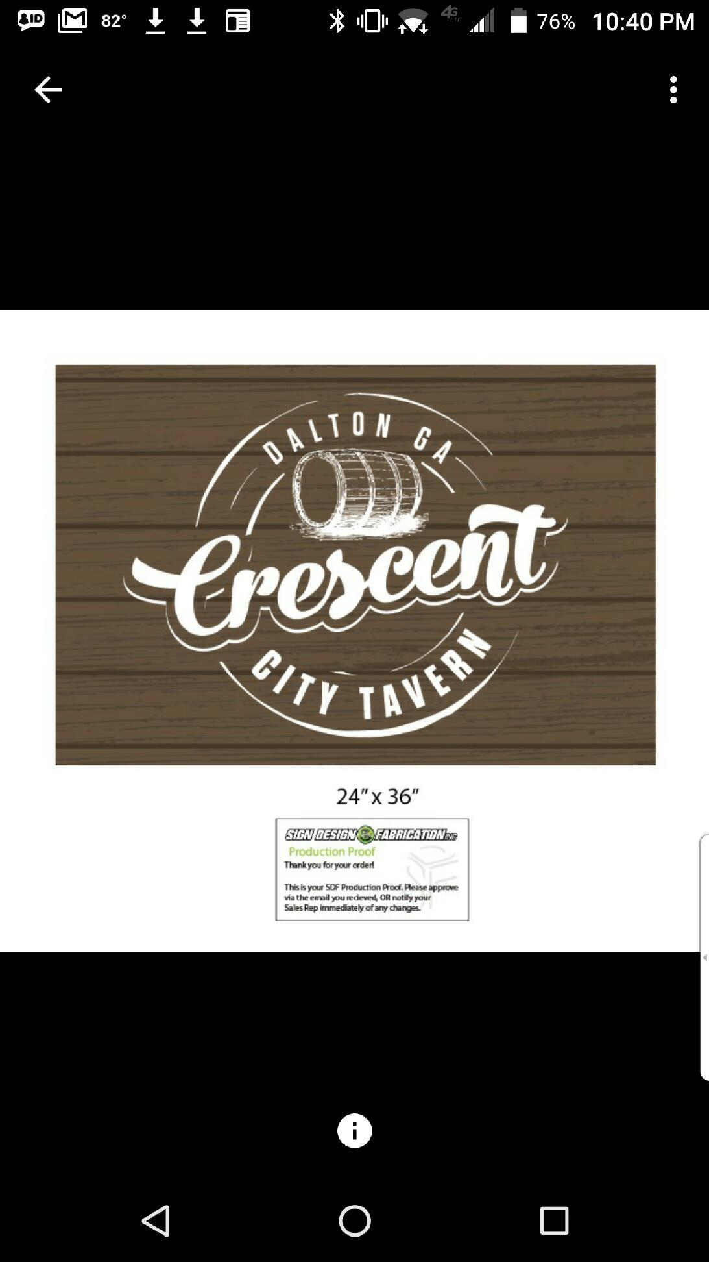
Sports Bar and Grill
Starting Line up
Corn nuggets
Creamy corn mixture battered and fried golden brown
Fried Mac n Cheese bites
Creamy mac n cheese battered and fried and served with your choice of dipping sauce
Chili cheese fries
Your choice of fries or tots topped with Crescent City Chili, queso, shredded cheese blend, diced tomatoes, and jalapenos
Loaded Potato Slabs
Potato slices topped with BBQ pork, cheddar cheese, and green onions served with a side of ranch
Southwest Spring Rolls
Chicken, black beans, corn, peppers, jalapeños and jack cheese wrapped inside a tortilla and fried golden brown served with a homemade chipotle ranch sauce
Fried Oysters
One dozen oysters fried golden brown and served with cocktail sauce
Chips and Queso
Creamy 4 cheese blend topped with diced tomatoes and jalapeños and side of salsa
Tavern Nachos
Your choice of chicken or beef on a bed of tortilla chips topped with queso, shredded cheese, shredded lettuce, Pico, and jalapenos

Salads and wraps
*Can be ordered as a salad or wrap*
Add chicken| Add Steak
House
Romaine lettuce topped with cucumbers, tomatoes, onions, cheese and your choice of dressing
Classic Caesar
A bed of romaine lettuce topped with creamy Caesar dressing, parmesan cheese, and croutons
Buffalo Chicken
A bed of romaine lettuce topped with buffalo chicken, bleu cheese crumbles, and your choice of ranch or bleu cheese dressing

Soup
Crescent City Chili
Five-bean steak chili served with cheese, sour cream, and crackers
Cheddar and Brew
Creamy beer cheese blend topped with green onions and served with grilled sourdough bread

Sandwiches
Monte Cristo
Sliced ham, turkey and Swiss cheese layered between bread slices, battered and deep fried sprinkled with powdered sugar and served with Raspberry Preserves
Chicken Tender
Chicken tenders tossed choice of your sauce and placed on Texas toast with choice of ranch or bleu cheese
Build your own Burger
Choose from a single or double patty topped with lettuce, onion, tomato, and pickles.
Add ons: cheese, jalapenos, bacon, fried egg
Grilled Chicken
Grilled chicken served with cheddar cheese, onion, lettuce, and tomato on Texas toast
Patty Melt
Beef patty topped with cheddar cheese and Thousand Island dressing served on toasted sourdough bread
Four-Cheese Grilled Cheese
Four cheese blends stuffed between two buttery slices of Texas toast
Sweet Hawaiian Sliders
Mini burgers topped with cheese and served on mini Hawaiian sweet rolls
French Dip
Thinly sliced roast beef served on a French roll

Chicken Tenders (fried or grilled)
Tossed or dipped
Sauces: Hot, Medium, Mild, BBQ, Lemon Pepper, Teriyaki, Sweet Chili Sriracha, Hot Honey Mustard
Served with your choice of side and bleu cheese or ranch

Small Plates
Quesadilla
Grilled Chicken Breast

Sides
Tater Tots
Waffle Fries
Steamed Broccoli
Sweet potato Fries
Pasta Salad
Onion Rings
Mexican Corn

Dessert
Key Lime Tart
Tart and tangy key lime filling inside of a graham cracker crust topped with whipped cream
Pecan Tart
Sweet and chewy pecan filling inside of a buttery crust
Brownie a la mode
Our house made brownie filled with chunks of chocolate, topped with vanilla ice cream, and drizzled with chocolate syrup
Coke Float
Creamy vanilla ice cream mixed with refreshing coca cola. Try it spiked for an upcharge

