- Name to incorporate in the logo?

In two parts:

Nitrous

Nitrous Consulting

2) Slogan to incorporate in the logo?

None

3) Description of the organization and its target audience

Nitrous Consulting is a Management Consultancy that helps companies find customers, get them to buy more, and keep them for longer.

Its target audience is Executives in the technology, e-commerce, sport, entertainment, travel and gambling industries, from all over the world.

4) Which type of style you would like to see in logo (ex: web 2.0, corporate, professional, fun...etc)

Professionally engaging – inspired by American sport logos. Need to stand out from a a text-heavy consulting space.

5) Would you like any icon in logo?

N

6) Would you like to share any logo as an example or you liked?

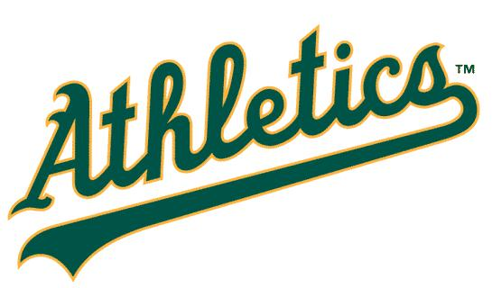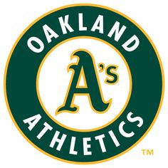

Where ‘Oakland Athletics’ sits in the roundel, I would like to see Nitrous Consulting

7) Do you have any selection in colour?

I have an idea but I need some advice on what works together. I was thinking Maroon for the body and the grey for the outline, but that might not look exciting.

I would also like a version of the round logo that looks like a cattle brand – black and seared, so I can include that on stationary.

