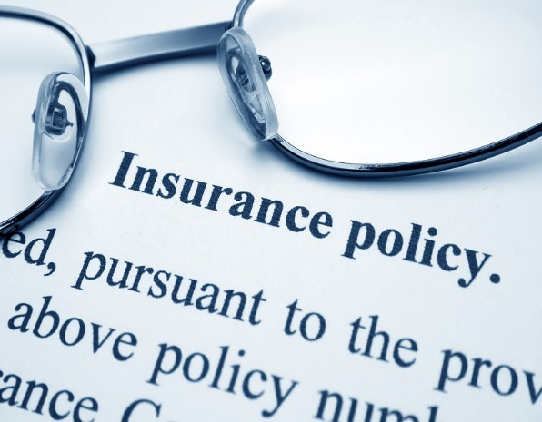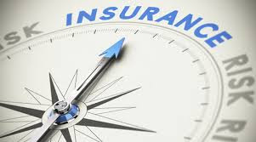

P&C Claim Support Houston Elite Risk Management provides specialized loss investigation, litigation support and consultation services for general liability, workers’ compensation, transportation, construction and other property/casualty claims. Our services include: investigation of third-party and employee accidents involving fatalities or serious injury; managing costs associated with large property damage repairs; system failure analysis; codes and standards compliance analysis; root cause analysis and incident reconstruction; investigation of fire, explosion and other losses; and expert testimony. Houston Elite Risk Management helps clients resolve the most difficult claims.

Environmental Claim Support Houston Elite Risk Management helps insurance companies plan strategies and choose the appropriate course of action for a wide range of environmental claims. Through expert fact-finding and problem-solving skills and extensive environmental claims experience, our staff assists insurance claim professionals in assessing coverage and ultimate exposure, identifying false or exaggerated claims, and settling covered claims equitably and expeditiously. Houston Elite Risk Management’s claim support services include: emergency response, cause & origin/loss investigation, claim oversight, technical audits and invoice review, litigation and settlement support, and expert witness services.

All Lines: Casualty, Bodily Injury, Property, Cat Service, Fires, Auto Liability, Trucking, Cargo, Professional Liability, Environmental, Pre-Trial, Coverage Issues, Workers' Compensation, Homeowners, Inland Marine, Heavy Equipment Appraisals, Auto Physical Damage Appraisals, Motorcycles, Crop and Livestock, Business Interruption, Construction Defects, Burglary, Theft, Mold, Hurricane, Fire, Smoke Wind & Hail, Flood & Water, Mold & Asbestos, Vandalism, Maritime, Aviation, Business Interruptions.

Insurance-Related Risk Control Houston Elite Risk Management provides loss control services to the insurance industry – offering expertise in fleet, general liability, pollution liability, and professional liability, property, and workers ’ compensation lines. We help our insurance clients identify, assess, and eliminate or reduce health, safety, security, property, liability, or environmental risks to enable sound underwriting and to reduce losses. Houston Elite Risk Management consultants work with insurance providers to assess policyholder risks prior to and after binding, provide loss control support during the policy period.

Environmental Liability Risk Assessment Houston Elite Risk Management works with insurance company underwriting and loss control/engineering personnel to provide the technical expertise and data analysis needed to evaluate potential environmental insurance risks – helping them make knowledgeable underwriting decisions and avoiding unnecessary and unforeseen problems. These assignments – ranging from telephone surveys, technical file reviews and onsite surveys. We follow industry best practices to rate risk as well as to provide loss control measures to mitigate identified exposures.

