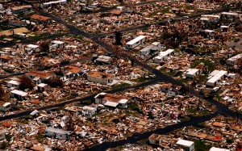
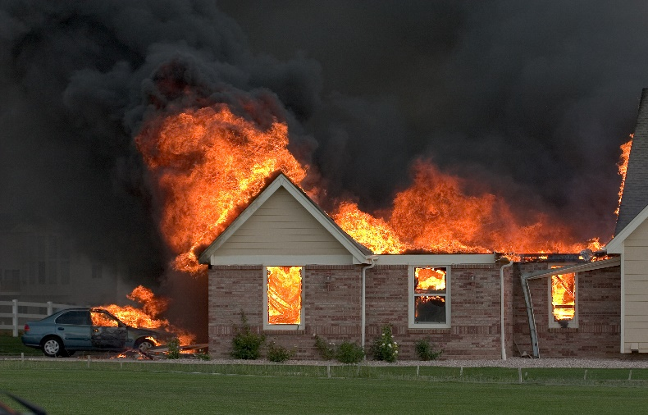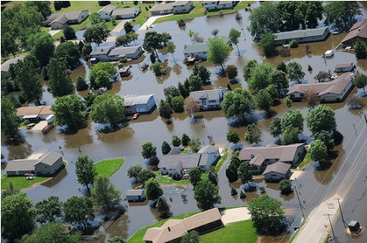
Our Catastrophe Division provides nationwide adjusting services for all types of residential and commercial property damage. Whether your loss results from wind, hail, earthquake, fire or flood – we are committed to the same high standards that you expect from our regular branch operations. Within hours of your initial call, our Response Team can supplement your existing staff.
- 24 hours a day, 7 days a week emergency service
- Catastrophe Claims Management
- Water removal
- Dehumidification and drying
- Odor removal
- Mold remediation
- Pack-out, storage, pack-back

