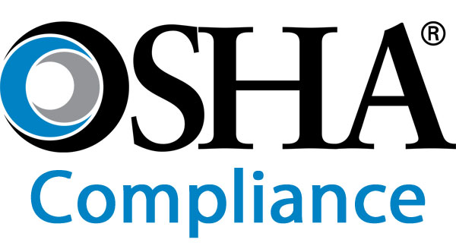

Safety Management Houston Elite Risk Management helps clients achieve peak safety performance. Our staff can assist in obtaining State or Federal OSHA Voluntary Protection Program (VPP) Status – through safety culture surveys involving executives and line employees, facility and organizational audits against best practices, and safety process improvement initiatives. Houston Elite Risk Management can also provide in-house personnel to assist with the implementation of corporate and project-specific health and safety programs.

Fleet Safety Houston Elite Risk Management performs transportation audits and risk assessments of exposures and develops safety procedures and programs to address the exposures. We can analyze existing fleet safety programs against industry best practices and regulatory requirements. In addition, we perform Department of Transportation inspections, audits and risk assessments.

Process Safety Management Houston Elite Risk Management engineers and technical staff have developed comprehensive OSHA Process Safety Management (PSM) programs – to identify and evaluate potential hazards associated with the use of Hazardous Chemicals. These programs identify and implement measures for preventing potential releases or exposure due to process, work practice, maintenance, or equipment failures. Houston Elite Risk Management assists clients with compliance with the PSM Standard. We are skilled at HAZOP studies and, FMEA and What-If programs to ensure operational safety and regulatory compliance.

OSHA Compliance Audits Houston Elite Risk Management EHS consultants assist clients in assessing their facilities for hazards in the workplace and compliance with the wide array of OSHA requirements. In addition to independent third-party audits and site evaluations, we provide cost-effective and technologically feasible solutions for the control of workplace hazards. Houston Elite Risk Management has the experience and technical expertise to help clients reduce the risk of injuries and illnesses in the workplace.

Construction Safety Houston Elite Risk Management consultants understand the liabilities, hazards and exposures of construction. We help clients with incident -free projects – from pre-bid to completion – by designing comprehensive construction safety and risk management programs specific to each project. We can assist in implementing hazard controls as well as identifying safety concerns prior to and during each project phase. Houston Elite Risk Management is experienced and can assist with a variety of construction project types.

Behavior-Based Safety Houston Elite Risk Management consultants work with clients to create behavior-based safety programs tailored to eliminate hazards that may cause accidents and unnecessary risk-taking. Behavior-based safety identifies key at-risk behaviors – objectively measuring those behaviors, providing reinforcing and corrective feedback, and conducting appropriate training. By empowering employee teams to identify solutions and implementing these “best practices”, clients experience improved productivity and higher employee morale – which translates to lower accident frequency and severity, as well as savings in workers’ compensation costs.

