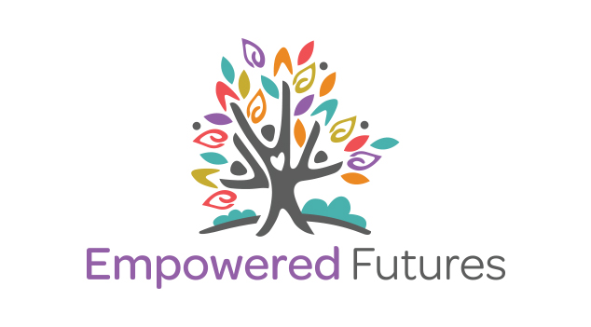

ILLUMINATE
2016 Information Booklet

Hub Locations: 23 Brisbane Rd, Bundamba
8/132 Yallambee Rd, Jindalee
Email: info@empoweredfutures.com.au
Postal Address: PO Box 10, Toowong DC, 4066
Phone: 1300 165 164
Website: www.empoweredfutures.com.au
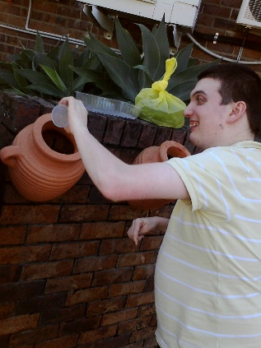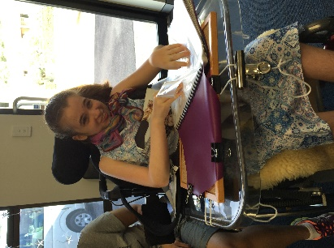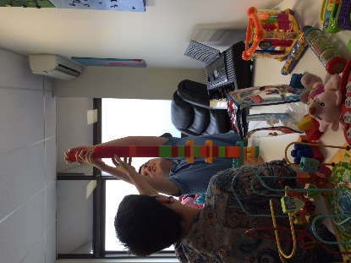
Welcome!
A Snapshot of Empowered Futures
- Family owned and operated
- Personal lived experience of complex disability – we understand!
- Small niche provider – personal service
- Two base Hubs – Bundamba and Jindalee
- Experienced, competent team members
- Multiple wheelchair accessible vehicles so you can get out into the local community!
- Plans and activities are driven by the passions and goals of the person with disability and their family
- Minimal management structure and no bureaucratic guff – you talk with real people who get it.
- We only offer high quality supports
- We are an NDIS compliant service

About Empowered Futures
Empowered Futures offers specialist disability services to individuals and families in order to build capacity and create an empowered future. We specialise in working with people who experience multiple disabilities often accompanied by complex health requirements.

Empowered Futures uses a wide range of tools to help in this discovery process. These tools inform and assist in the development of an individual and holistic Comprehensive Lifestyle Support Plan. Our team will work closely with the individual and their family/supporters ensuring that plans are comprehensive and accurate.

Empowered Futures is the outward expression of the passions of founders and owners Carolyn & Brett Swann. Carolyn & Brett are parents of a child with profound disabilities. As professionals they have a long work history in the community sector with a strong educational background across multiple disciplines. Empowered Futures was registered in 2013.

We specialise in:
- Individually tailored plans
- Strengthening your young person’s community links
- Skills retention and development
- Facilitating your young person to build meaningful relationships
- Complex health needs
- Alternative communication approaches and technologies
- Connecting interests and passions to skills and goals

You can access the services of Empowered Futures using a range of funding. These may include:
- Your Life Your Choice funding
- School Leavers support funding
- Individual Recurrent funding package
- Brokerage funding
- Department managed family support package or fee-for-service funding
- Self-Funded
- Insurance and/or injury settlements
- NDIS funding

Service Model
Due to the complexity of many of the young people we work with, our staff to service user ratio ranges from one-on-one to one-on-two support.

We offer our services in a range of contexts depending on the service and the person we are working with. These range from the following:

- One-on-one support to access mainstream community activities, events, and facilities
- In-home support either one-on-one or for a small group of people based on existing friendships or support clusters
- Centre based activities at our hubs, ranging from one-on-one through to one-on-two support worker ratios
- A combination of all of the above

We do not offer a one size fits all model because it doesn’t work! Instead we work with each individual to develop a unique plan which is based around their goals and passions.

Types of Support
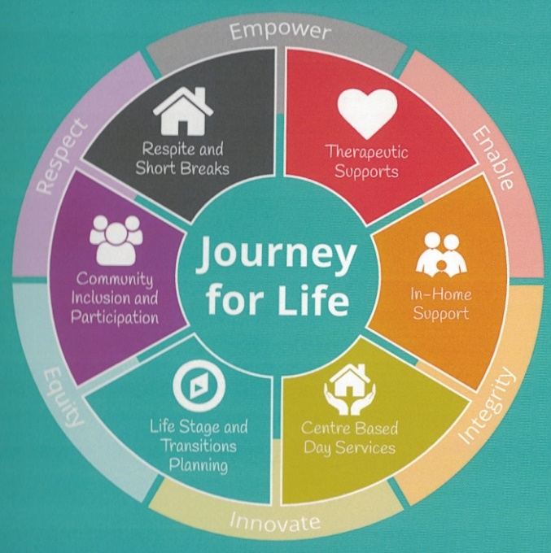
Empowered Futures operates on a ‘journey for life’ model where we recognise that different life stages will call for changing support needs.

Using our case management strategies, we work closely with all of our young people and their families to ensure that we are providing relevant support throughout your ‘journey for life’.

Eligibility
Empowered Futures works with all people with a disability aged 0-65 years and their families and carers. That said, we have specialist skills in working with people who have complex and multiple disabilities aged 0-35 years.

Why we exist
It is our passion to bring about transformation to the way disability services are currently delivered. For over twenty years we have observed and experienced the commercialisation and commodification of disability care. We have felt first-hand the frustration of service limitations and provider’s supports driven solely by funding.
- We believe that there must be a better way and are committed to exploring it

- We are committed to travelling with families to find creative solutions to everyday challenges

- We are committed to empowering families to triumph over the ‘disability system’ which rather than provide the necessary supports more often appears to be a blockage or source of frustration

Our Core Values
ENABLE – We exist to enable and facilitate young people and their families to receive high quality services. We can act as the conduit which can connect you to the right person at the right time so that small challenges don’t become big barriers. If we can’t provide the service we’re not afraid to link you with someone else who knows more about your area of need then we do.

EMPOWER – We seek to empower young people and their families to have maximum control and optimal choice about the future. We want the best for your future and will plan and work with you to achieve it.

INNOVATE – We want to excel at finding new and different ways to approach problems and help you achieve your goals. We won’t settle for simply doing things the conventional way but will look for better and more effective solutions and approaches to the challenges you face.

INTEGRITY – We are committed to the highest levels of personal and professional integrity. We will be honest - living our lives in a genuine and authentic way. We will act with openness, transparency and accountability which will allow us to build strong relationships built on trust.

EQUITY – We believe in fairness for all – irrespective of your ability or social status. We will not allow our personal feelings to bias our decisions and believe everyone should get a fair go. We’re prepared to take on challenges and deal with difficult situations even if unpopular.

RESPECT – We seek to show respect for the worth of every human – honouring and celebrating each individual’s uniqueness and showing ultimate regard for their dignity in all of our actions.

Service Agreement
Once you choose to engage services from Empowered Futures you will receive a service agreement. This document is used to ensure that all parties are fully informed regarding:
- support expectations
- fees & charges
- key milestones
- obligations and responsibilities
- any other relevant information which assists to clearly communicate what is needed to ensure your young person successfully achieves their life goals.
Fees & Charges
We have been guided by the NDIS recommendations with regards to the setting of fees and charges. Once supports have been agreed upon a service agreement will be entered into between Empowered Futures and the person receiving support or their guardian. In the event that additional fees and charges apply your permission will be sought prior to any expenditure occurring.

Fee-For-Service Rates (Effective - 1st August 2016)
All rates include wages, super, payroll tax, insurances and administration costs and are GST “Exclusive”
Type of Support Provided | Description | Staff Ratio | Mon – Fri  6am - 8pm | Saturday  6am - 8pm | Expenses
Community Access Support  Or  In-home respite | These rates do not include any travel allowances (see details below). Please refer to the cancellation conditions outlined below. These prices are based on the current NDIS price list and subject to change. | 1 on 1 | $45.17 | $62.66 | At cost
Community Access Support  Or  In-home respite |  | 1 on 2 | $28.47 | $39.51 | At cost
Coordination of supports | This category may include preparation of case plans, comprehensive lifestyle supports plans, coordination of therapy services or equipment purchases | 1 on 1 | $92.27

Cancellation of Bookings:
In accordance with the Modern Award MA000100 Clause 25.5 (d) (i) shifts require 7 days’ notice for all changes. In the event that 7 days’ notice has not been provided the shift shall be rescheduled to an alternative time but not cancelled.

OTHER INFORMATION | RATE
Mileage when a staff member’s private vehicle is used | 78 cents per kilometer
There is no charge for the use of Empowered Futures’ motor vehicles during the course of regular community access activities. If charges are to be incurred permission will be sought prior to the conducting of the activity. | No charge
There is no charge for the use of Empowered Futures’ day facilities | No charge
All entrance charges are invoiced on a cost recovery basis and permission is sought prior to the activity or excursion | At cost
All in-home support shifts are a minimum of 2 hours’ duration

Our Team
Our team provide a high level of support and facilitation to everyone we provide services to. Every effort is made to ensure that we know our young people well and that we have considered their unique requirements.
The development of your young person’s Comprehensive Lifestyle Support Plan ensures the highest levels of person centred care is provided. We commit to reviewing these plans at least annually or as significant changes occur.

Our staff are both experienced and trained professionals. Empowered Futures is strongly committed to ensuring that our care is of the highest quality. Typical training and skills you can expect from our staff are:
- Seizure management and emergency medication administration
- Safe lifting and manual handling
- PEG feeding
- Bowel management
- Person centred planning
- Personal Care
- Working with children blue cards & criminal history screening checks

Options and Opportunities in 2016 – some of the things our young people have done!
- Formed our own Bronco’s Fan Club, regularly attending training sessions at Red Hill
- Regularly participated/played with the animals at the Ipswich Animal Welfare League
- Visited and interacted with parks and gardens and then planned, planted and tended our own gardens
- Ball games, BBQ’s and picnics at the park
- Food experimentation and tasting sessions
- Painting, drawing and colour exploration
- Exploring passions and interests at the mega shopping centre (Indro)
- Connecting with the local men’s Shed
- Enabling young people to research, select and borrow books from the local library
- Planning, exploring and purchasing from Bunnings and building small projects
- Learning successful personal hygiene routines
- Skills in using switches to access alternative technologies allowing independent action
- Improving young people’s proficiency in communicating with others eg. PODD books, Eyegaze technology, keyword signing and language development.

