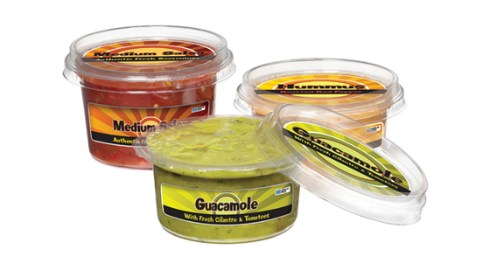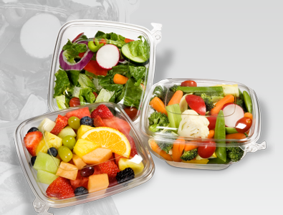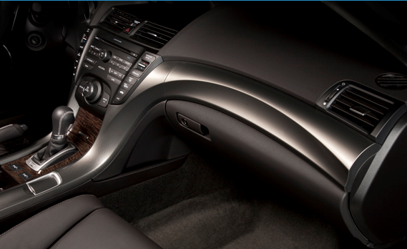
Display Pack is coming to Cedar Springs and we’re bringing 220 jobs with us!
We are a family owned company opened in 1967 that has outgrown our Grand Rapids facility. We have purchased the building currently housing Wolverine World Wide. We expect to start moving equipment to the new location in November.

Our product line includes packaging for a number of industries including: food, cell phone accessories, hardware, sporting goods, automotive, health, beauty and household products.
We also produce decorative parts for the interior of automobiles including trim for the dash, doors and center console.
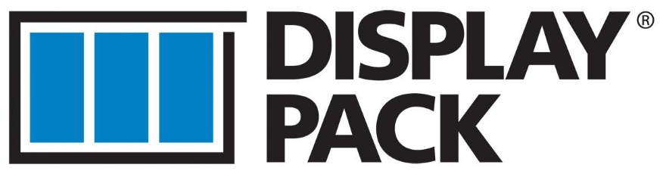
Some positions we hire for:

Mold and Die Makers
Thermoforming Technicians
Warehouse
Packers
Quality
Plastics Engineers
Packaging Engineers
Trimming Inspectors

We offer:
Competitive wages
Benefits
Paid Vacation
Paid Personal Time
401k Plan

To apply for a position, send your resume to jobs@displaypack.com or 1340 Monroe Ave. NW Grand Rapids, MI 49534 or stop in to our Monroe location between 8:00 am and 4:30 pm to fill out an application.
www.displaypack.com
616 574-6184

