Bamboo  Skin Polish  Exfoliating Scrub  60ml / 2 fl oz  Chi  FUSION | Use weekly for smooth skin & clean pores. polish it all away with Bamboo Skin Polish.  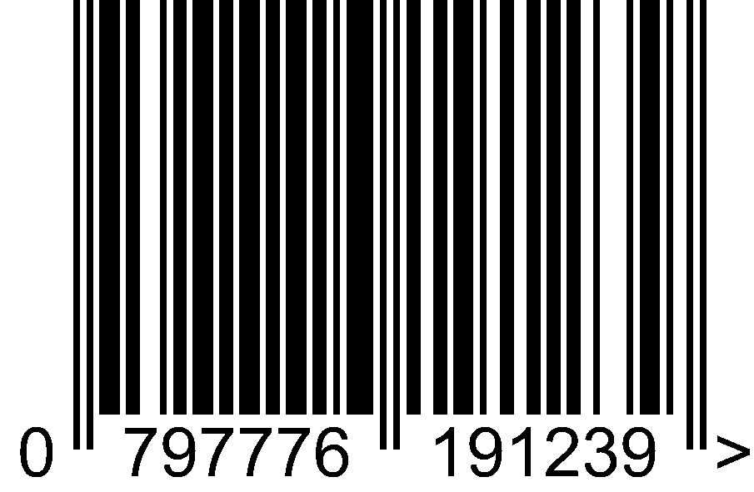
  Directions:  - Cleanse  - Spritz  - Serum Solution  - Eye Cream  - Moisturise  - Exfoliate  - BB Cream | Ingredients:  Aloe Vera, Safflower Oil, Steric Acid,Cetyl Alcohol, Ground Bamboo, Extracts of Chamomile, Cucumber, Calendula, & Rosemary, Allantoin, Sodium PCA, Bromelain & Papain Enzymes, Lecithin, Guar Gum, Iron Oxide, Corundum Powder, Mango Butter, Natural Minerals, Xanthan Gum, Potassium Sorbate, Sodium Benzoate, Citric Acid
  External use only  Avoid contact with eyes  Discontinue if irritation occurs. | Free of Parabens, SLS, Petroleum, Artificial Colours and Fragrances Cruelty free.
  Owned and distributed by:  Chi Para-Medical Aesthetics TM PTY LTD  67 Greenhill Road Wayville SA 5034  AUSTRALIA  www.chiaustralia.com | 

