Green Tea  Cleanser  Normal to Oily  120ml / 4 fl oz  Chi  FUSION | A gentle cleansing gel formulated with the anti-oxidant and anti-bacterial properties of Green Tea.  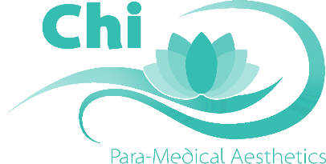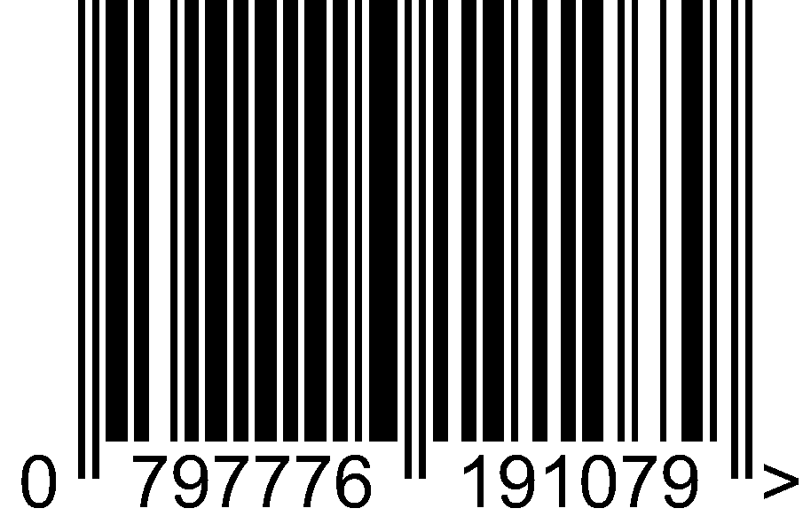
  Directions:  - Cleanse  - Spritz  - Serum Solution  - Eye Cream  - Moisturise  - Exfoliation  - BB Cream | Ingredients:  Pure Water, Ammonium Lauryl Sulfate (derived from coconut), Disodium Cocoamphodiactate, Green Tea Extract, Aloe Barbadensis Gel, Allantoin, Panthenol, Polysorbate 20, Orange Extract, Kiwi Extract, Chamomile, Grape Seed Extract, Tocopheryl Acetate, White Oak Bark, Potassium Sorbate, Chloroxylenol, Yucca Extract, Magnesium Ascorbyl Phosphate
  External use only  Avoid contact with eyes  Discontinue use if irritation occurs. | Free of Parabens, SLS, Petroleum, Artificial Colours, and Fragrances Cruelty free.
  Owned and distributed by:  Chi Para-Medical Aesthetics TM PTY LTD  67 Greenhill Road Wayville SA 5034  AUSTRALIA  www.chiaustralia.com | 
Floral Oil  Cleanser  Normal to Dry  120ml / 4 fl oz  Chi  FUSION | A nourishing oil cleanser formulated with the protective antioxidant effects of Grape Seed oil, Vitamin E and Algae Extract.  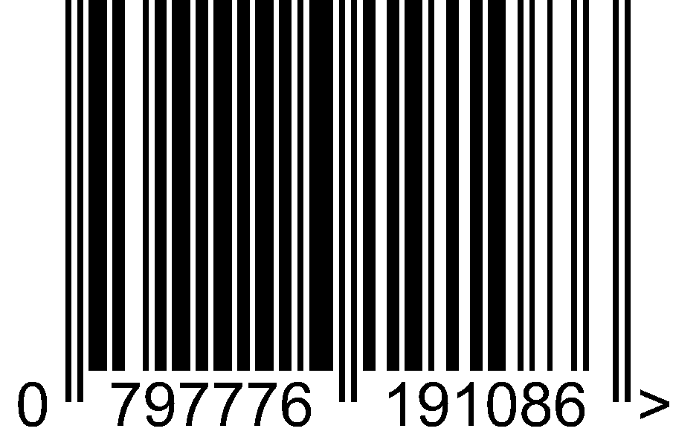
  Directions:  - Cleanse  - Spritz  - Serum Solution  - Eye Cream  - Moisturise  - Exfoliation  - BB Cream | Ingredients:  Caprylic/Capric Triglyceride,  Dicaprylyl Carbonate,  Peg-8 Glycery, Isostearate,  Grape Seed Oil,  Alpha-tocopherol,  Algae Extract,  Lavender Essential oil,  Ylang Ylang Essential Oil,  Bergamot Essential Oil
  External use only  Avoid contact with eyes  Discontinue use if irritation occurs. | Free of Parabens, SLS, Petroleum, Artificial Colours and Fragrances Cruelty free.
  Owned and distributed by:
  Chi Para-Medical Aesthetics TM PTY LTD
  67 Greenhill Road Wayville SA 5034
  AUSTRALIA
  www.chiaustralia.com

