Tax Services

We prepare tax returns ranging from the simplest individual return to the most complex business.
- Individuals, partnerships, companies, trusts and SMSF’s
Including:
- Rental properties
- Capital Gains Tax
- Share Portfolios
- GST, BAS and IAS
- Deceased estates
- Tax Planning
- ATO communications
Own your own business?
We understand running a business is hard work. Let us work with you to help improve your business performance.
- New business start up
- Purchase and sale of business
- Asset protection
- Succession planning
- Purchase and sale of property
- Budgeting and benchmarking
- Cloud accounting software



Have you reviewed your loan lately?

We provide our clients with a FREE annual review of their existing commercial and residential loan portfolio and can assist our clients in obtaining new loans.
- Free annual loan portfolio review
- Selection of 25 residential lenders
- Selection of 8 commercial lenders
- Secure competitive rates available in the market

Simply give us a call and we will handle the rest.

Take control of your Super
SMSF's are a fast growing vehicle for investment, accounting for approximately one third of all superannuation assets with more than 6,500 funds being setup per quarter.

The SMSF structure enables members to have the flexibility to CONTROL their investment strategy to suit their personal circumstances.
- SMSF Establishment/Rollover
- Compliance obligations
- Consultancy and strategic advice
- Retirement strategies
- Estate planning
Speak to one of our consultants about our SMSF services.

Contact Us

A 930 Port Road
Woodville West SA 5011
P (08) 8244 5660
E admin@hooper-co.com.au
W hooper-co.com.au

Location Map
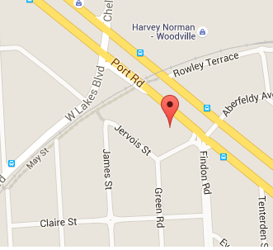


HOOPER & CO
Our Origins
The firm's origins were established in 1994 when Jonathan Hooper commenced public practice in Glenelg. In 2006, the firm relocated to Woodville West as the client base grew.
At Hooper & Co, we understand that the world is constantly changing, however when it comes to values we believe some things should never change.

Values such as trust, integrity and confidentiality are as fundamental to us in our business relationships as they are in our everyday lives.
Client Testimonials
We have been a client of Hooper & Co for twenty years and are very happy with their services. Hooper & Co has been the perfect accounting firm for all our accounting needs, business advice and support. Jon and his team place customer satisfaction at the top of their agenda and back it up with all of the knowledge you could ever need. Any enquiry or concern is swiftly dealt with and the support is second to none.
Over the years Hooper & Co have been an important and stable part of our company and we will enjoy using their services in the future.
Frank, Builder, Gawler
Our newsagency was fortunate to be a client of Hooper & Co for over 20 years. We received amazing supported by Jon and his team during a particularly difficult personal time, the sale of our family business. When the sale was complete, considering all the time we were afforded, we were amazed at the very small amount we had to pay for their amazing support.
Marianne, Glenelg

- Accounting and Taxation
- Mortgage and Finance
- Self Managed Super Funds

Contact us today to book a free appointment to discuss how we can assist you



Principal: Jonathan Hooper

