I’d like your help designing a big banner, about 6-8ft wide and 7 ft. tall for a trade show display.
I need a banner (face and two narrow end caps) and a one-page website (for now).
On the next page is something I threw together for discussion purposes. It is more mechanically correct vs. stylish. I just tried a few things with some earlier components, but feel free to get creative and start from scratch if you think necessary!
For instance, the two dashboard images should probably be placed on images that show a desktop/laptop and iPad/tablet and iPhone to emphasize that it is platform independent.
Some of the text may change, but I just grabbed some existing elements from an old banner.
I would entertain a logo change, unless you think what we have is fine. I like the idea of indicating some ‘extraction action’.
This is primary to be seen by consultants and office managers who are age 35-55 and 85% female.
I am fine if the end caps just show just large web address www.dentametrix.com.
We need to have banner finished to send to a banner company no later than 8/31. Sooner would be better, of course.
I can get print specs for you later.
Rick Willeford, CPA
Example of facing panel and end caps.
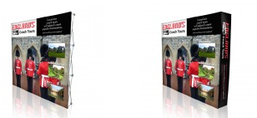

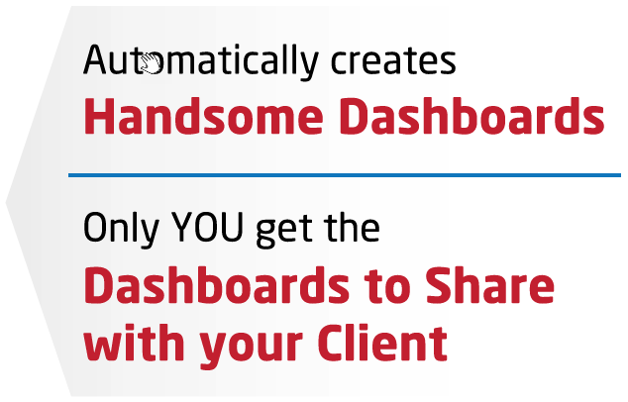
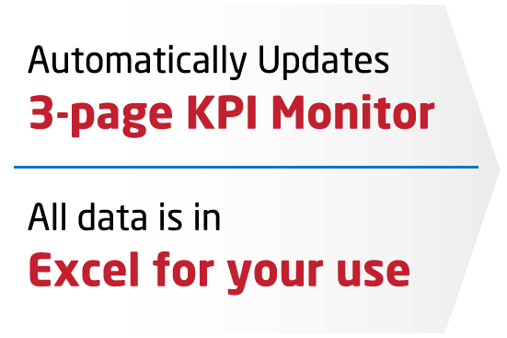
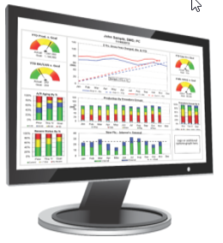
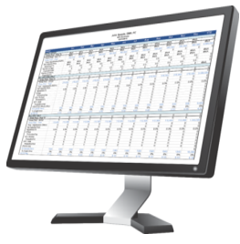



www.dentametrix.com
Unlock the Secrets and Plug the Profit Leaks
With Actionable Business Intelligence

