

1032 Morrell Avenue
Connellsville, PA 15425
(724) 628-7930
(724) 628-7984 fax
jaredquinn.com
quotemejared.com
jaredquinn@allstate.com
August 10, 2015
«First_Name» «Last_Name»
«Street_Address»
«City», «State» «Zip»
Dear «First_Name»,
Congratulations «First_Name»!!! You and your family will be SAFER AND WEALTHIER just by reading this letter….
Really, by the end of this letter «First_Name», I will show you how your family will be better protected AND richer simply by reading this letter. First let me introduce myself. My name is Jared Quinn, and I run the best insurance agency around. That’s right…. In fact I will show you how my clients are better protected by the service we offer. A service so nice that I have clients that have chosen to pay hundreds of dollars more per year to stay with me rather than switching to rival companies that could save them money.….
My insurance agency is different... And the difference will better protect you!
You see «First_Name», I never intended to be an insurance agent. I am an attorney and have been for over ten years. In fact, if you told me five years ago I would be selling insurance today, I would have absolutely told you that you are crazy and I never would have believed you.
But I came to see that my legal clients were being advised about their insurance needs by “insurance professionals” who often weren’t in the same state and don’t even have to have a high school degree in order to be licensed in insurance. The more I thought about it, the more I felt that my backround could really provice a service and better protect my clients with their insurance needs. Besides, one main reason you get insurance is to protect you and your family from being sued…. Who better can really advise you of your needs than a professional who can sue someone and has defended lawsuits.?
Here is the funny thing….. «First_Name» you can get the best insurance protection around AND save money….. at the same time!!!
«First_Name», here is the funny about insurance, rates vary by company and they effect everyone differently. You see when a new rating plan came out for the largest company I represent, I noticed that it was giving better rates to certain segments of the population. So rather than run commercials, newspaper ads or internet advertising, I have decided to target the segments of the population that this rating plan tends to really favor.
To put it another way, I really think that I can save you money…. No I REALLY think I can save you money. «First_Name», I am not blanketing this offer all over «City». I have used software to gather certain homeowners that almost certainly will save money from our services. In fact, I am so sure, that I am including a guarantee…. I will save you $307 per year or I will send you $20 for wasting your time. That’s right….
I Guarantee to SAVE YOU OR SEND YOU MONEY…. PERIOD
The guarantee really is that simple. There is only one condition, you have to qualify for home and auto insurance. That’s it… that’s the list. If I can’t save you $307 per year off of your home and auto insurance then I will send you a $20 gift card to sheetz or walmart for wasting your time.
That’s right… I am so confident that I can save you money that I am willing to put my own money where my mouth is.
However, your family will be safer as well….
«First_Name», I am a realist. Most people in your position are going to switch to my agency simply because I save them money. But the best part of this offer is that simply by talking the trusted advisors in my office your family will be safer. Often, many people we talk to have never really thought about their insurance and what their limits should be. Either myself or my trusted advisors Ben or Mike will discuss all of your different coverages and show you which ones will better protect your family. Even if we can’t save you money, you will have a better understanding of what to look for and you will be able to take that information back to your insurance carrier and better protect your family.
Don’t wait, our office is not running this promotion forever….
Like all good things in life, this promotion will not last forever. We are only running this guarantee until the end of August, 2015. Take this opportunity while it lasts. To make it easier on you, there are a 5 different ways to get in contact with us. The easiest way is quotemejared.com. I have simplified this site to just the bare essentials that Myself, Ben or Mike will need in order to get your quote (we did send you this letter after all, «First_Name», So we do have some of your information!). Another way is to go to my Allstate website via jaredquinn.com. Here you can run a quote yourself if you so choose. The third way you can get a hold of us is with this mailing. On the back of the flyer included with this mailing is a basic form that you can use to send us your information through the mail. We have provided a return envelope for your convenience. The last two ways of contact are the email and phone number on this letter (jaredquinn@allstate.com or (724) 628-7930)).
Sincerely
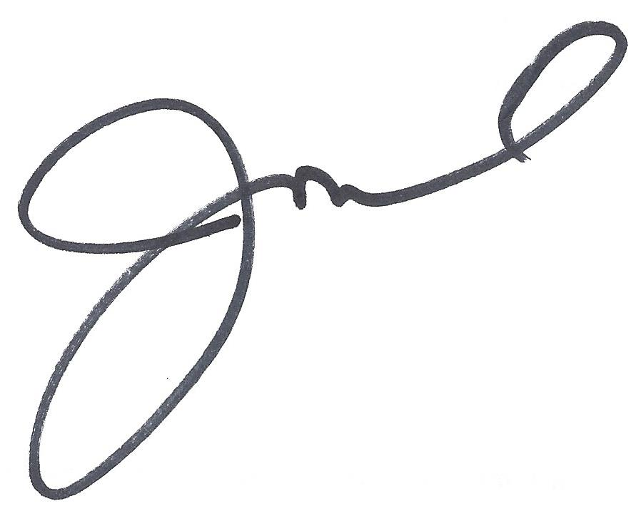
Jared Quinn

P.S. – Bring this letter and flyer into our office to discuss your insurance and you will get a $10 gift card just for coming to do it in person!

P.P.S.- The easiest way to get a hold of us is www.quotemejared.com!!!

Quick Quote Form

Dear «First_Name»,

We have your address as: «Street_Address», «City» «State» «Zip»

If your physical address matches your mailing address, simply fill out all drivers names, birth dates and cars below. If you have a different physical address please give us the correct address on the blank side of this form.

Please provide the following information

Drivers Names Date of Birth Year/Make/Model of Car

- _______________________________________________________________________________________________________
- _______________________________________________________________________________________________________
- _______________________________________________________________________________________________________
- _______________________________________________________________________________________________________
- _______________________________________________________________________________________________________
Best Contact Information for you «First_Name»
Phone ________________________________________ Email _______________________________________________
Please sign below to show we have your permission to run the quote.

________________________________________________________________

Please return this form in the self addressed envelope provided. We will contact you promptly when we receive it. We look forward to working with you «First_Name»! Thank You

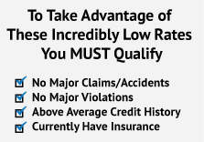
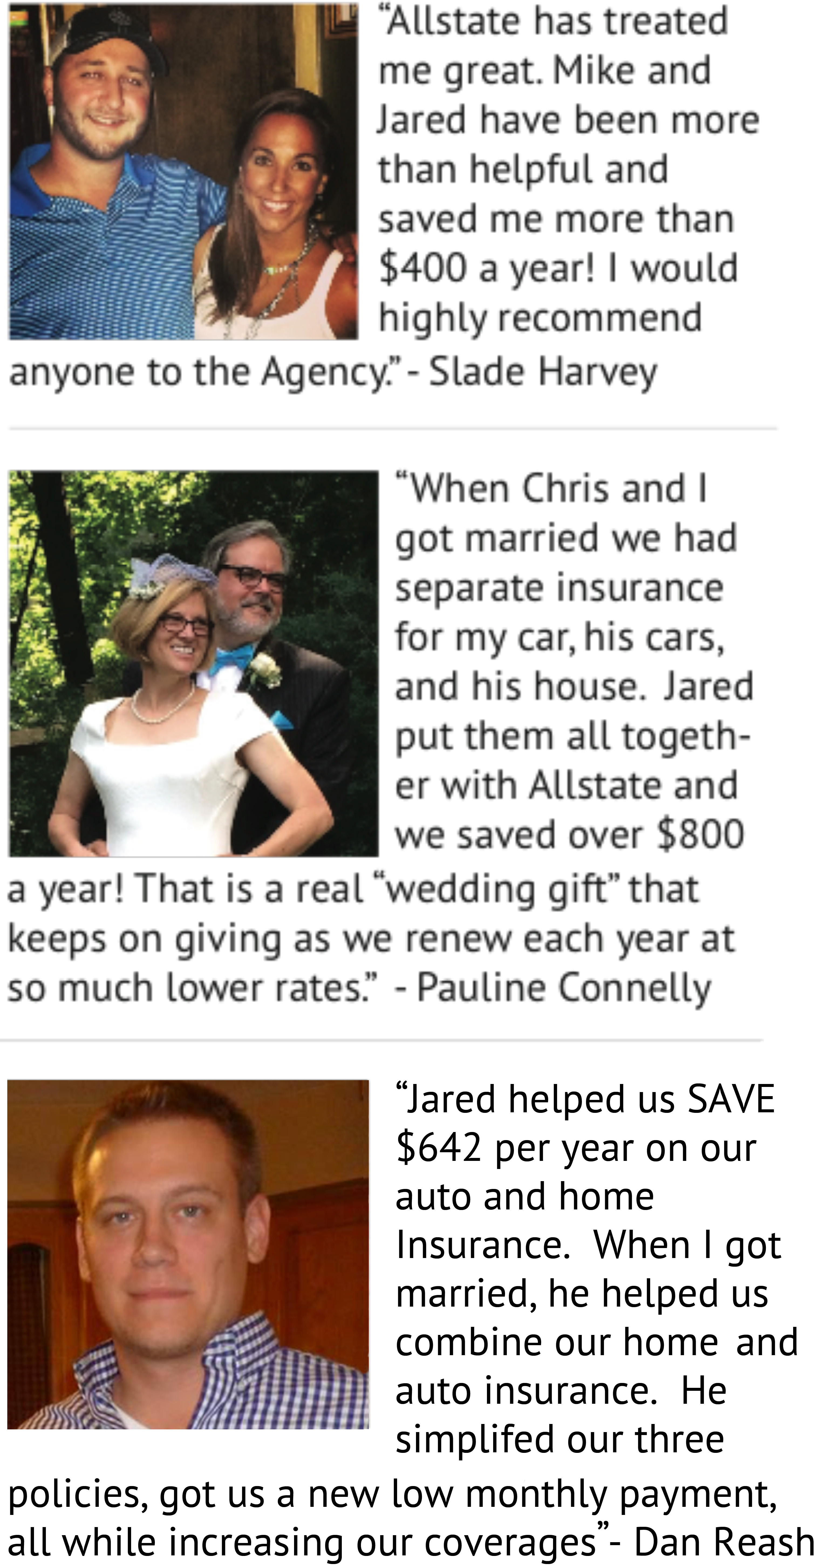

Dear «First_Name»,

The auto & home insurance carriers I work with just LOWERED RATES in Pennsylvania! We’ve been helping your neighbors save hundreds of dollars per year.
In fact, I’m so confident I can save you money... If I can’t save you at least $307.00 - I’ll pay you $20. 00 as my penalty just for wasting your time. (You just need to qualify for auto and home insurance.)
ONE CALL DOES IT ALL! We’ll cancel your existing policies for you, request
any refund you may be
owed, PLUS notify DMV,
your bank, and contact
your mortgage company
for escrow payment, so
the process is easy and
pain-free for you!!

Call (724) 628-7930 Right Now or visit us at quotemejared.com!

ATTN: «City» Residents…
FREE $10 Gift Card
Bring this flyer into my office WITH your current auto and home insurance policy declaration pages, and receive a $10.00 gift card to a local restaurant, store, or gas card. No purchase necessary. No pressure or obligation to buy anything... You don’t even need to get a quote!
“Our NEW Rates are So Low…
If I Can’t Save You AT LEAST $307⁰⁰ Per Year on Your
Auto and Home Insurance, I’ll Pay You $20⁰⁰!”

FREE $10 Gift Card
Bring this flyer into my office WITH your current auto and home insurance policy declaration pages, and receive a $10.00 gift card to a local restaurant, store, or gas card. No purchase necessary. No pressure or obligation to buy anything... You don’t even need to get a quote!
Jaredquinn.com
quotemejared.com
jaredquinn@allstate.com
(724) 628-7930

