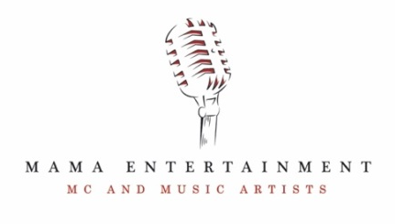

HOME WHAT WE DO ABOUT US WHY HIRE M.A.M.A? COUPLES GALERY QUOTE CONTACT OUR BUDDIES
HOME PAGE
YOU’RE HERE – SUPER!
WELCOME TO THE ONLINE HOME OF M.A.M.A ENTERTAINMENT!
WE’RE ARE YOUR WEDDING PARTY CREW – MC VARVARA & DJ ART
OK, in a more professional and grownup tone, M.A.M.A Entertainment is a Sydney based professional Master of Ceremonies and DJ company, specializing in providing the best possible Wedding & Party Entertainment experience for our wedding couples.
OUR MISSION IS TO RID THE EARTH OF BORING WEDDINGS!
Our pledge is to do everything in our power to deliver you a totally unique, one off wedding celebration that will define you as a couple, and will be the talk among your friends and family for many years.
We’ll remove all the formal stuffiness that a traditional wedding reception can bring and help to get you and your guests relaxed enough to sit back and enjoy your celebration.

WHAT WE DO
Wedding Master of Ceremonies
Master of Ceremonies Varvara will act as MC, entertainer, singer and the peacemaker of the celebration. She will be working on ways to enhance your wedding, and she will think up new methods to personalise your celebration. She will re-write and create both fun and functional timeline for your wedding party. She will check your speeches, offer advice, answer questions and do whatever it takes to make your wedding truly FUN-tissemo and bellissimo!! (nope, we don’t speak Italian – it just sounds fun! ;))

Wedding DJ
DJ Art will look after the music element of your wedding entertainment. Your guests won’t want to leave the dance floor as the perfect mix of music is created with your personal selections in mind. DJ Art is always rehearsing, learning new techniques (what a wonderful geek!), practicing, looking at your music choices and working on ways to create the right atmosphere with his music. Check out what our beautiful couples say.

Extensive Wedding Party Pre-Planning
We’ll spend on average 35 hours to help make your wedding celebration the best it can be. Together we’ll think about what represents you as a couple and incorporate it into your wedding. We’ll design your wedding celebration in great detail with dynamic and fresh ideas, fun and heartwarming wedding games and actives, tasteful jokes and beautiful remarks about you and those close to you. Each wedding celebration is unique, warm and a lot of fun.

ABOUT US
First off a big thanks for enquiring about our services and being interested in what we’re all about.
We are MC Varvara and DJ Art - your wedding party crew or a husband and wife team, whichever you prefer. Between us we have 19 years of experience in wedding entertainment, and a wedding of our own, which all come in very handy when planning for your special day. We walk in our couples’ shoes because completely understand the needs and concerns they may have when planning for their special day. We’re here to guide you through the entire journey.
From humble beginnings, our business has grown out of a genuine passion for our own wedding (which was a bit bumpy on the entertainment-side of things), and a desire to make the wedding day of each and every one of our couples stress-free and fun. Meeting you for the first time and getting to know you better as a couple, is one of our favourite parts! It brings a smile to our face, fills our heart with joy and incites happy dancing. Yes, we happy-dance a lot! (feel free to join in). :)
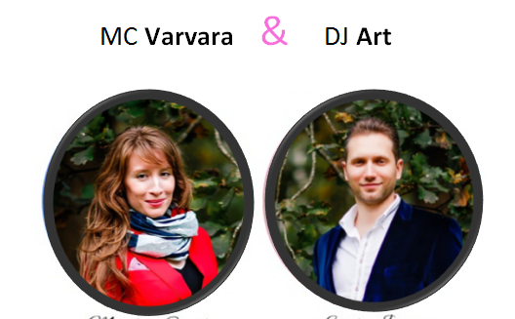
Varvara is a professional wedding Master of Ceremonies, entertainer and a singer. She hols a Master of Arts’ degree in Communications and a Bachelor’s degree in Theatre Studies. Art says that working with Varvara is a lot of fun! She is passionate, creative and entertaining. She bosses him around a little though, but he doesn’t mind that at all. “Happy wife - happy life!”, he wisely notes.

Art became DJ and a sound engineer, after meeting Varvara. Boom! He is a computer guru with Master and Bachelor’s degrees in IT, and he loves all things sound and music. Varvara says that it’s so cool to work with Art. They’re always on the same page and well prepared, which makes everything run smoothly. “Weddings and parties are the only places where Art lets me boss him around (well, not really…hehe)”, she says.
WHY HIRE M.A.M.A?
TO CREATE THE BEST ATMOSPHERE AND GIVE YOU A PARTY LIKE NO OTHER!

HERE ARE A FEW THINGS THAT MAKE US STAND OUT…

We walk in our couples’ shoes. In addition to our extensive experience in wedding entertainment we
also share a wedding of our own. We completely understand our couples as we’ve been there and we’ve done it.

Passion - our true passion is to create a stress-free and fun environment for our brides & grooms. Your wedding day is all about you. Our job is to coordinate everything, and entertain you and your guests. Your job is to be Mr. and Mrs. Awesome, relax and enjoy your special day. :)

Extensive Pre-Planning – One of the secrets to a successful wedding party is the pre-production work. We’ll spend on average 35-40 hours to help make your wedding celebration the best it can be. We’re available for all your reception planning 7 days a week.

Two entertainers are better than one - The dynamic of two performers makes a tremendous difference in the energy and excitement of your celebration. Surely, one person acting as MC/DJ is capable of making announcements and playing music. However, if you wish to get your guests more engaged, animated and entertained throughout the celebration, it’s worth having MC and DJ i.e. us! ;)
Emotional connection - It’s hard to please everyone with venue, catering, entertainment... We believe that a secret to a successful and memorable wedding is to get your guests emotionally involved in the reason they are there – the two people they love are joining their lives together. We involve everyone emotionally through heart-warming stories about our couples, tasteful jokes, interactive games, customised music, and other creative activities.

Surprise! Ta-Da! - Varvara is also a professional singer but she never gives the game straight away as she doesn’t want to spoil the surprise. When she bursts into song during your wedding celebration, you’ll love to see the reaction on your guests faces!

Creativity - We have tons of dynamic fresh ideas and useful tips that will help make your wedding celebration spectacular. For example, why throw one bouquet when you can surprise your single girlfriends by throwing 3 little ones? Wheee triple happiness!! Or, just before the Gutter Toss, why not have an arm wrestling competition to warm the boys up? ;) Little details like these will make your wedding celebration more special and fun.
Professional in every way - We don’t smoke and don’t drink so you can be sure that we’ll be in the best shape possible for the entire celebration. We wear only upscale formal attire that will correspond with the color theme of your wedding. Having a Star Wars theme? No problem, we’ll look the part! ;)
Music to entertain - DJ Art has a great selection of music. However, he is more than happy to play your and your guests’ favorite tunes. All you need to do is to send him your music choices and he’ll work his magic.
Professional sound & music equipment, including microphones for the guests.
We’re early birds – we’ll arrive at least 3 hours prior to the start of your wedding to set-up, sound check and liaise with venue staff. We’ll ensure everyone is on the same page and ready to bring their A-Game for your wedding.

Well, enough chatter from us… Sorry if we’ve gone on a bit, we’re just super passionate about our job!

If all of the above has stirred your interest, then the best thing to do for now is have a meeting with us, which is obligation-free. You will get a real feel for everything we can do to make you stand out from the crowd.
Contact us on 0413 826 964 or via info@mama-entertainment.com.

We look forward to hearing from you! xo Varvara & Art

OUR HAPPY COUPLES
(Note to designer: Maybe we can organise clients’ testimonials in the way as on the picture below – with a scrolling bar. So testimonials look neat and take less space. Though it looks ordinary and quite boring. Any other ideas? )
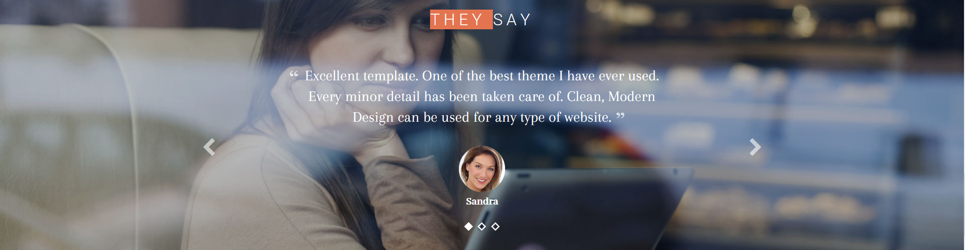
“Dear Varvara and Art, thank you for the wonderful entertainment you provided at our wedding. Even two months later friends and relatives still are raving about the wonderful evening and the enjoyment your music inspired. You are very talented. We’ll definitely recommend your services to family and friends. You’re professional, organized and lots of fun. Thank you for making our wedding day so special!”. Love, Iana & Andrei
“Varvara, we are extremely happy that you hosted our special day for us. Your level of organization, signing talent and positive attitude is at the very top. Among all the little problems that we had during the day you were one of few people who helped us solve them, like the time when you helped us with extra sitting arrangements. All the guests loved your beautiful signing, the way your hosted the whole party and all those amazing and fun games we had during the reception. The way all the entertainment was balanced was also perfect, just the right amount of dancing, singing and games. Thank you for being so flexible with all our requests and making the party along with our wedding theme. Thank you for everything; it was a pleasure to have you on this special day for us.” Elena & Alex Kudryavtsev
“Varvara and Art were professional at all times, enthusiastic, patient and so much fun! Their experience helped guide us on making it a fantastic celebration. Their personal touches make you feel like you aren’t just another wedding but like you are unique. Thank you so much and we’ll definitely recommend you to our friends”. Marie & Steven Ridout
“Honestly, it was a pure luck to find Varvara and Art! Varvara is an incredible MC from what we’ve seen and we’ve seen quite a lot. We had a bilingual wedding and it was almost impossible to find modern MC who can maintain traditions and on top of that make it fun and interesting!!! A lot of my friends keep saying that our wedding was the most incredible. I know you think they said it because they wanted to be polite, but they are still talking about it even 2 years after our wedding day. Ask M.A.M.A Entertainment to be your wedding MC and DJ and you will get the best wedding day ever!” Kate & Alex Usachev
GALERY

Note to designer: Photos of our weddings and events.
INSTANT QUOTE
OUR WEDDING PACKAGE INCLUDES:
- Varvara - Professional Master of Ceremonies/Interactive Entertainer
- Art - Professional DJ/Sound Engineer
- State of the Art Sound & Music Equipment
- Microphones for You & Your Guests
- Your Song Choices
- Extensive Pre-Planning
- Unlimited phonecalls and emails
- We’re avaiable 7 days a week
- Equipment delivery, setup and packdown (total time of approx. 6 hrs)

Please fill in the details in the request form and receive an instant quote. All fees are GST inclusive.

Note to designer: Here we’d like to have a Wizard form that will generate quotes.

The form will have the following questions (each with a drop down options) and the ‘get an instant quote’ button:

- Event Location
- Event Duration
- Number of guests
- ‘Get instant quote’ button

CONTACT US
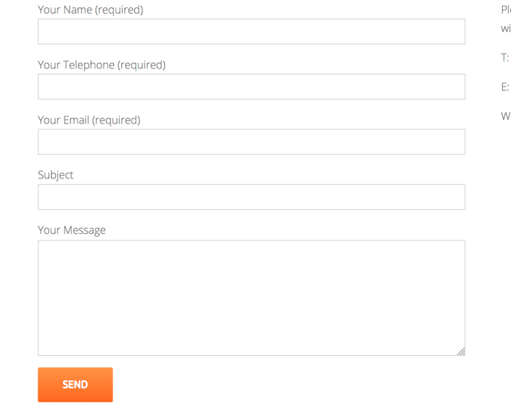
We’d love to hear from you!
Contact us on 0413 826 964 to arrange a time to get together, chat about ideas and to learn how, with our powers combined, we can create something truly FUN-tissemo and totally you.
info@mama-entertainment.com www.mama-entertainment.com
Or please fill in your details in the ‘Contact us’ form and we’ll contact you shortly.

OUR TRUSTED FRIENDS
Azure Sky Photo Art Studio by Kate Leo www.azuresky.com.au
We worked with Kate at many weddings and events in Sydney, and she was the photographer at our own wedding. So we’re recommending her without hesitation. Kate is warm, hard-working and very creative - a true professional who can be trusted to deliver beautiful and memorable photos.

Gentle Flowers by Alena www.gentleflowers.com.au Alena specialises in floral arrangements for weddings. She is a true floral guru, and just a beautiful lady.
StanisLove Radzievski is an acclaimed professional saxophone player. Ah, we absolutely love Stas! He’ll touch your heart with his music, guaranteed! www.stas-sax.com

Tell us about your needs and we’ll recommend great people who can help make your wedding celebration special.

