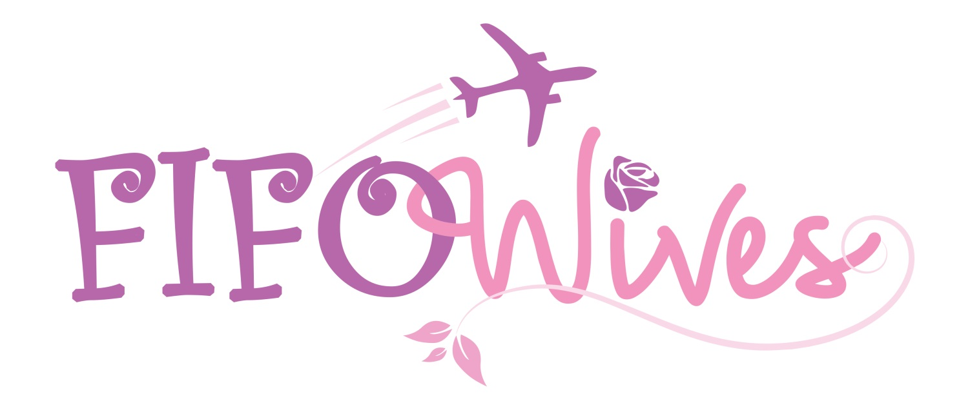
{A community of strong women}

FIFO Wives is supported by:

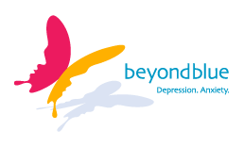




OUR VISION
Our vision is to empower women to embrace and create a healthy FIFO lifestyle, by providing a platform for wives/partners/girlfriends with FIFO/DIDO/BIBO partners onshore and offshore; to connect, communicate, and be supported in a safe and nurturing environment.
OUR MISSION
Our mission is to provide competent, professional, and holistic and wellness focused services that promote healthy relationships, prevent development of mental health challenges and address social-emotional difficulties that currently exist within the FIFO Wives community.
OUR VALUES
Hope - We value hope, courage and determination, knowing that people can manage their mental health and maintain healthy defacto/family relationships.
Respect- We accept and honour diversity, uniqueness and the contribution of others.
Compassion- Remembering that caring is as important as care. The highest calling of our FIFO Wives community is to provide comfort for those that require support.
Integrity – We value honesty and accountability in our relationships with our consumers, families, staff and stakeholders.

About FIFO Wives
{A community of strong women}
FIFO Wives is an online platform for wives/partners/girlfriends with FIFO/DIDO/BIBO partners, both onshore and offshore to connect with others living in similar mining lifestyles.
Founder Libby Twine, a Mental Health advocate aims to provide professional and holistic and wellness focused services. In particular, ,FIFO Wives seeks to provide a support network to women experiencing negative social-emotional challenges like depression, anxiety, isolation, relationship breakdown and parenting issues.

