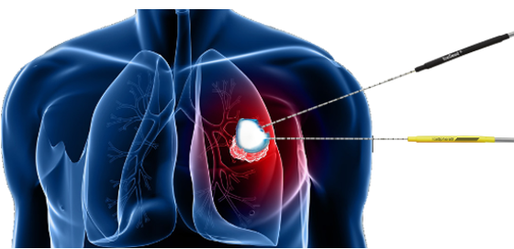

The Cryoablation illustration could be something like this, but only with one needle.

When we inject the immunotherapy, we use a multi prong needle to distribute the immunotherapy over a larger area. See: http://rexmedical.com/quadra-fuse.html

http://technical.sanguinebio.com/wp-content/uploads/2012/12/xTumor_microenvironment_cells-370x402.jpg.pagespeed.ic.d32U5fbHOJ.jpg

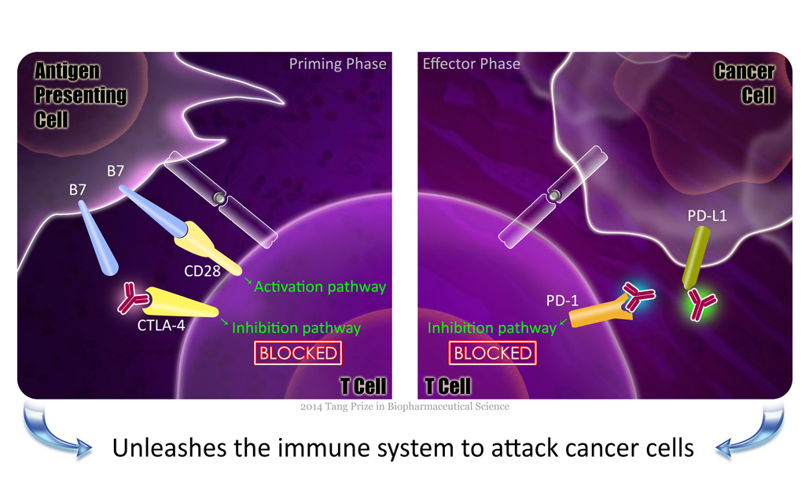

http://www.tang-prize.org/UserFiles/Image/Laureates/diagram-v5-blocked.jpg

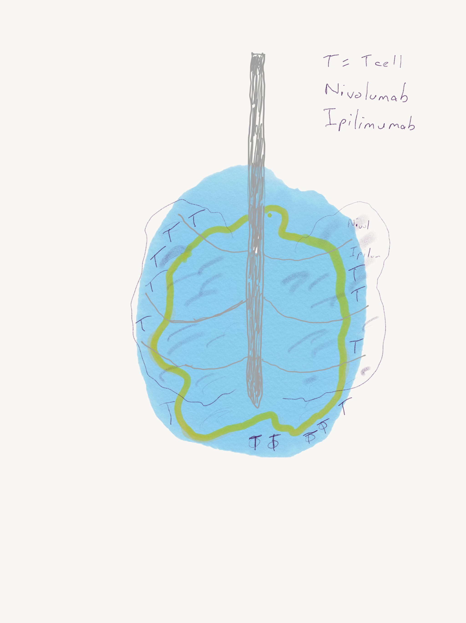

The concept is that initially the tumor is killed with Cryoablation. The new immunotherapy drugs Ipilimumab (an anti-CTLA-4 drug) and Nivolumab (anti-PD-1 drug) are injected into and around the ablated tumor. It is here, in the tumor microenvironment that the immune system is primed and taught to attack the tumor that was just killed. Then the immune system knows how to kill the tumor and will kill it in other locations of the body.

