

About Us
Established by Robert Boyles in 2011 Modern Earth Electrical Limited offers first class electrical services across the Isle of Man. Our fully qualified, professional electricians are committed to providing outstanding customer service every time. We consult closely with our domestic, commercial, and industrial clients to provide clean, modern, energy efficient systems that meet all expectations. We specialise in data networking, security lighting, home automation systems, fire alarms, emergency lighting, maintenance and inspection services.


Domestic Electrical Services
Modern Earth Electrical Limited are experts in all domestic electrical jobs. Our friendly and reliable electricians can carry out everything from full re-wiring to simply changing a light fitting. Our fully qualified electricians can personally undertake any electrical work you need and no job is too small. On top of our first class service, we offer quick response times, fair prices, and free impartial advice.

NEW BUILDS AND EXTENSIONS

With years of experience on countless projects, we have grown to understand that a project such as a new build or extension can cause disruption and stress. In order to minimise this we work closely with the client during the design process and throughout the project to completion. We also work very closely with all contractors involved to ensure that the project runs seamlessly.

Fault Finding, Repairs & Re-wiring

It is important to keep the electrics in your home in good working order. We are able to give friendly advice on the maintenance and repair of your electrical system and can also undertake both complete or partial re-wiring tasks.

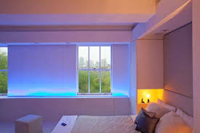
INstallations and Lighting

We excel in designing and installing all different types of lighting, promoting energy efficient LED lighting both indoor and outdoor. Give us a call today to arrange a free lighting consultation.

Commercial Electrical Services
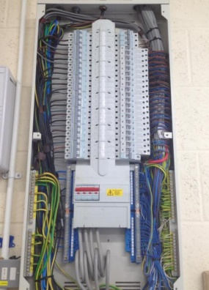
Our commercial electricians are perfectly suited to carry out any type of electrical work for your business. We understand that getting through all the building regulations can be tough, and are fully on hand to offer advice, and guide you through the process. Our commercial electricians have years of experience, and can ensure that your work is carried out on time and to budget.
If you are moving offices, Modern Earth Electrical can advise you on the best electrical system for your business, and handle the entire process for you, from design to installation, and even maintenance and repairs. Each of our electricians is City & Guilds qualified, to ensure that your workplace meets all the electrical health and safety standards.
EMERGENCY LIGHTING
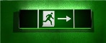
Emergency lighting is vital for a working environment to ensure the safety of your employees. We are able to expertly install and maintain these systems, and advise you on the best solution for your business.

FIRE ALARM MAINTENANCE
All fire systems must be regularly tested and maintenance is essential as it will prolong the life of a system and discover any faults that may occur. A system that is not maintained cannot be guaranteed to protect life and property. The only reliable and measurable means of ensuring that your existing fire detection and warning system remains compliant and fully functional is to instigate a plan of regular routine maintenance and testing carried out by a ‘competent’ person supplemented by weekly user tests.
Security Alarms and CCTV
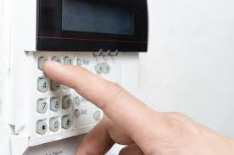
It’s vital to keep your security and CCTV systems in good working order to reduce false alarms and to ensure that the alarm will be raised in the event of a break-in and your CCTV is located and recording properly. A maintenance contract will ensure that your intruder alarm and CCTV is inspected and tested regularly and can often pre-empt issues with your alarm system which would otherwise require an emergency call-out.

Biometrics
Unlike keys, electronic swipe cards, proximity cards, chip and pin cards, or keypad number sequences, access through a biometric reader cannot be transferred from person to person unless explicitly authorized, it is unique, which is what makes biometric readers and biometric technology more secure. From major government applications to commercial buildings, our biometric readers & biometric systems provide the ultimate in security, reliability and convenience. While perfect for applications large and small, their low error rates translate into incredible reliability. 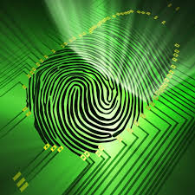
New Lighting and Power Systems
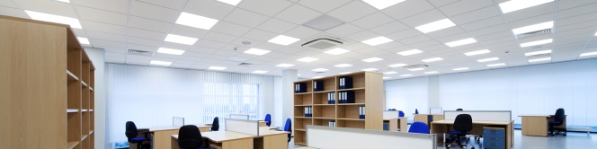
Our commercial electricians can design and install the perfect lighting and power system for your business, and are on hand to give you advice and support that you need. We can also assist with government approved Green Loan schemes which will provide funding for new energy efficient lighting. Terms and conditions apply.

ELECTRICAL TESTING
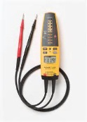
We can carry out all electrical inspection and testing for your home or business. This is needed in order to ensure that a working or living environment is electrically safe from potential faults. Our friendly and experienced electricians can help you, by ensuring that your employees and residents are safe from potential hazards. Not only is it vital to meet all health and safety regulations for legal reasons, but the tests will also give you complete peace of mind that your building is safe.
There are many types of Electrical Inspection, and it can often be difficult to understand exactly what level of electrical testing you need. We are on hand to guide you and provide the advice required.
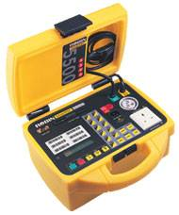
It is important when having Electrical Inspections carried out on your property, that you employ a trustworthy and reliable company. The safety of our customers is our number one priority, which is why we always use best quality equipment in our testing process.
We also carry out Portable Appliance Testing (PAT) for businesses, landlords and individuals to ensure that the electrical products you use on a daily basis are safe. For businesses, these annual tests are mandatory by law, however we also advise that testing is carried out on personal appliances.
To discuss any of your electrical requirements please contact us
Email: info@modernearthelectrical.com
Phone: 07624 477061

